Consumer Perception Survey
May 2017 YSS-F Administration
Children and Youth (Family Report)
Jonathan Rich, Ph.D.
02/20/2018

The Youth Satisfaction Survey for Families (YSS-F) was offered to all parents and guardians of children and youths attending mental health services at a County or contract CYBH clinic from May 15-19, 2017. YSS-F records with birthdates corresponding to an age of 0 – 25, with a valid program code, and with a CYBH, ADAS or Prevention & Intervention program indicated were retained for this analysis. This reduced an initial YSS-F file of 825 surveys to 723 surveys.

YSS-F Results

Sample description:

N: 723
Gender (n = 695): F-300 (43.2%), M-390 (56.1%), O-5 (0.7%)
Age (n = 723): Mean = 11.2, s = 4.2, range = 0-20.
Form Language (n = 723): English- 346 (52.7%), Spanish- 355 (49.1%), and Vietnamese-22 (3.0%).
Function Area (n = 723): CYBH-658 (91.0%), P&I-65 (9.0%).

Race/Ethnicity (n = 881):

Survey respondents describe their race and ethnicity by selecting as many of the following categories as applicable: Hispanic, American Indian, Asian, Black, Pacific Islander, White, Other Race, and Unknown Race. These selections were reduced to six categories as follows. If either Asian, Pacific Island, or both are selected, that is considered a single category, “Asian/Pacific Islander.” If only one category is selected, then the participant is assigned to that category. If more than one category is selected, or if “Other Race” or “Unknown Race” is selected, the participant is classified as “Mixed/Other.” If “Hispanic” is selected, the client is classified as “Hispanic,” regardless of the other selections.

Figure 1. Client race/ethnicity
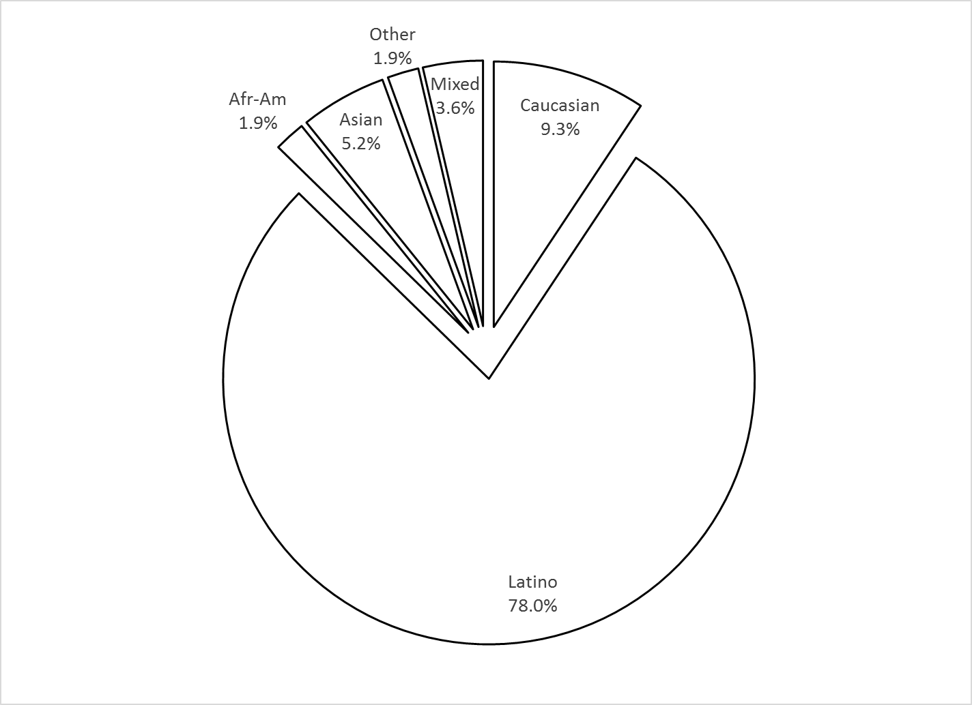

County vs. Contract (n = 723): County 191 (26.4%) vs. Contract 532 (73.6%)
Division (n = 723): CYBH 658 ( 91.0%), P&I 65 (9.0% ).
Mean YSS-F scale scores:

Figure 2. Mean Scores: YSS-F
(Scale is 1-"strongly disagree" to 5-"strongly agree"
Error bars show +/- 1 SD)

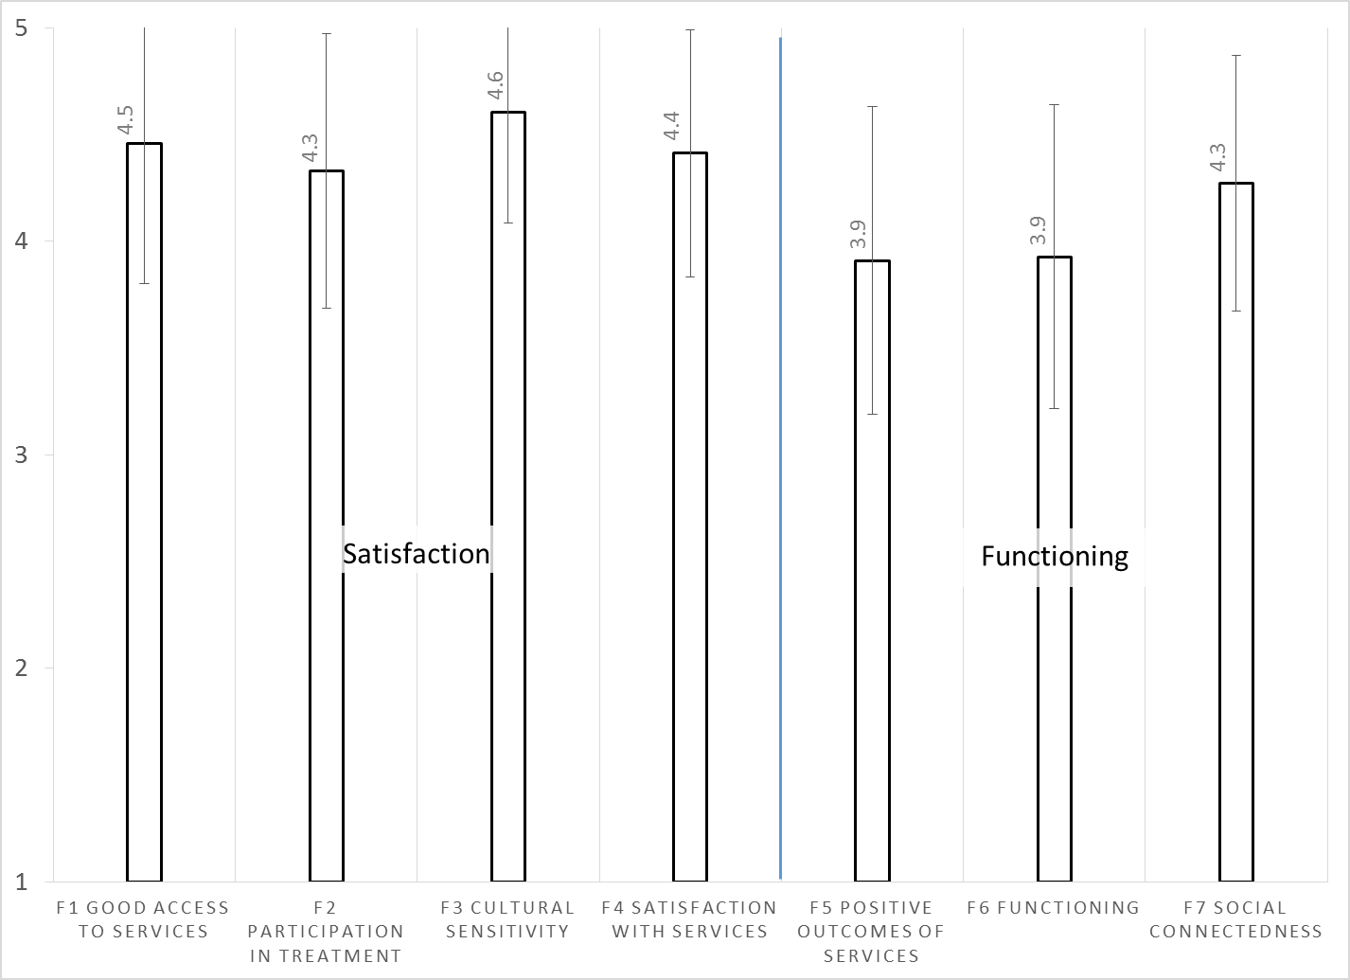

Factors affecting YSS-F scores:

YSS-F scales did not differ significantly by race/ethnicity.

Figure 3. YSS-F scores by race/ethnicity
(No significant differences, p > .01 for all scales)
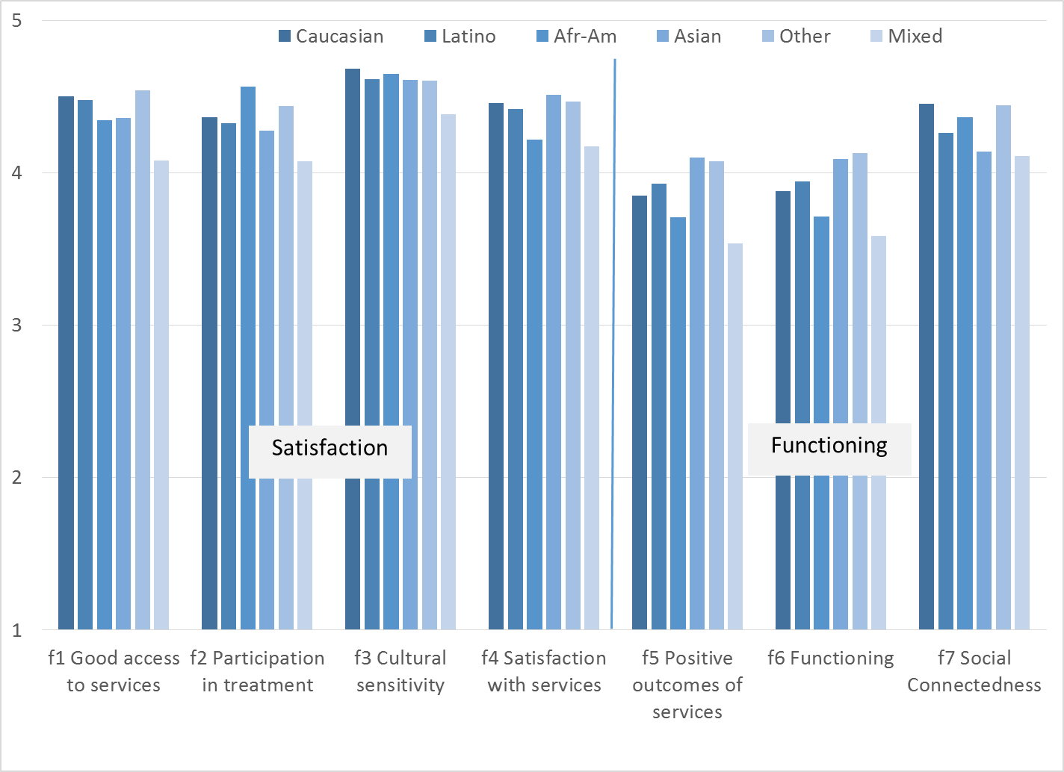

Participants completing the form in English were compared to those completing the form in Spanish and Vietnamese. Spanish-speakers indicated slightly more positive outcomes than English-speakers. Vietnamese-speakers’ ratings of outcomes were not significantly different from either the Spanish- or English-speaking group.

Figure 4. Positive Outcomes of Services, English vs. Spanish vs. Vietnamese forms
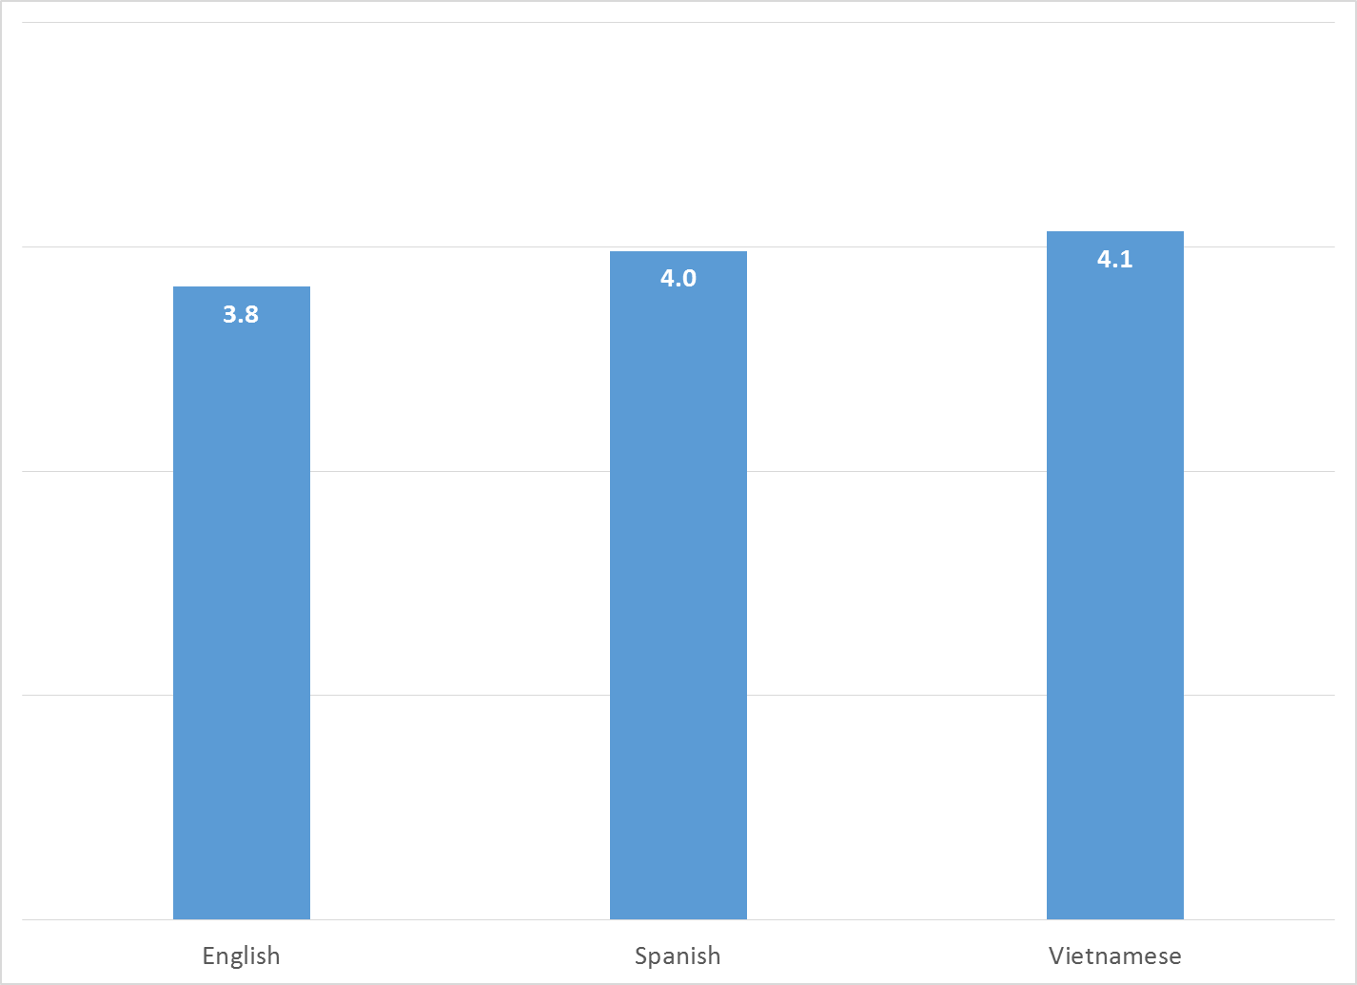

There were no significant gender differences.

Clients who had been enrolled longer in services tended to score higher on the Functioning scale. This relationship is depicted in Figure 5 along with the non-significant relationships of other scales with time in service.

Figure 5. YSS-F Scores by time in service (*p < .01)
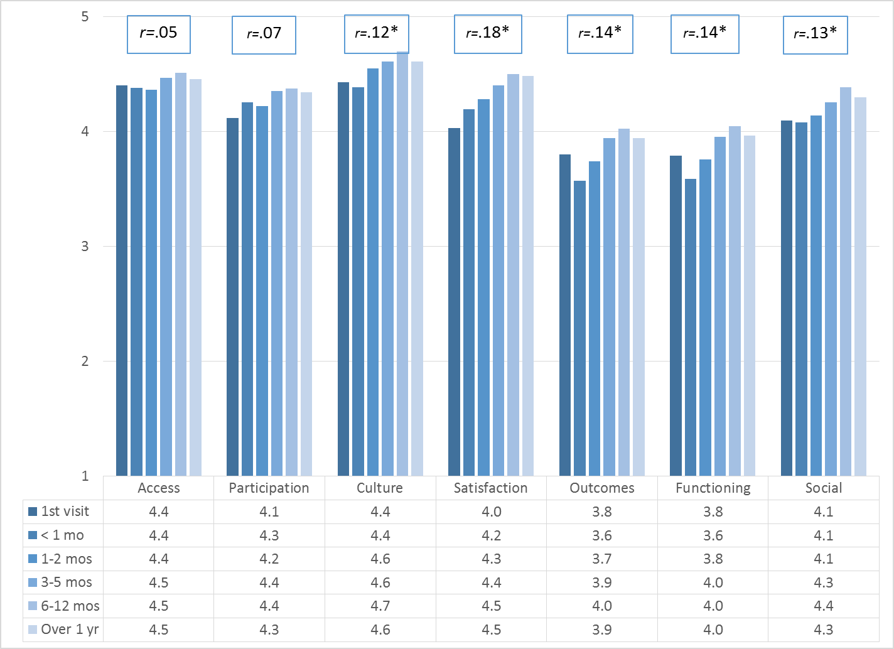

Living Situation

Parents/guardians were asked, “Has your child lived in any of the following places in the last 6 months? (Mark all that apply.)”

Figure 6. Percentage in living situation over past 6 months
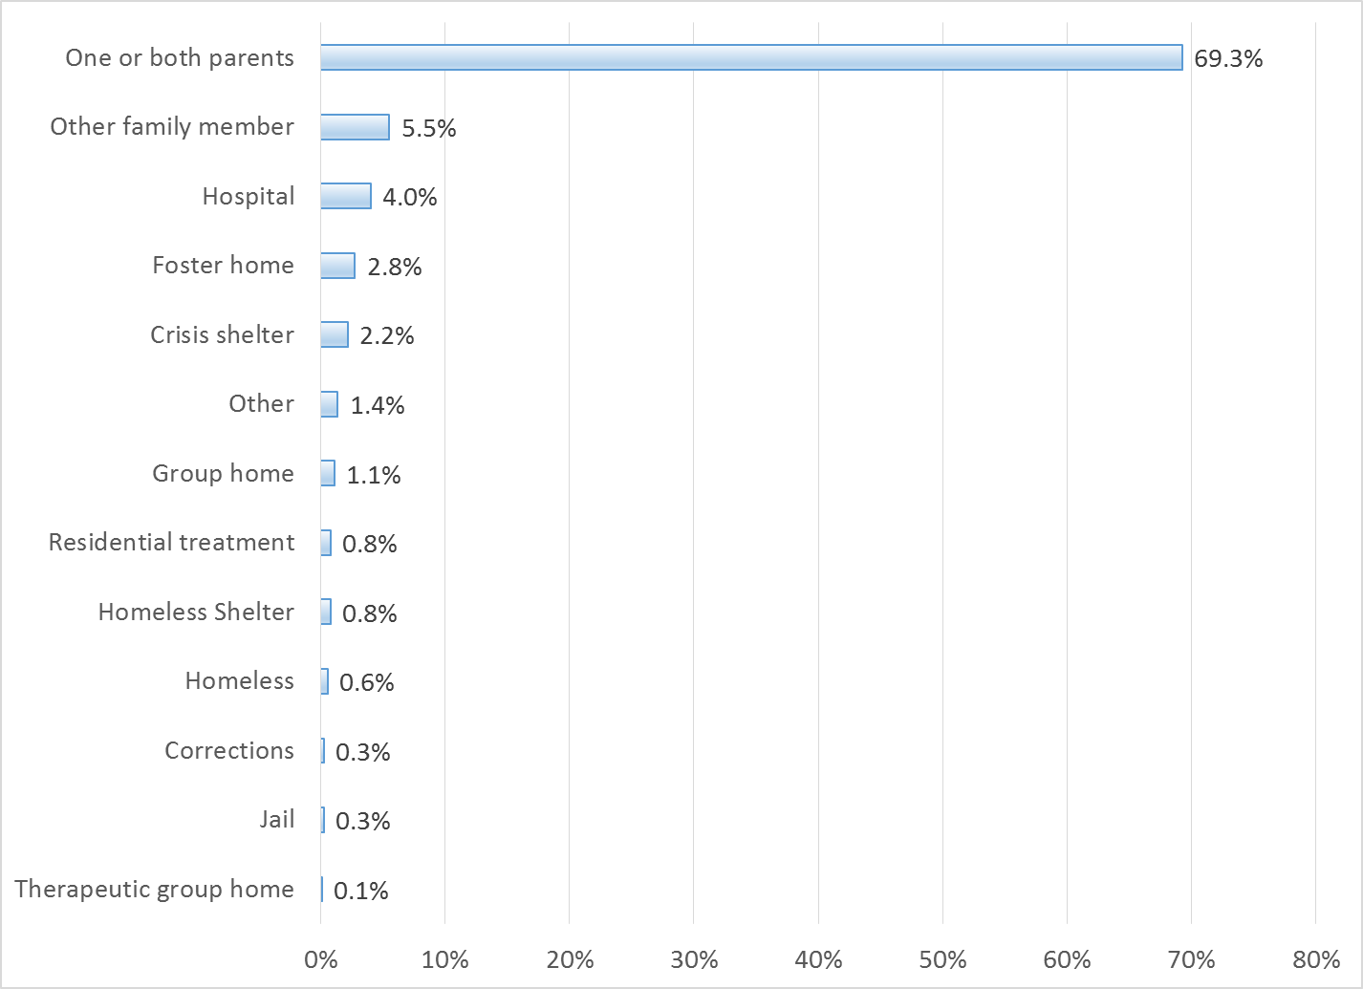

Doctor visits and medication

As seen in Figure 7, 77.0% of clients reporting (510/662) were seen for a medical clinic or office visit in the prior year. The rate did not differ by age, ethnicity, form language or gender.

Figure 7. "In the last year, did you see a medical doctor (or nurse)
for a health check-up or because you were sick?"
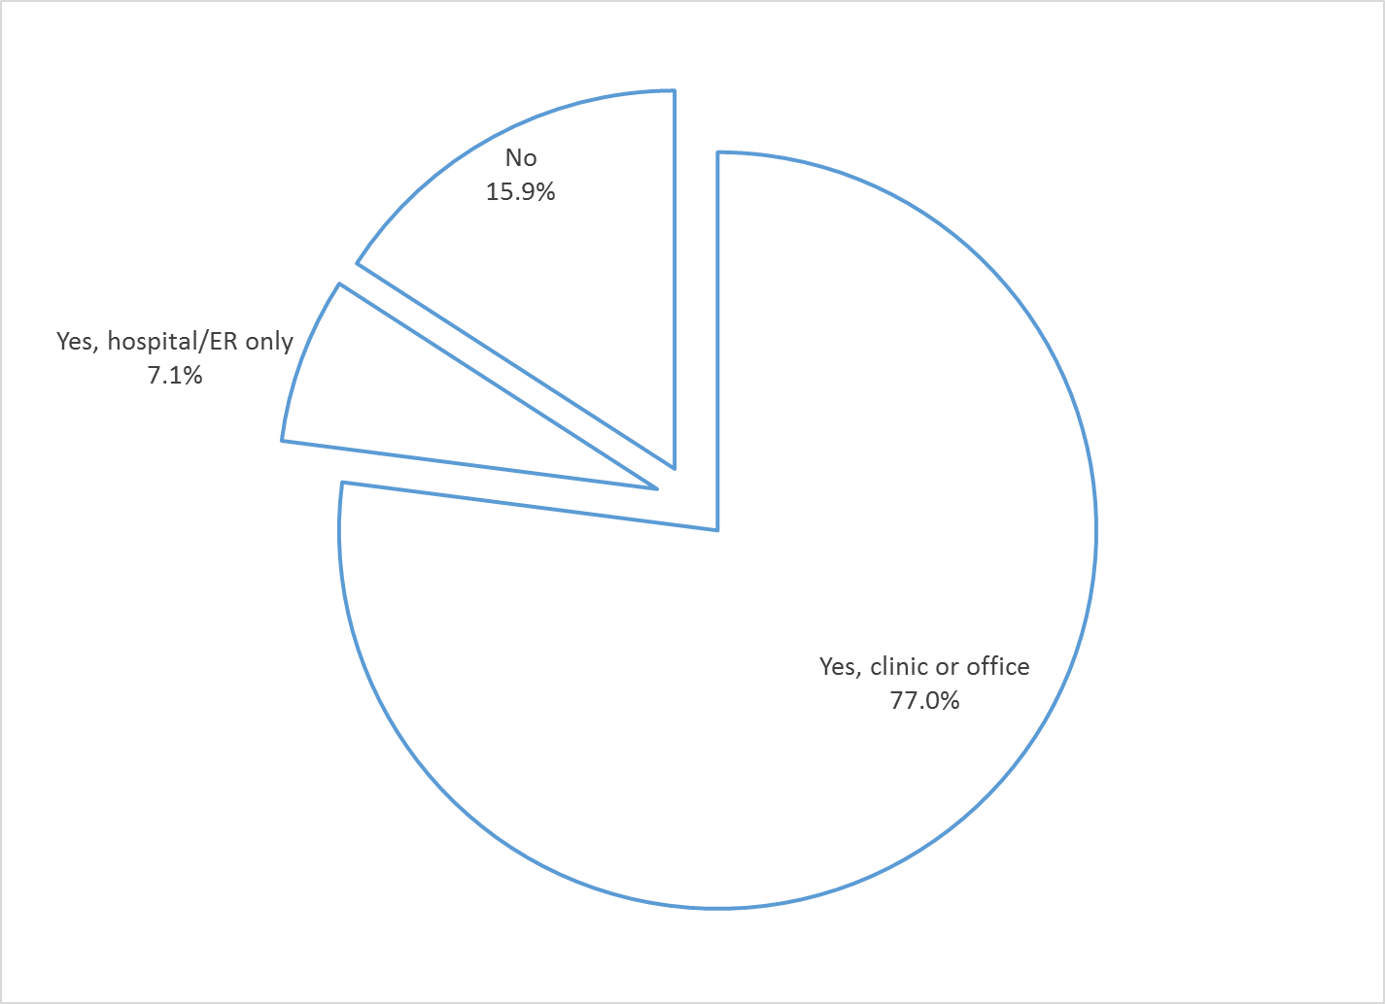

Thirty percent of clients (31.2%, 205/657) are taking psychotropic medication. Of the clients taking medication, 75.6% (155/205) reported that their medical provider had discussed side-effects with them.

Table 1. YSS-F mean scores by program
Program | Access | Partic | Culture | Satis | Outcomes | Func | Social | N
BHS Outreach & Engagement | 4.0 | 4.0 | 4.8 | 4.1 | 2.6 | 2.6 | 4.0 | 2
Child Guidance Center | 4.3 | 4.3 | 4.5 | 4.3 | 3.8 | 3.8 | 4.2 | 104
Child Guidance Center, BP | 4.6 | 4.4 | 4.6 | 4.6 | 4.1 | 4.1 | 4.6 | 17
Children’s Hospital of Orange County Co Occurring Clinic | 4.1 | 4.3 | 4.4 | 4.2 | 4.0 | 3.9 | 4.1 | 23
Collaborative Courts FSP | 4.5 | 4.5 | 4.7 | 4.6 | 4.3 | 4.3 | 4.6 | 27
Community Counseling and Supportive Services | 3.6 | 3.8 | 3.8 | 4.4 | 3.9 | 3.8 | 4.6 | 4
Connect the Tots | 4.8 | 4.5 | 4.8 | 4.6 | 4.4 | 4.4 | 4.4 | 56
CYBH CM | 4.7 | 4.3 | 4.8 | 4.4 | 4.0 | 4.1 | 4.0 | 13
CYBH East | 4.3 | 4.1 | 4.5 | 4.3 | 3.8 | 3.8 | 4.2 | 129
CYBH MV Los Alisos | 3.9 | 4.1 | 4.2 | 4.1 | 4.0 | 4.0 | 4.4 | 9
CYBH South, LB Wesley | 4.3 | 4.1 | 4.6 | 4.4 | 3.9 | 3.9 | 4.4 | 14
CYBH, North | 4.1 | 4.1 | 4.5 | 4.2 | 3.8 | 3.8 | 4.2 | 47
Families First | 4.3 | 4.0 | 4.3 | 4.3 | 4.0 | 4.1 | 4.1 | 18
KCS (Korean Community Services) [Distribute through OCAPICA, 22120] | 4.3 | 4.3 | 5.0 | 4.6 | 4.3 | 4.3 | 4.1 | 4
Kinship Seneca | 4.8 | 4.9 | 5.0 | 4.6 | 3.5 | 3.5 | 4.3 | 3
New Alternatives WRAP | 3.4 | 3.1 | 3.9 | 3.4 | 3.9 | 3.7 | 3.6 | 7
OCAPICA FSP | 4.0 | 4.3 | 4.6 | 4.3 | 3.8 | 3.9 | 4.3 | 14
Orange County Center for Resiliency, Education & Wellness(OC CREW) | 4.3 | 4.1 | 4.5 | 4.2 | 4.4 | 4.4 | 4.3 | 12
Pathways CS STAY | 4.2 | 4.3 | 4.6 | 4.4 | 3.8 | 3.9 | 4.2 | 31
Pathways Garden Grove | 4.7 | 4.5 | 4.7 | 4.5 | 4.0 | 4.0 | 4.5 | 21
Pathways RENEW | 4.5 | 4.3 | 4.6 | 4.5 | 3.8 | 3.9 | 4.3 | 93
Pathways, Anaheim | 4.3 | 4.2 | 4.3 | 4.3 | 3.9 | 3.9 | 4.1 | 44
Pathways, Santa Ana | 4.4 | 4.2 | 4.7 | 4.4 | 3.9 | 4.0 | 4.2 | 48
Seneca OC Wraparound | 5.0 | 5.0 | 5.0 | 5.0 | 3.5 | 3.5 | 5.0 | 1
Touchstones (Adolescent) | 4.3 | 4.3 | 4.6 | 4.5 | 4.2 | 4.2 | 4.4 | 12
VNCOC (Vietnamese Community of OC) OCAPICA FSP | 4.4 | 4.2 | 4.6 | 4.3 | 4.1 | 4.1 | 4.2 | 9
Western Youth Services West: Fountain Valley | 4.3 | 4.1 | 4.5 | 4.3 | 3.9 | 3.9 | 4.3 | 84
WYS East (Santa Ana) | 4.2 | 4.1 | 4.4 | 4.2 | 3.6 | 3.6 | 4.0 | 114
WYS North (Anaheim) | 4.3 | 4.2 | 4.5 | 4.3 | 3.8 | 3.8 | 4.1 | 197
WYS, Mission Viejo | 4.3 | 4.2 | 4.5 | 4.3 | 3.8 | 3.8 | 4.0 | 64
Youth as Parents | 4.0 | 4.5 | 4.4 | 4.3 | 4.3 | 4.3 | 4.3 | 5
Youthful Offender Wraparound | 4.4 | 4.4 | 4.4 | 4.4 | 4.1 | 4.2 | 4.2 | 37
Total | 4.3 | 4.2 | 4.5 | 4.3 | 3.9 | 3.9 | 4.2 | 1258
Yellow highlight: Significantly higher
Grey highlight: Significantly lower
+/- 2 std. errors highlighted.

