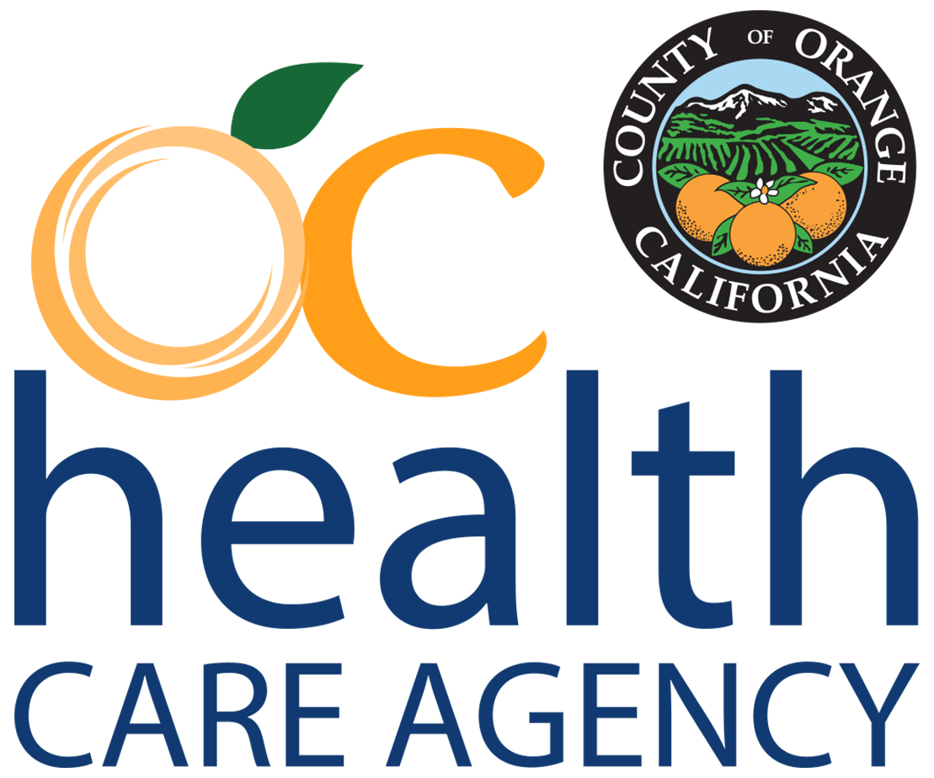
新聞報道
橙縣 公共衛生局

即時發布：2022 年 8 月 11 日 聯繫： 公共衛生局通訊
HCAComm@ochca.com
(714) 834-2178

食品藥品監督管理局公佈猴痘疫苗管理新指引
（加利福尼亞州聖安娜）2022 年 8 月 9 日，美國食品藥品監督管理局（the U.S. Food and Drug Administration）發布了一項關於為猴痘感染高風險人群接種 Jynneos 疫苗的新方法的緊急使用授權 (Emergency Use Authorization)。 是次緊急使用授權允許醫療保健提供者為 18 歲及以上人士通過皮內注射接種疫苗。
此公告具有科學根據：皮內途徑（皮膚層之間）產生與皮下途徑（進入皮膚下的脂肪層）相同水平的免疫原性。 新指引建議為高危人群注射目前 Jynneos 疫苗五分之一的劑量。此舉能令可用劑量增加多達 5 倍。閱讀詳細公告。
截至 2022 年 8 月 11 日，橙縣公共衛生局（Health Care Agency）呈報了 52 例確診或懷疑確診的猴痘個案，並為 1986 餘人接種疫苗。 接種疫苗的人士為直接接觸過猴痘，或感染風險極高的人群。 放眼國際，目前有 32,000 多個猴痘病例，來自共 91 個國家，其中美國有 10,392 個病例，加利福尼亞州有 1,733 個病例。
副衛生官員兼傳染病控制部醫療主任Matt Zahn醫生說：「公共衛生局的公共衛生服務（Public Health Services）傳染病控制部（Communicable Disease Control Division）團隊當前正在與我們的社區夥伴攜手合作，確保這些有限的疫苗資源能夠用得其所。美國食品藥品監督管理局和疾病控制中心的新指引能讓我們保護更多處於高危的人士。」

公共衛生局亦與社區組織合作，確保感染猴痘的人士可以接受抗病毒藥物 tecovirimat（TPOXX）治療。 如欲了解更多有關猴痘和疫苗接種指引的資訊，請到 www.ochealthinfo.com/monkeypox 查閱。

請採取以下措施：
為防止猴痘傳播，大家應該：
- 告知您的性伴侶最近身體有什麼不適或疾病，如您或您的伴侶的身體（包括生殖器和肛門）上出現新的或來歷不明的瘡或皮疹，務必多加注意。
- 避免與有潰瘍或皮疹等症狀的人親密接觸，包括擁抱、親吻、擁抱和性行為
- 停止與有症狀的人共用物件（例如餐具、水杯、衣服、毛巾、床上用品等）
- 經常使用肥皂和水或含酒精的洗手液洗手
- 照顧有症狀的人時，使用適當的個人防護設備 (PPE)（例如口罩、隔離袍和手套等）
- 避免接觸受感染的動物

懷疑自己患有猴痘或被猴痘感染的居民應立即聯繫醫護人員。 商業實驗室，包括 Quest Diagnostics、Labcorp、Aegis Sciences 和 Mayo Clinic Laboratories 可提供聚合酶鏈反應檢測（PCR testing）。

如欲獲得更多關於猴痘的資訊，例如病例數字、預防方法、疫苗接種以及公共衛生局在橙縣的工作，請到 www.ochealthinfo.com/monkeypox 或 https://www.cdc.gov/poxvirus/monkeypox/index.html 查閱。

