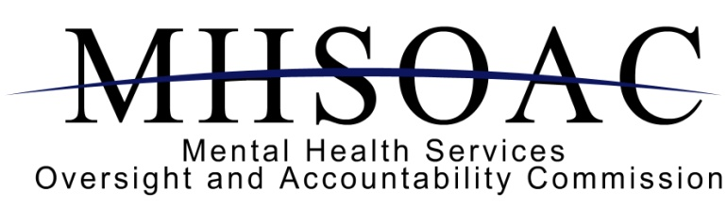
Presents a

Community Forum
on the Impact and Progress of the Mental Health Services Act (Prop 63)

Sponsored by the MHSOAC Client and Family Leadership Committee and the Cultural and Linguistic Competence Committee

When
September 13, 2012
3:30 PM to 7:00 PM

Where:
Delhi Center
505 East Central Avenue
Santa Ana, CA 92707
(714) 489-9600
(Directions only)

RSVP to:
mhsoac@mhsoac.ca.gov or
(916) 445-8696



Fish Pond, Sheila Dery

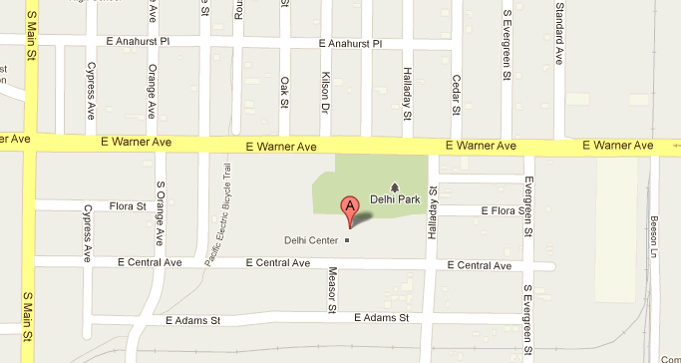



Interpreters will be made available upon request. Please contact the MHSOAC at, mhsoac@mhsoac.ca.gov or (916) 445-8696 for these requests. Providing at least 7 days advanced notice will help to ensure availability. Late requests will be honored if possible.

