Consumer Perception Survey: MHSIP

November 2017 Administration
Adults and Seniors
Jonathan Rich, Ph.D.
July 16, 2018

The Mental Health Statistical Improvement Program (MHSIP) was offered to all clients attending mental health services at a County or contract adult program during the week of November 13-17, 2017. There were 912 records returned. Records were discarded if the program number was missing, was not a valid number or if the program was part of Children and Youth Behavioral Health. Only cases with an age from 18-120 were retained. This left 664 cases.

Sample description:

N: 664
Gender (n = 651): F 49.6%, M 49.8%, O 0.6%
Age (n = 664): Mean: 38.2 years, s = 12.3, range = 18 to 90.
Form Language (n = 664): English, 86.1% Spanish, 13.3%, Vietnamese, 0.6%
County/Contract (n = 664): County 57.5%, Contract 42.5%

Figure 1. Function Area (n = 664)
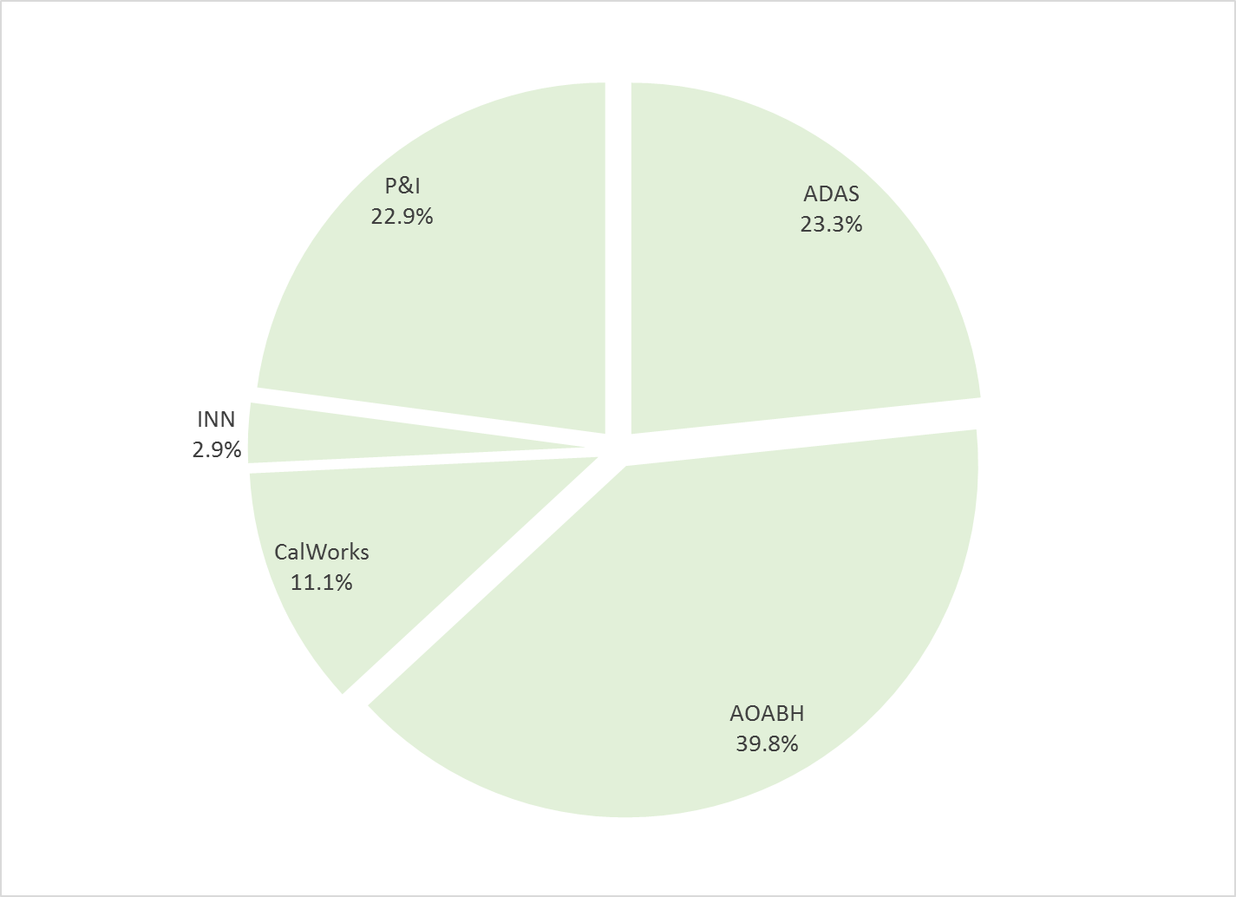

Figure 2. Race/Ethnicity (n = 641)
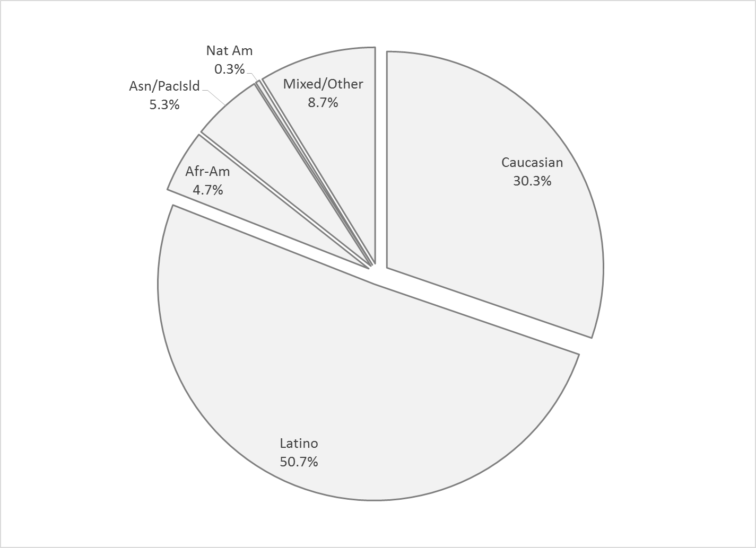

Survey respondents describe their race and ethnicity by selecting as many of the following categories as applicable: Hispanic, American Indian, Asian, Black, Pacific Islander, White, Other Race, and Unknown Race. These selections were reduced to six categories as follows. If either Asian, Pacific Island, or both are selected, that is considered a single category, “Asian/Pacific Islander.” If only one category is selected, then the participant is assigned to that category. If more than one category is selected, or if “Other Race” or “Unknown Race” is selected, the participant is classified as “Mixed/Other.” If Hispanic is selected, the client is classified as “Hispanic,” regardless of the other selections.

MHSIP Scale Scores:

Consistent with past results, responses to service satisfaction items average between “Agree” (4) and “Strongly Agree” (5). Response to items that reflect personal functioning are lower, just at the “Agree” level. Endorsement of service satisfaction items (“Agree” or “Strongly Agree”) was above 90%; at least three fourths of respondents endorsed personal functioning items.

Figure 3. Mean Scores: MHSIP Service Satisfaction
(Scale is 1-"strongly disagree" to 5-"strongly agree")

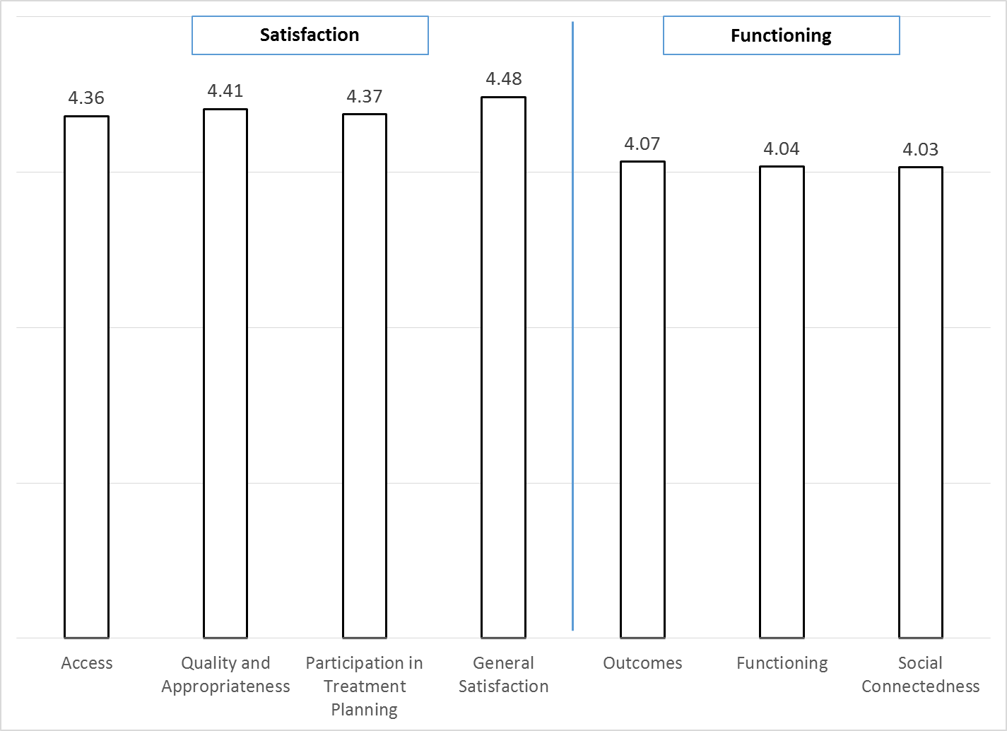

Figure 4. Percent with scores at or above 3.5, "Agree" and "Strongly Agree"
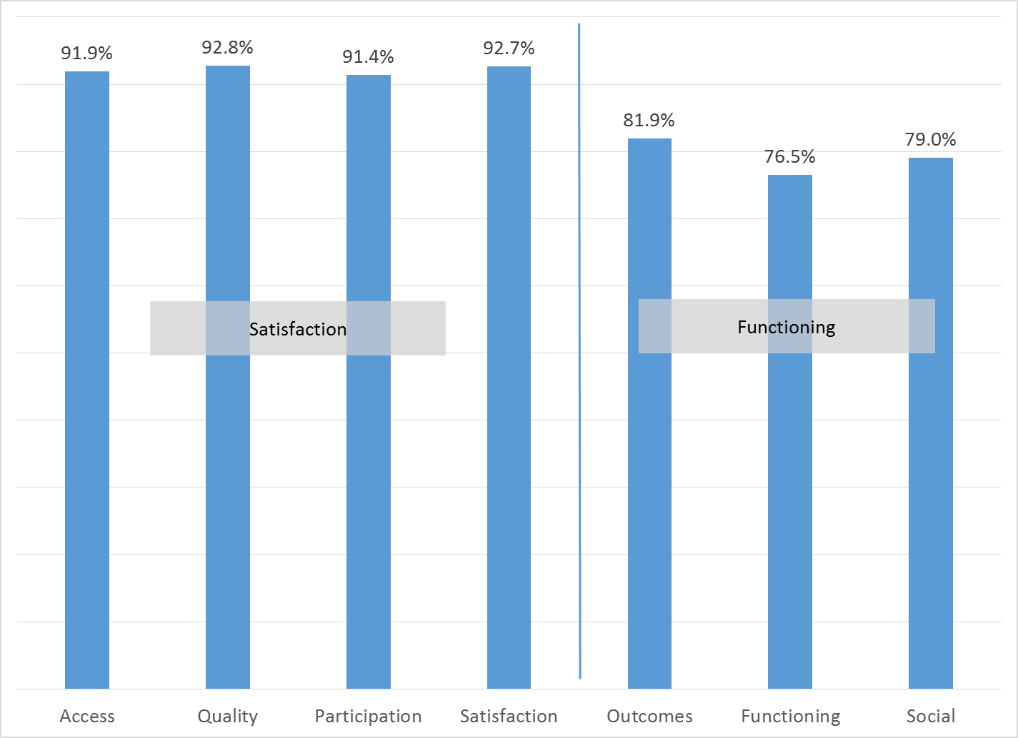

Factors affecting MHSIP scores

There were no significant differences on the MHSIP scores by ethnicity (see Figure 5) or for County vs. contract clinics.
Figure 5. MHSIP scores by race/ethnicity
(No statistically significant differences, p > .01)
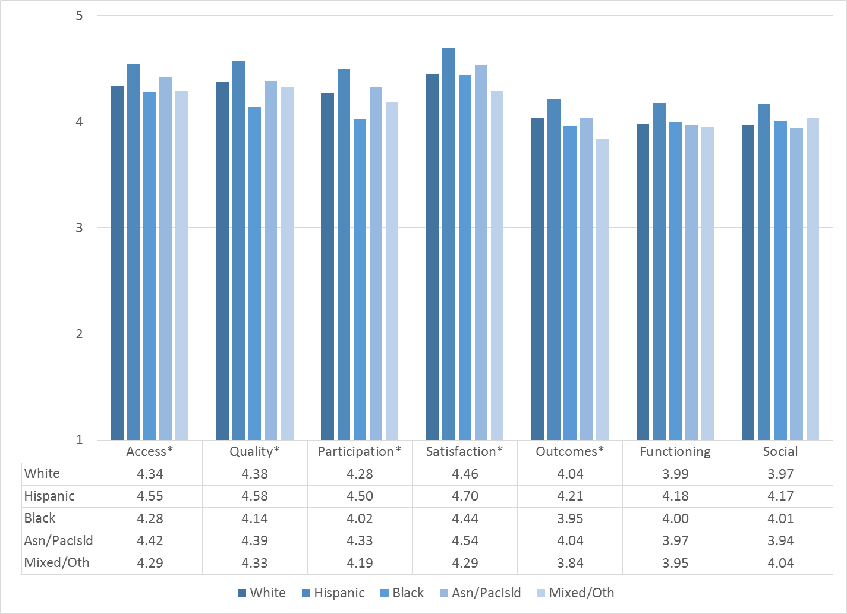

MHSIP scores differed by form language on all MHSIP scales except Social Connectedness (p < .001). Consumers who responded to the English-language survey reported slightly worse outcomes and functioning than Spanish-speaking clients (Figure 6).

Figure 7. MHSIP scores by form language

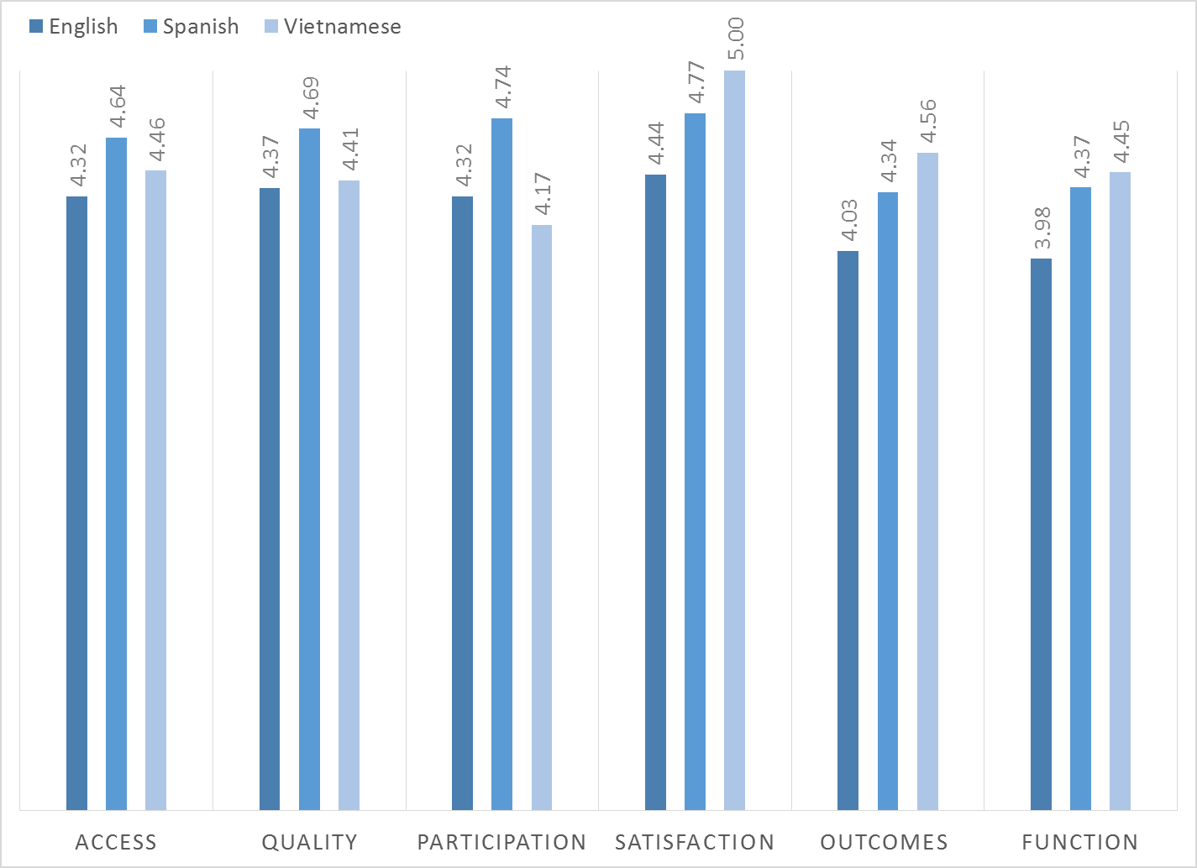

As seen in Figure 8, women’s ratings of satisfaction measures were slightly higher than men’s. While the ratings of other-gendered individuals tended to be higher, there were only four in this sample and the differences were not statistically significant.
Figure 8. MHSIP General Satisfaction differences by gender
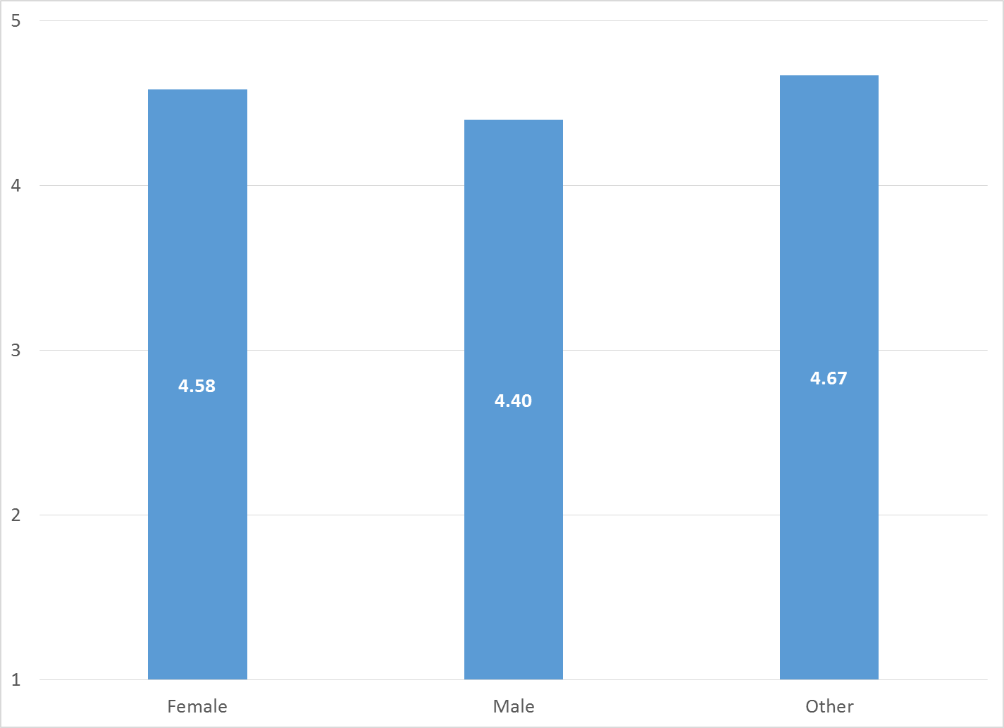

As reflected by Figure 9, all MHSIP scales differed by function area. Clients in the CalWorks, Innovations, and Prevention & Intervention programs tended to give the highest satisfaction ratings. Clients in Substance Use Disorder programs and Prevention & Intervention tended to rate their own functioning highest.

Figure 9. MHSIP differences by function area
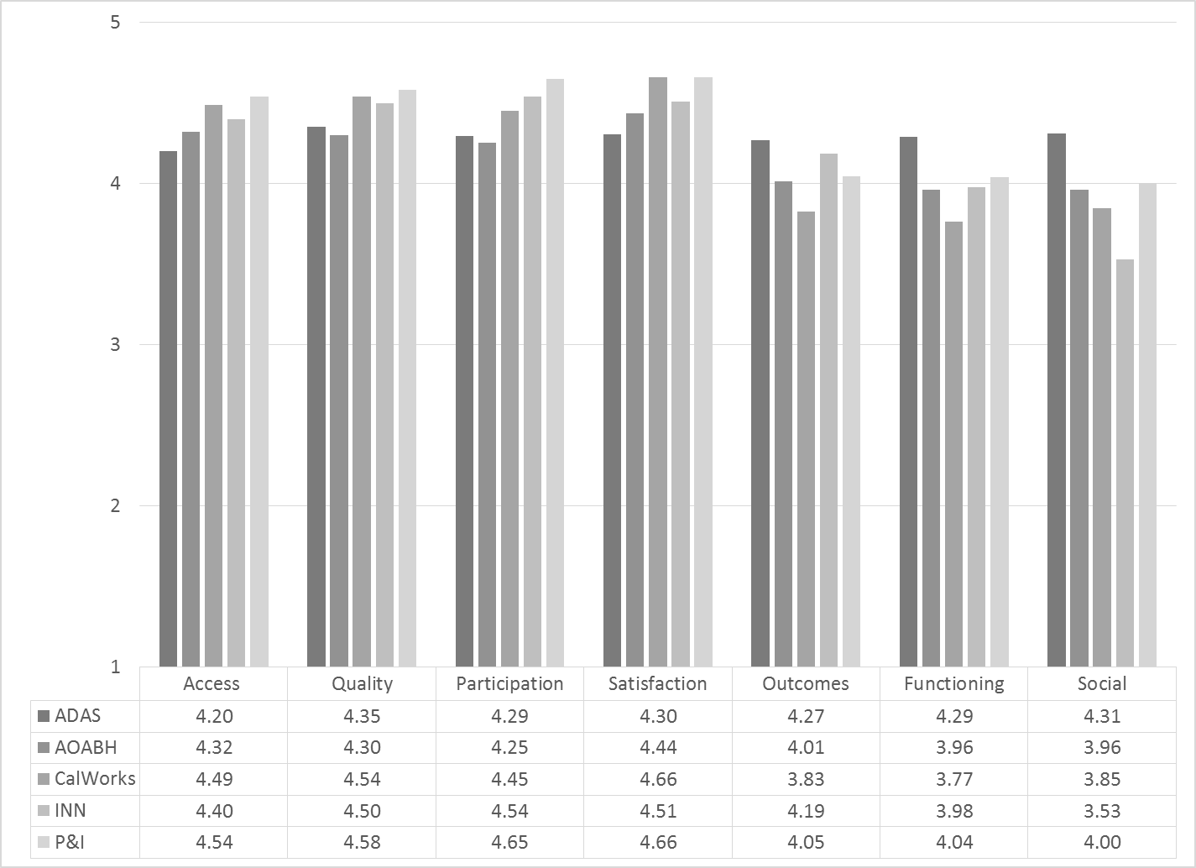

There was not a significant relationship between age or time-in-treatment and any of the MHSIP scales.

Table 1. MHSIP results by program

Program | ACC | QUAL | PARTIC | SATIS | OUTC | FUNC | SOC | N
Assisted Outpatient Treatment FSP | 4.35 | 4.45 | 4.35 | 4.39 | 4.24 | 4.34 | 4.40 | 13
ADAS AOD Anaheim Clinic | 4.10 | 4.26 | 4.25 | 4.33 | 4.14 | 4.19 | 4.15 | 27
ADAS AOD Westminster | 4.17 | 4.11 | 4.50 | 4.00 | 4.00 | 4.00 | 4.00 | 1
ADAS AOD, Santa Ana | 4.18 | 4.04 | 4.25 | 4.00 | 4.17 | 4.07 | 4.17 | 6
ADAS Perinatal, Aliso Viejo | 4.33 | 4.73 | 4.80 | 4.47 | 4.75 | 4.80 | 4.75 | 5
ADAS Perinatal, Anaheim | 4.56 | 4.56 | 4.33 | 4.67 | 4.46 | 4.60 | 4.75 | 3
Anaheim N. DUI Cout | 4.08 | 4.38 | 4.38 | 4.33 | 4.34 | 4.42 | 4.38 | 24
AOABH AB109 | 4.50 | 4.50 | 4.50 | 4.00 | 4.50 | 4.50 | 4.50 | 2
AOABH Anaheim I | 4.38 | 4.46 | 4.26 | 4.56 | 3.83 | 3.94 | 4.17 | 21
AOABH Anaheim II | 4.33 | 4.09 | 4.00 | 4.41 | 3.58 | 3.38 | 3.90 | 12
AOABH Anaheim PACT | 4.43 | 4.43 | 4.14 | 4.57 | 3.68 | 3.80 | 3.75 | 7
AOABH FSP Opportunity Knocks | 4.53 | 4.54 | 4.50 | 4.79 | 4.06 | 4.05 | 3.82 | 25
AOABH FSP Steps | 4.42 | 4.34 | 4.40 | 4.49 | 4.20 | 4.16 | 4.21 | 70
AOABH Fullerton PACT I | 4.25 | 4.03 | 4.06 | 4.44 | 3.50 | 3.59 | 3.78 | 9
AOABH Fullerton PACT II | 4.50 | 4.33 | 4.29 | 4.67 | 4.28 | 4.40 | 3.76 | 7
AOABH PACT TAY | 3.67 | 3.33 | 3.00 | 5.00 | 4.25 | 3.00 | 2.50 | 1
AOABH PACT TSR | 4.54 | 4.36 | 3.38 | 4.25 | 4.10 | 3.85 | 3.50 | 4
AOABH Peer Mentoring Services | 4.39 | 4.48 | 4.67 | 4.11 | 4.75 | 4.73 | 4.83 | 3
AOABH Santa Ana | 4.09 | 4.27 | 4.34 | 4.19 | 3.71 | 3.54 | 3.61 | 19
AOABH Santa Ana Pac Asian | 3.17 | 2.75 | 2.50 | 5.00 | 3.38 | 3.00 |  | 1
AOABH SUD/Perinatal Outpatient: Santa Ana | 4.83 | 5.00 | 5.00 | 5.00 | 5.00 | 5.00 | 5.00 | 1
AOABH SUD/Perinatal Outpatient: Westminster | 4.83 | 4.85 | 4.50 | 4.78 | 4.65 | 4.60 | 4.67 | 6
AOABH Westminster Clinic | 4.58 | 4.58 | 4.63 | 4.67 | 4.11 | 4.40 | 4.13 | 4
AOABH Westminster PACT | 4.71 | 5.00 | 5.00 | 5.00 | 4.71 | 4.80 | 4.63 | 4
Behavioral Health Services for Military Families Child Guidance Center | 4.49 | 4.46 | 4.58 | 4.71 | 4.18 | 4.09 | 4.00 | 8
BHS Outreach & Engagement | 4.52 | 4.48 | 4.55 | 4.60 | 4.21 | 4.15 | 4.28 | 11
CalWORKS Mariposa Women & Family Center | 4.52 | 4.63 | 4.53 | 4.82 | 3.90 | 3.77 | 3.89 | 19
CCS CalWORKS Anaheim | 4.54 | 4.58 | 4.48 | 4.68 | 3.84 | 3.80 | 3.95 | 33
CCS CalWORKs Santa Ana | 4.42 | 4.33 | 4.29 | 4.44 | 3.61 | 3.49 | 3.46 | 15
Community Counseling and Supportive Services | 4.53 | 4.64 | 4.68 | 4.74 | 3.97 | 3.99 | 3.94 | 63
Drug/DUI/DV Court | 3.99 | 4.20 | 4.13 | 4.26 | 4.24 | 4.23 | 4.22 | 29
Mariposa CalWORKs San Juan Capistrano | 4.31 | 4.59 | 4.42 | 4.62 | 4.01 | 4.16 | 4.04 | 7
North Drug Court | 4.27 | 4.37 | 4.30 | 4.18 | 4.36 | 4.37 | 4.34 | 32
North Recovery Center | 4.61 | 4.43 | 4.17 | 4.67 | 3.92 | 3.93 | 3.92 | 3
OC Accept | 4.64 | 4.73 | 4.73 | 4.88 | 4.17 | 3.88 | 3.94 | 15
Older Adult Services PACT | 4.00 | 4.00 | 4.00 | 4.00 | 3.93 | 3.50 | 3.00 | 2
Older Adult Support and Intervention System (OASIS) | 4.00 | 3.11 | 3.50 | 4.00 | 3.83 | 4.00 | -- | 1
Orange County Center for Resiliency, Education & Wellness(OC CREW) | 4.06 | 3.59 | 4.30 | 4.00 | 3.42 | 3.58 | 3.82 | 7
Orange County Parent Wellness Program (OCPWP) | 4.63 | 4.65 | 4.72 | 4.72 | 4.12 | 4.15 | 3.97 | 39
Phoenix House Orange County Adult | 4.37 | 4.41 | 4.26 | 4.33 | 4.02 | 4.04 | 4.27 | 21
Step Forward Program Collaborative On Site Engagement | 4.33 | 4.53 | 4.50 | 4.36 | 4.19 | 3.91 | 3.23 | 11
Stress Free Families | 4.45 | 4.41 | 4.39 | 4.31 | 4.23 | 4.33 | 4.35 | 14
Telecare and Orange (TAO) | 4.06 | 4.03 | 3.91 | 3.99 | 3.66 | 3.45 | 3.55 | 29
Western Pacific | 4.16 | 4.28 | 4.11 | 4.54 | 4.25 | 4.19 | 3.85 | 18
Western Pacific Rehab Outpatient Methadone Services | 4.13 | 4.10 | 4.22 | 4.15 | 4.18 | 4.09 | 4.00 | 9
Total | 4.36 | 4.41 | 4.37 | 4.48 | 4.07 | 4.04 | 4.03 | 661

Yellow highlight = higher than overall average (+3 std. errors)
Grey highlight = lower than overall average (-3 std. errors)

