Consumer Perception Survey: MHSIP

May 2016 Administration
Adults and Seniors
Jonathan Rich, Ph.D.
December 28, 2016

The Mental Health Statistical Improvement Program (MHSIP) was offered to all clients attending mental health services at a County or contract adult program during the week of May 16-20, 2016. There were 862 records returned. Records were discarded if program number was missing or was not a valid number, leaving 785 cases. Cases were then removed if the program was part of Children and Youth Behavioral Health, leaving 752 cases. Only cases with an age from 18-120 were retained. This left 689 cases.

Results

Sample description:

N: 689
Gender (n = 667): F 56.1%, M 43.3%, O 0.6%
Age (n = 689): Mean: 39.5 years, s = 12.4, range = 18 to 75.
Form Language (n = 689): English, 82.9% Spanish, 14.4%, Vietnamese, 2.8%
County/Contract (n = 689): County 57.8% vs. Contract 42.2%

Figure 1. Service Area (n = 689)
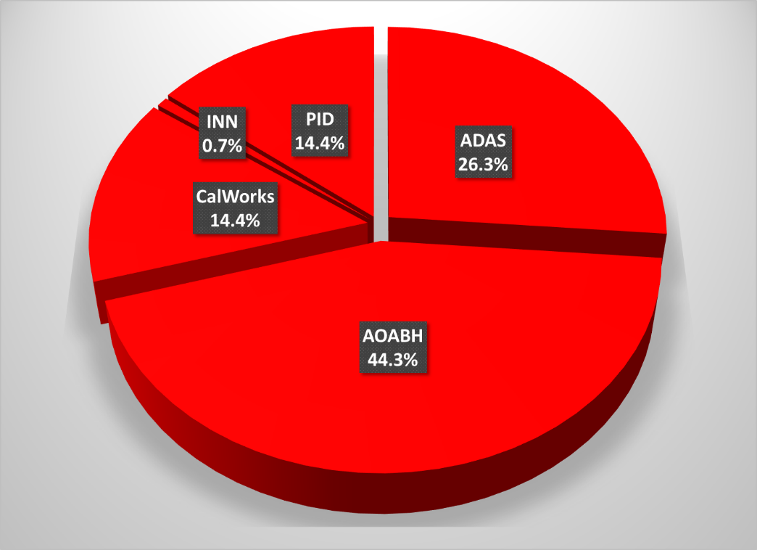

Figure 2. Race/Ethnicity (n = 667)
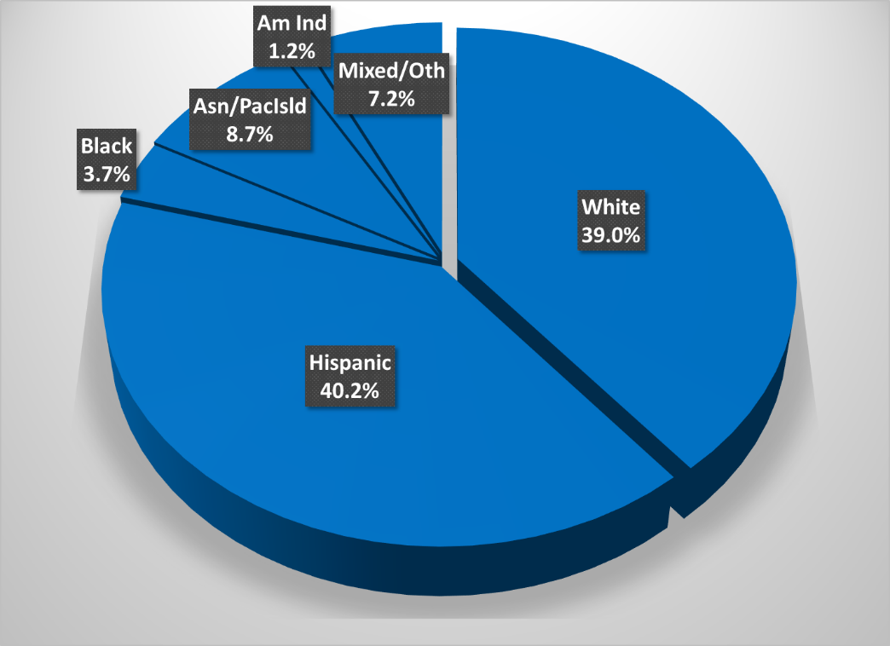

Survey respondents describe their race and ethnicity by selecting as many of the following categories as applicable: Hispanic, American Indian, Asian, Black, Pacific Islander, White, Other Race, and Unknown Race. These selections were reduced to six categories as follows. If either Asian, Pacific Island, or both are selected, that is considered a single category, “Asian/Pacific Islander.” If only one category is selected, then the participant is assigned to that category. If more than one category is selected, or if “Other Race” or “Unknown Race” is selected, the participant is classified as “Mixed/Other.” If Hispanic is selected, the client is classified as “Hispanic,” regardless of the other selections.

MHSIP Scale Scores:

Consistent with past results, responses to service satisfaction items average between “Agree” (4) and “Strongly Agree” (5). Response to items that reflect personal functioning are lower, just at the “Agree” level (4.0). Endorsement of service satisfaction items was near 90%; about three fourths of respondents endorsed personal functioning items.

Figure 3. Mean Scores: MHSIP Service Satisfaction
(Scale is 1-"strongly disagree" to 5-"strongly agree")

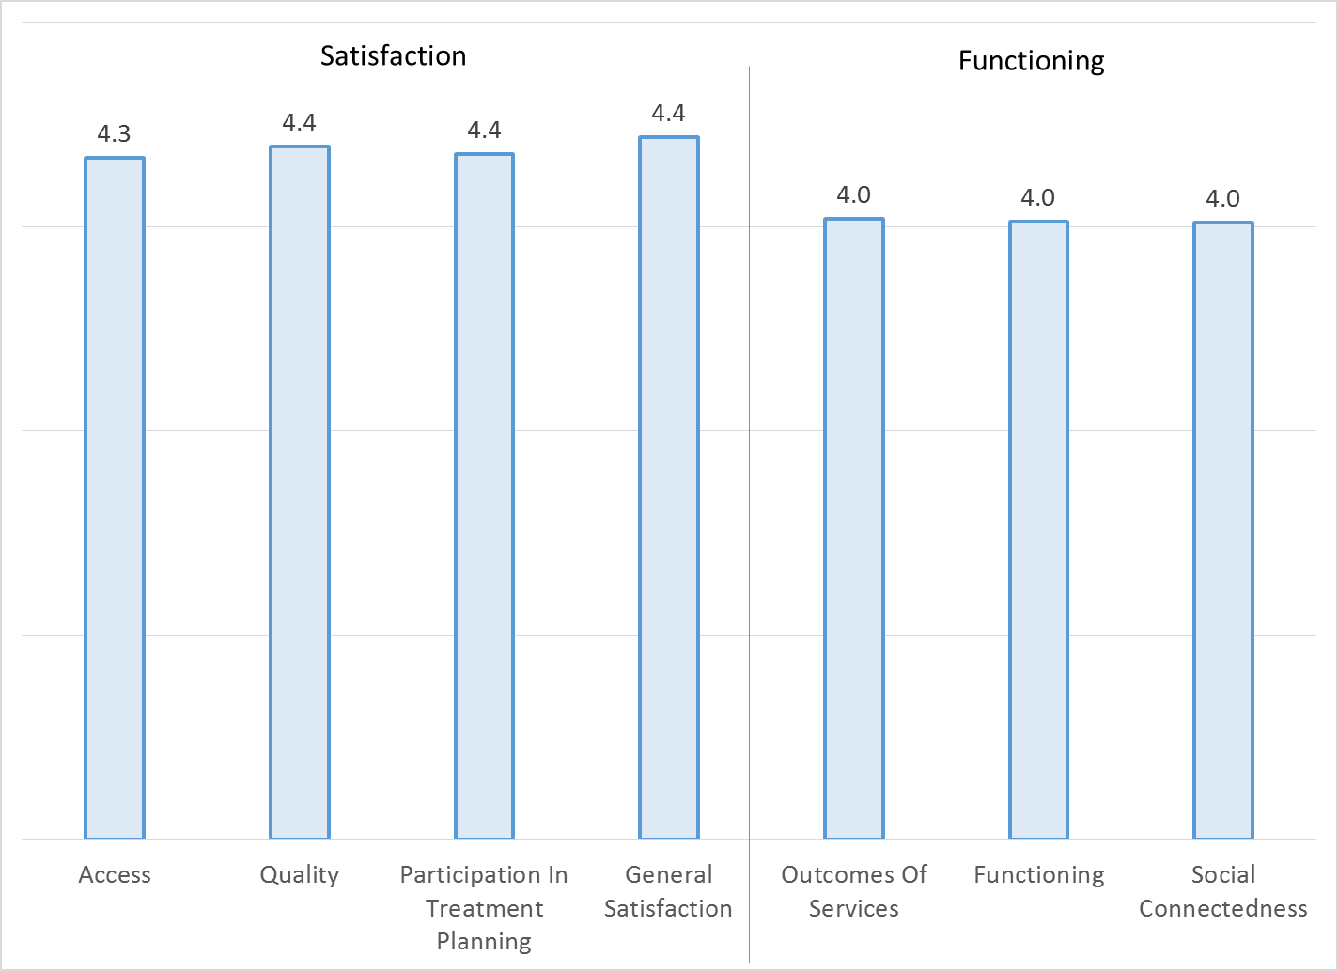

Figure 4. Percent with scores at or above 3.5, "Agree" and "Strongly Agree"
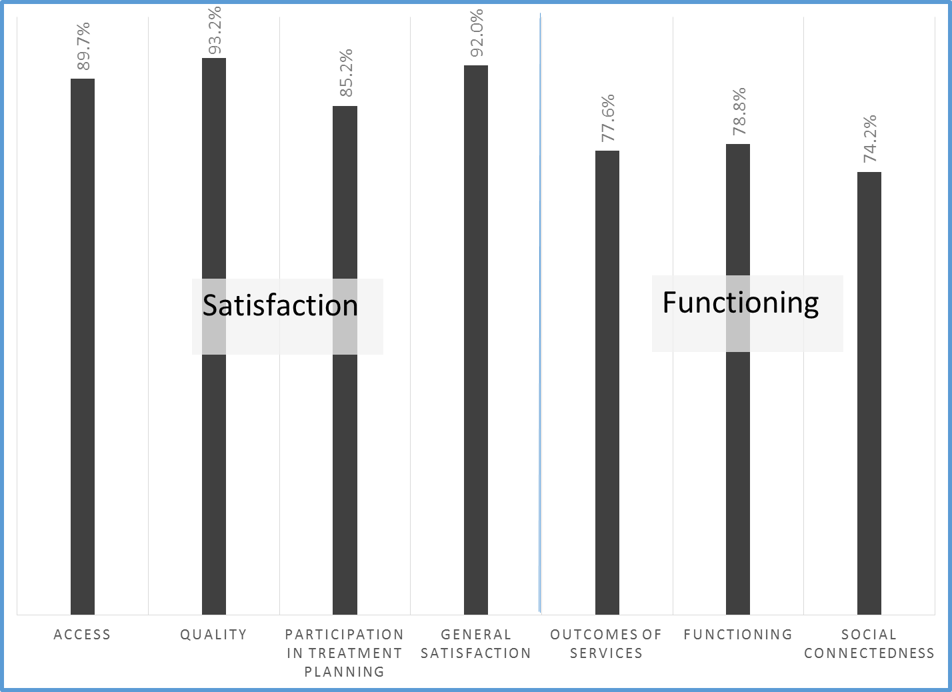

Factors affecting MHSIP scores

The MHSIP mean scores did not differ significantly by race/ethnicity (see Figure 5), whether a program was County vs. contract, or by length of time in the program.

Figure 5. MHSIP scores by race/ethnicity
(Note: Race/ethnicity differences are non-significant on all scales, p > .01)
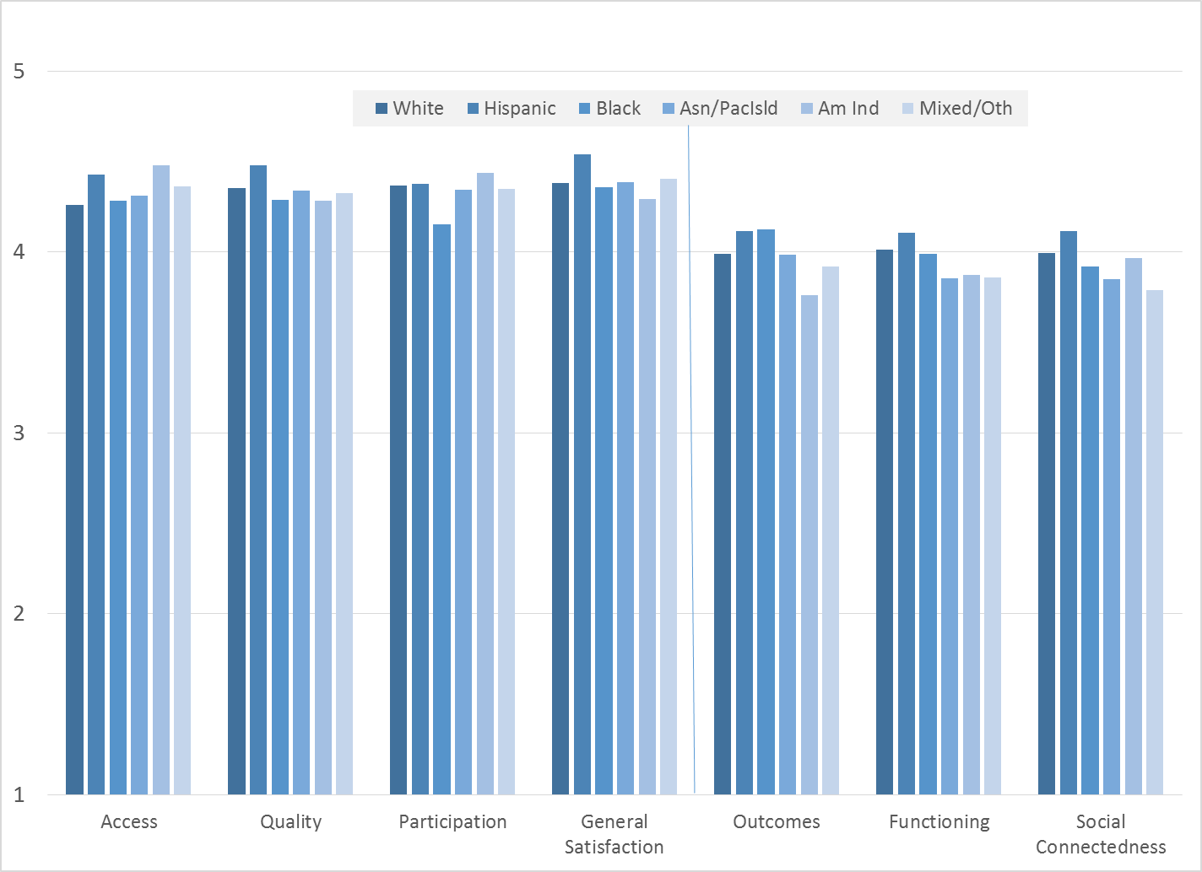

MHSIP scores differed by form language on all MHSIP scales. Consumers who responded to the English-language survey reported slightly worse outcomes and functioning than Spanish-speaking clients (Figure 6).
Figure 6. MHSIP scores by form language
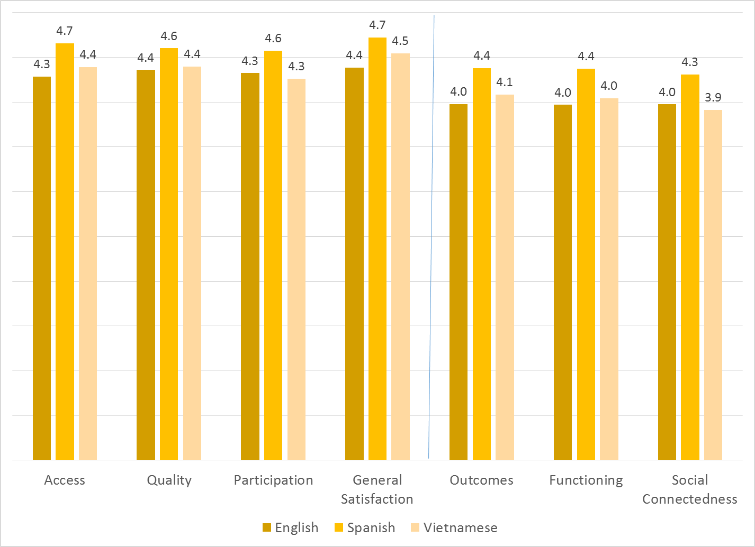

As seen in Figure 7, women’s ratings of access, general satisfaction and treatment plan participation were slightly higher than men’s.
Figure 7. MHSIP differences by gender
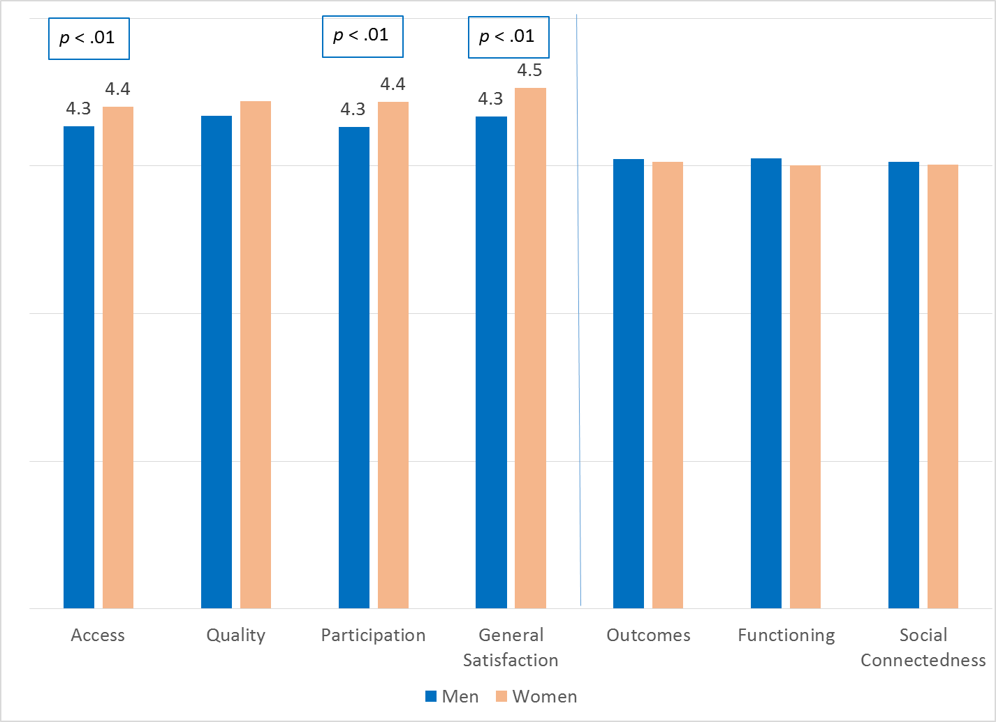

As reflected by Figure 8, all MHSIP scales differed by function area. Consumers in the CalWorks and Prevention & Intervention programs tended to give the highest satisfaction ratings. Consumers in Substance Use Disorder programs and Prevention & Intervention tended to rate their own functioning highest.

Figure 8. MHSIP differences by function area
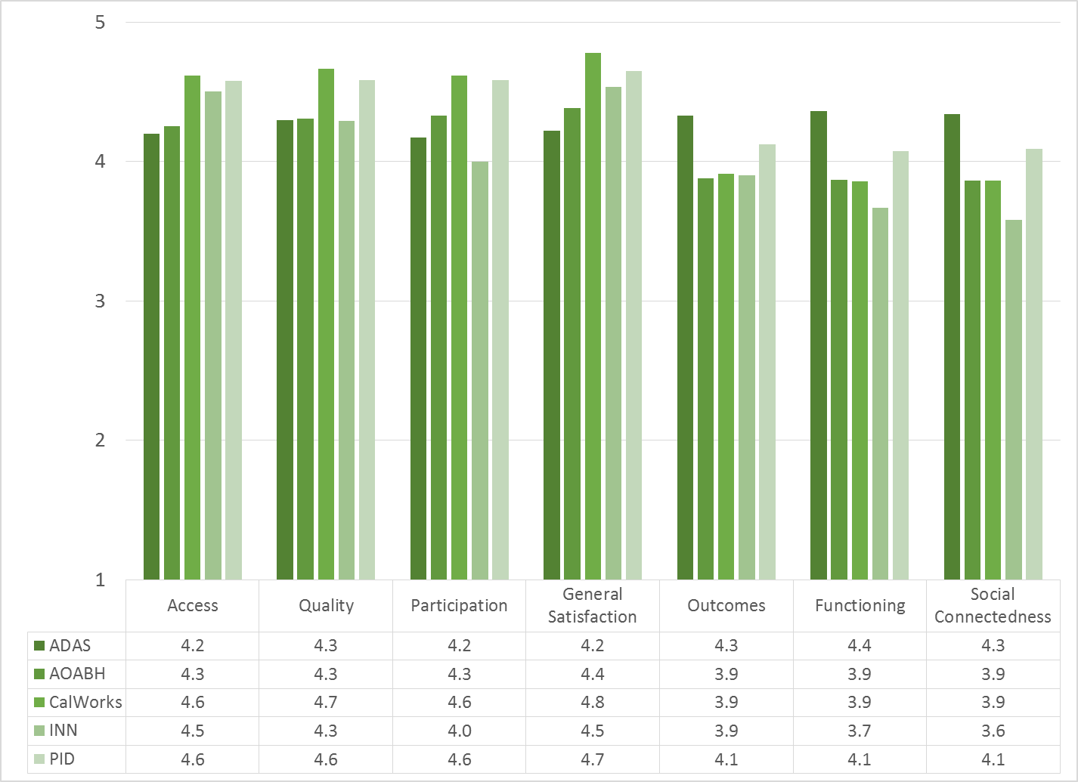

There was a significant negative correlation with age for the Functioning (r = -.11) and Social Connectedness scales (r = -.12), indicating that ratings of both areas drop with age.

Figure 9. Social Connectedness & Functioning by age group
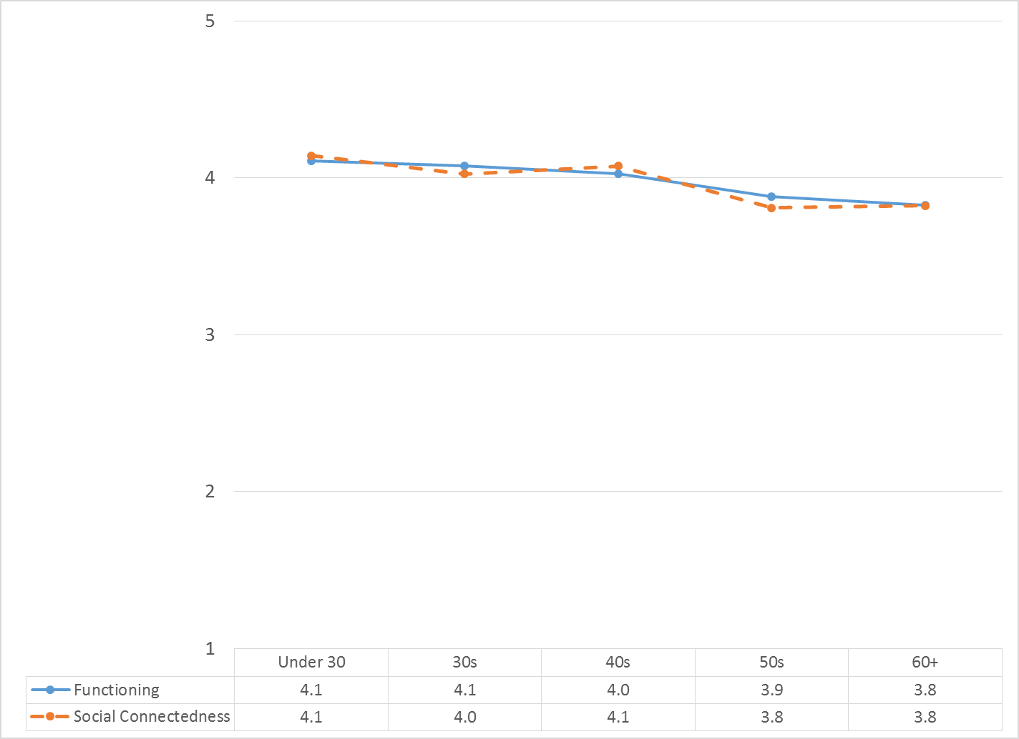

Table 1. MHSIP results by program
Progarm: | Access | Quality | Partici-pation | General Satisfaction | Outcomes | Functioning | Social Connect-edness | N
ADAS Aliso Viejo Drug Court | 4.4 | 4.5 | 4.5 | 4.2 | 4.5 | 4.6 | 4.7 | 11
ADAS AOD Aliso Viejo | 4.4 | 4.4 | 4.2 | 4.3 | 4.6 | 4.6 | 4.1 | 3
ADAS AOD Anaheim Clinic | 4.3 | 4.3 | 4.2 | 4.3 | 4.3 | 4.3 | 4.3 | 16
ADAS AOD, Santa Ana | 4.3 | 4.3 | 4.3 | 4.6 | 4.5 | 4.4 | 4.6 | 4
ADAS Perinatal, Aliso Viejo | 4.2 | 4.2 | 4.3 | 4.2 | 4.1 | 4.4 | 4.4 | 5
ADAS Perinatal, Anaheim | 4.3 | 4.5 | 4.3 | 4.5 | 4.4 | 4.5 | 4.5 | 9
Anaheim N. DUI Cout | 4.3 | 4.3 | 4.2 | 4.2 | 4.4 | 4.4 | 4.4 | 17
AOABH AB109 | 4.8 | 4.6 | 5.0 | 4.5 | 4.3 | 4.3 | 4.5 | 2
AOABH Aliso Viejo Clinic | 4.2 | 4.4 | 4.4 | 4.3 | 3.6 | 3.5 | 3.4 | 18
AOABH Anaheim I | 4.2 | 4.0 | 4.4 | 4.3 | 3.6 | 3.4 | 3.3 | 4
AOABH Anaheim II | 4.2 | 4.1 | 3.9 | 4.4 | 3.4 | 3.6 | 3.6 | 8
AOABH Anaheim PACT | 3.7 | 5.0 | 3.5 | 5.0 | 2.8 | 2.6 | 2.5 | 1
AOABH CalWORKs: Westminster | 4.6 | 4.7 | 4.7 | 4.7 | 3.9 | 3.9 | 3.9 | 23
AOABH Costa Mesa PACT | 4.2 | 4.3 | 4.3 | 4.3 | 4.2 | 4.2 | 4.2 | 19
AOABH FSP Opportunity Knocks | 4.3 | 4.2 | 4.2 | 4.5 | 3.9 | 3.9 | 3.6 | 41
AOABH FSP WIT | 4.3 | 4.3 | 4.2 | 4.3 | 4.1 | 4.2 | 4.4 | 24
AOABH Fullerton PACT I | 4.3 | 4.1 | 4.0 | 3.8 | 3.8 | 3.7 | 3.6 | 2
AOABH Fullerton PACT II | 4.8 | 4.8 | 4.8 | 4.9 | 4.2 | 4.1 | 4.2 | 14
AOABH PACT TSR | 4.5 | 4.1 | 4.2 | 4.3 | 4.0 | 3.8 | 3.5 | 3
AOABH Recovery Maintenance Services | 5.0 | 5.0 | 5.0 | 5.0 | 5.0 | 5.0 | 5.0 | 1
AOABH Santa Ana | 4.2 | 4.4 | 4.5 | 4.1 | 4.1 | 4.0 | 4.1 | 14
AOABH Santa Ana Pac Asian | 4.0 | 4.2 | 4.0 | 4.1 | 3.9 | 3.8 | 4.0 | 10
AOABH SUD/Perinatal Outpatient: Santa Ana | 4.0 | 4.1 | 3.8 | 4.0 | 3.9 | 4.1 | 4.1 | 9
Behavioral Health Services for Military Families Child Guidance Center | 4.9 | 4.7 | 4.8 | 5.0 | 3.7 | 3.5 | 3.8 | 3
CalWORKS Mariposa Women & Family Center | 4.6 | 4.7 | 4.7 | 4.8 | 3.7 | 3.7 | 3.6 | 28
Camino Nuevo | 3.9 | 4.7 | 4.5 | 5.0 | 3.6 | 3.8 | 4.2 | 3
CCS CalWORKS Anaheim | 5.0 | 5.0 | 5.0 | 5.0 | 4.6 | 4.8 | 4.8 | 1
CCS CalWORKs Santa Ana | 4.5 | 4.5 | 4.5 | 4.7 | 3.6 | 3.5 | 3.7 | 17
Community Counseling and Supportive Services | 4.6 | 4.6 | 4.6 | 4.7 | 4.2 | 4.1 | 4.1 | 56
Drug/DUI/DV Court | 4.2 | 4.3 | 4.1 | 4.2 | 4.4 | 4.4 | 4.3 | 40
Harbor Drug Court | 3.8 | 4.1 | 3.9 | 3.9 | 4.1 | 4.1 | 4.1 | 21
ICS Korean Community Services Health Center | 4.4 | 4.4 | 4.5 | 4.5 | 4.1 | 3.7 | 4.0 | 2
ICS Southland Health Center | 4.6 | 4.8 | 4.3 | 4.7 | 3.9 | 3.9 | 3.7 | 6
Integrated Community Services County Home | 4.3 | 4.4 | 4.5 | 4.5 | 4.1 | 4.2 | 3.8 | 5
LPS | 5.0 | 5.0 | 5.0 | 5.0 | 3.0 | 3.0 | 2.0 | 1
Mariposa CalWORKs San Juan Capistrano | 4.7 | 4.7 | 4.6 | 4.8 | 4.2 | 4.1 | 4.2 | 30
Mission Viejo PACT Services | 4.5 | 4.5 | 4.5 | 4.8 | 4.5 | 4.5 | 4.5 | 2
North Drug Court | 4.2 | 4.3 | 4.2 | 4.3 | 4.4 | 4.4 | 4.4 | 45
North Recovery Center | 4.6 | 4.5 | 4.5 | 4.7 | 4.3 | 5.0 | 4.5 | 2
OA Mental Health Recovery Program | 4.7 | 4.2 | 4.4 | 4.5 | 4.5 | 4.4 | 4.3 | 7
Older Adult Services PACT | 4.7 | 4.9 | 5.0 | 5.0 | 4.0 | 3.8 | 4.0 | 1
Older Adult Support and Intervention System (OASIS) | 4.5 | 4.5 | 4.5 | 4.8 | 4.0 | 3.8 | 3.8 | 5
Orange County Center for Resiliency, Education & Wellness(OC CREW) | 4.8 | 4.8 | 5.0 | 4.7 | 4.5 | 4.6 | 4.5 | 1
Orange County Postpartum Wellness (OCPPW) | 4.6 | 4.6 | 4.6 | 4.6 | 4.1 | 4.0 | 4.0 | 41
South Recovery Center | 4.5 | 4.4 | 4.5 | 4.9 | 3.9 | 4.1 | 4.1 | 5
Step Forward Program Collaborative On Site Engagement | 3.8 | 3.7 | 3.3 | 3.8 | 4.3 | 4.0 | 3.3 | 2
Telecare and Orange (TAO South) | 4.1 | 4.2 | 4.4 | 4.3 | 3.8 | 3.8 | 3.9 | 66
Telecare and Orange (TAO) | 4.1 | 4.3 | 4.3 | 4.2 | 3.4 | 3.5 | 3.5 | 39
West DUI Court | 5.0 | 5.0 | 5.0 | 5.0 | 5.0 | 5.0 | 5.0 | 1
Total | 4.3 | 4.4 | 4.4 | 4.4 | 4.0 | 4.0 | 4.0

Highlighting shows scores that are significantly HIGHER or LOWER than the overall program mean.

