Consumer Perception Survey: MHSIP

May 2015 Administration
Adults and Seniors
Jonathan Rich, Ph.D.
December 28, 2015

The Mental Health Statistical Improvement Program (MHSIP) was offered to all clients attending mental health services at a County or contract adult program during the week of May 11-15, 2015. There were 998 records returned. Records were discarded if program was missing, if the program was part of Children and Youth Behavioral Health, or if the age was less than 18 or over 120. This left 796 cases.

Results

Sample description:

N: 796
Gender (n = 768): F 53.4%, M 45.8%, O 0.8%
Age (n = 796): Mean: 40 years, s = 12.6, range = 18 to 80.
Form Language (n = 796): English, 91.1% Spanish, 7.3%, Vietnamese, 1.6%
County/ Contract (n = 796): County 53.8% vs. Contract 46.2%
Figure 1. Division (n = 796)
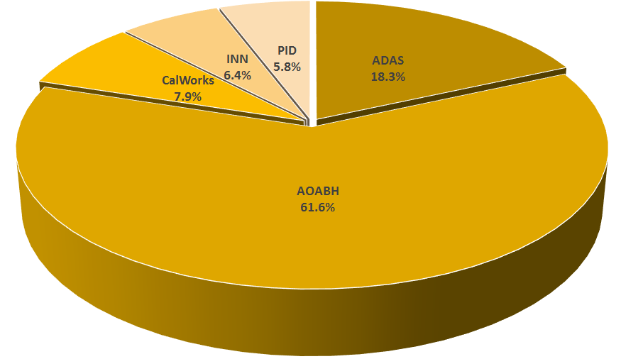

Figure 2. Race/Ethnicity (n = 762)
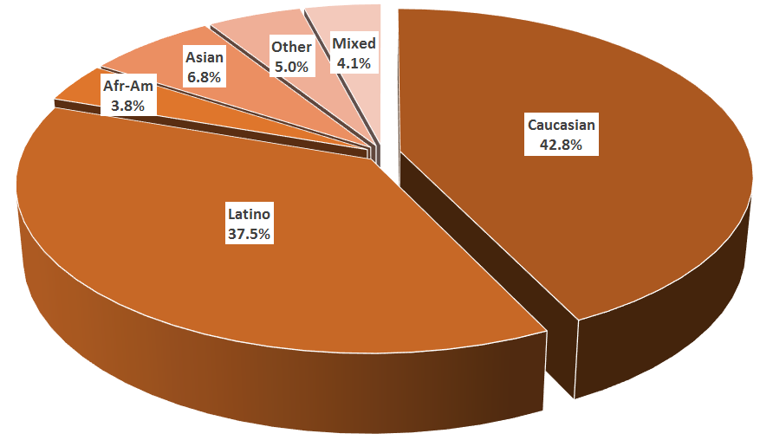

MHSIP Scale Scores:

Consistent with past results, responses to service satisfaction items average between “Agree” (4) and “Strongly Agree” (5). Response to items that reflect personal functioning are lower, just below the “Agree” level. More than 90% of responses endorsed service satisfaction items; about three fourths of responses endorsed personal functioning items.

Figure 3. Mean Scores: MHSIP Service Satisfaction
(Scale is 1-"strongly disagree" to 5-"strongly agree")

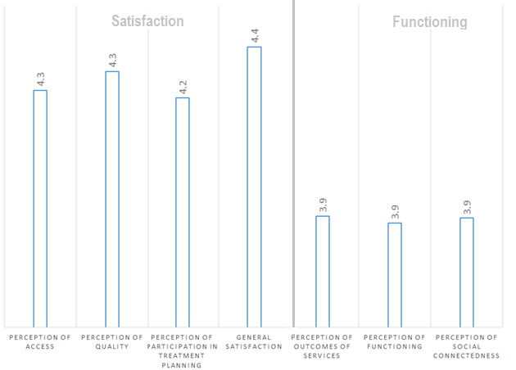

Figure 4. Percent with scores at or above 3.5, "Agree" and "Strongly Agree"
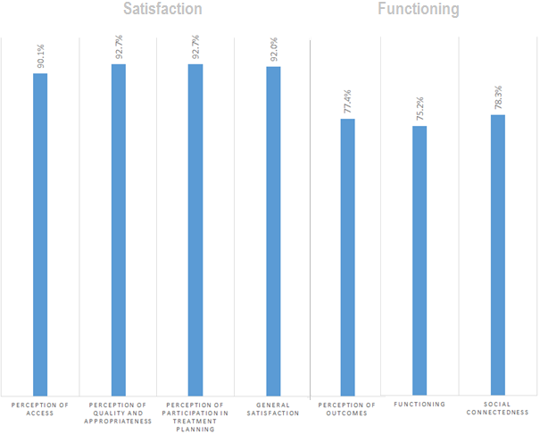

Factors affecting MHSIP scores

The MHSIP mean scores did not differ significantly by race/ethnicity (see Figure 5), whether a program was County vs. contract, or by length of time in the program.

Figure 5. MHSIP scores by race/ethnicity
(Note: Race/ethnicity differences are non-significant on all scales, p > .01)
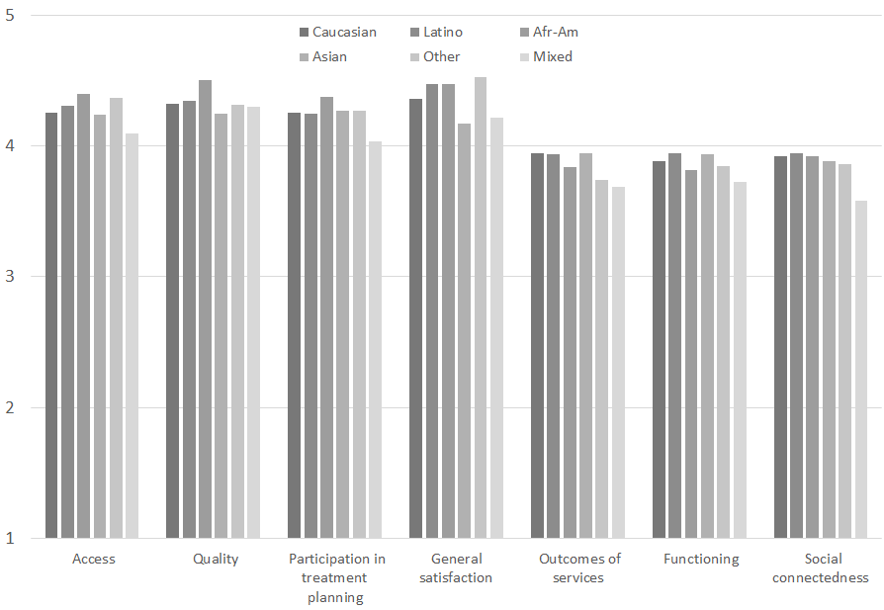

MHSIP scores differed by form language on only one scale, Perception of Quality. Consumers who responded to the Spanish-language survey rated the program as higher quality than consumers who took the English- or Vietnamese-language survey (Figure 6).
Figure 6. MHSIP scores by form language
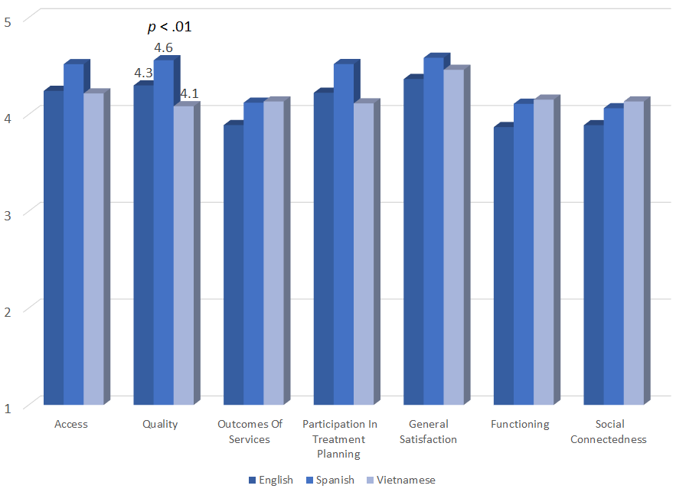

As seen in Figure 7, women’s satisfaction ratings were slightly higher than men’s.
Figure 7. MHSIP differences by gender
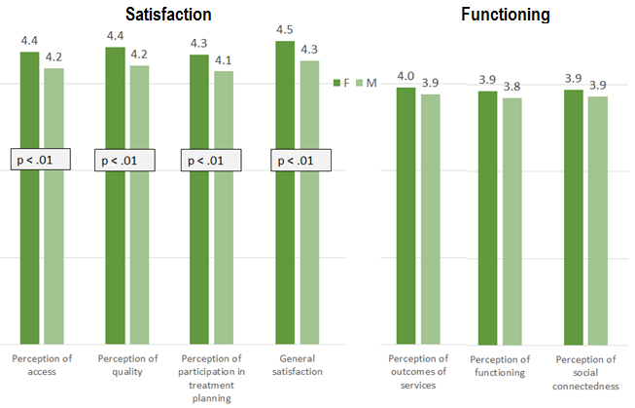

As reflected by Figure 8, all MHSIP scales differed by division. Consumers in the CalWorks and Prevention & Intervention programs tended to give the highest satisfaction ratings. Consumers in Substance Use Disorder programs tending to rate their own functioning highest.

Figure 8. MHSIP differences by division
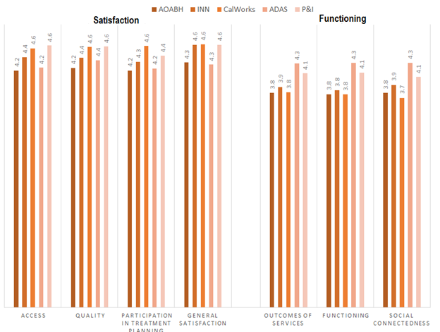

There was a significant negative correlation with age for the Functioning and Social Connectedness scales (r = -.14 and -.11, respectively). As seen in Figure 9, self-ratings of personal functioning and social connectedness tend to drop after about age 35.
Figure 9. Perception of Functioning and Social Connectedness by age group
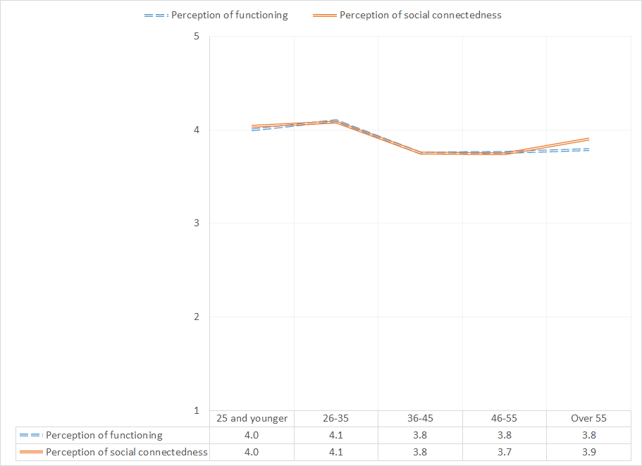

Table 1. MHSIP results by program
 | Satisfaction with Services |  |  |  | Functioning
Program | Access | Quality | Participation | General | Outcomes | Functioning | Social | N
ADAS Perinatal, Santa Ana | 4.7 | 4.6 | 4.5 | 4.3 | 4.6 | 4.7 | 4.7 | 3
ADAS Aliso Viejo Drug Court | 4.3 | 4.4 | 4.3 | 4.2 | 4.5 | 4.6 | 4.4 | 11
ADAS AOD Aliso Viejo | 4.0 | 4.0 | 3.8 | 4.3 | 4.4 | 3.9 | 4.0 | 3
ADAS AOD Anaheim Clinic | 4.1 | 4.3 | 4.1 | 4.5 | 4.2 | 4.2 | 3.8 | 17
ADAS AOD Westminster | 4.2 | 4.3 | 4.3 | 4.1 | 4.2 | 4.0 | 4.2 | 8
ADAS AOD, Santa Ana | 3.6 | 3.7 | 3.5 | 3.7 | 3.7 | 3.7 | 3.6 | 3
ADAS Perinatal, Aliso Viejo | 4.6 | 4.6 | 4.6 | 4.7 | 4.4 | 4.6 | 4.5 | 13
ADAS Perinatal, Anaheim | 4.1 | 4.2 | 4.0 | 4.3 | 4.2 | 4.2 | 4.4 | 11
ADAS Perinatal, Westminster | 4.3 | 4.4 | 4.3 | 4.5 | 4.1 | 4.2 | 4.2 | 18
Anaheim N. DUI Cout | 4.5 | 4.3 | 4.1 | 4.3 | 4.4 | 4.3 | 4.5 | 8
AOABH AB109 | 4.6 | 4.5 | 3.9 | 4.8 | 4.6 | 4.4 | 4.1 | 5
AOABH Aliso Viejo Clinic | 4.2 | 4.2 | 4.1 | 4.4 | 3.8 | 3.8 | 4.0 | 20
AOABH Costa Mesa PACT | 4.2 | 4.4 | 4.3 | 4.3 | 4.1 | 4.0 | 4.0 | 35
AOABH Fullerton PACT - I | 3.4 | 4.0 | 3.8 | 4.0 | 3.2 | 2.8 | 2.9 | 3
AOABH Fullerton PACT - II | 4.7 | 4.7 | 4.6 | 4.8 | 4.3 | 4.1 | 3.9 | 7
AOABH PACT TAY | 5.0 | 5.0 | 5.0 | 5.0 | 5.0 | 5.0 | 5.0 | 1
AOABH PACT TSR | 4.6 | 4.5 | 4.6 | 4.5 | 3.7 | 3.8 | 3.8 | 10
AOABH Santa Ana | 4.0 | 4.2 | 4.0 | 4.3 | 3.4 | 3.4 | 3.5 | 41
AOABH Santa Ana Pac Asian | 3.8 | 3.5 | 3.4 | 3.7 | 3.4 | 3.4 | 3.3 | 8
AOABH Westminster Clinic | 4.3 | 4.2 | 4.1 | 4.5 | 3.5 | 3.2 | 3.7 | 12
AOABH Westminster PACT | 4.7 | 4.6 | 4.7 | 4.8 | 4.1 | 4.1 | 3.6 | 3
AOABH Westminster, Pac Asian | 4.7 | 3.6 | 4.0 | 5.0 | 3.8 | 4.0 | 4.0 | 1
AOABH-Anaheim I | 3.7 | 3.6 | 3.6 | 3.9 | 3.4 | 3.5 | 3.5 | 16
AOABH-Anaheim II | 4.0 | 4.1 | 3.9 | 4.2 | 3.2 | 3.3 | 3.4 | 20
AOABH-Anaheim PACT | 4.2 | 4.3 | 4.1 | 4.1 | 3.8 | 4.0 | 3.6 | 4
Camino Nuevo | 4.6 | 4.4 | 4.4 | 4.6 | 3.9 | 4.0 | 4.1 | 17
CCS CalWORKS Anaheim | 4.7 | 4.8 | 4.7 | 4.8 | 3.9 | 3.9 | 3.8 | 28
CCS CalWORKs Santa Ana | 4.3 | 4.3 | 4.4 | 4.3 | 3.6 | 3.5 | 3.5 | 13
CCS CalWORKs Westminster | 4.6 | 4.5 | 4.6 | 4.7 | 3.7 | 3.7 | 3.7 | 22
Collective Solutions: A Family-Focused Crisis Management Program | 4.4 | 4.6 | 4.4 | 4.6 | 4.0 | 4.1 | 4.0 | 10
College Community Services, Opportunity Knocks | 4.5 | 4.5 | 4.5 | 4.6 | 4.2 | 4.1 | 4.1 | 20
Drug/DUI/DV Court | 4.1 | 4.4 | 4.1 | 4.0 | 4.3 | 4.3 | 4.5 | 19
Harbor Drug Court | 4.0 | 4.3 | 4.1 | 3.9 | 4.3 | 4.4 | 4.6 | 9
ICS- Central City Community Health Center | 4.2 | 4.0 | 4.1 | 4.4 | 3.4 | 3.2 | 3.8 | 5
ICS-Southland Health Center | 4.8 | 4.4 | 3.0 | 5.0 | 3.4 | 2.8 | 4.3 | 1
Integrated Community Services-County Home | 4.5 | 4.4 | 4.2 | 4.5 | 3.7 | 3.6 | 3.6 | 16
North Drug Court | 4.2 | 4.3 | 4.3 | 4.1 | 4.4 | 4.3 | 4.5 | 16
North Recovery Center | 4.3 | 4.5 | 4.5 | 4.8 | 3.9 | 4.3 | 4.0 | 4
OC ACCEPT | 4.6 | 4.6 | 4.8 | 4.9 | 4.1 | 4.3 | 4.3 | 12
Older Adult Support and Intervention System (OASIS) | 4.1 | 4.2 | 4.1 | 4.4 | 3.8 | 3.8 | 3.9 | 27
Orange County Center for Resiliency, Education & Wellness(OC CREW) | 4.2 | 4.2 | 4.0 | 4.3 | 4.0 | 4.3 | 4.3 | 4
Orange County Postpartum Wellness (OCPPW) | 4.7 | 4.6 | 4.5 | 4.7 | 4.1 | 4.1 | 4.1 | 42
Project Life Coach | 4.3 | 4.2 | 4.3 | 4.6 | 4.1 | 4.0 | 4.1 | 7
Telecare and Orange (TAO-South) | 4.2 | 4.3 | 4.3 | 4.3 | 3.9 | 3.9 | 3.8 | 70
Telecare and Orange (TAO) | 4.1 | 4.1 | 4.2 | 4.2 | 3.6 | 3.6 | 3.6 | 101
Telecare STEPS | 4.3 | 4.3 | 4.2 | 4.4 | 4.2 | 4.2 | 4.2 | 57
Volunteer to Work | 4.3 | 4.0 | 4.3 | 4.5 | 4.0 | 4.0 | 4.1 | 6
West Drug Court | 4.7 | 4.7 | 4.6 | 4.8 | 4.5 | 4.7 | 4.5 | 7
Total | 4.3 | 4.3 | 4.2 | 4.4 | 3.9 | 3.9 | 3.9 | 790

