Consumer Perception Survey: MHSIP

November 2014 Administration
Adults and Seniors
Jonathan Rich, Ph.D.
November 5, 2015

The Mental Health Statistical Improvement Program (MHSIP) was offered to all clients attending mental health services at a County or contract adult program during the week of November 17-21, 2014. There were 1204 records returned. Records were discarded if program was missing, if the program was part of Children and Youth Behavioral Health, or if the age was less than 18 or over 120. This left 947 cases.

Results

Sample description:

N: 947
Gender (n = 947): F 60.2%, M 39.6%, O 0.2%
Age (n = 917): Mean: 41.6 years, s = 14.8, range = 18 to 114.
Form Language (n = 947): English: 88.2% Spanish, 7.1%, Vietnamese, 4.4%, Chinese, 0.3%
County/ Contract (n = 947): Contract 44.0% vs. County 56.0%
Figure 1. Division (n = 796)
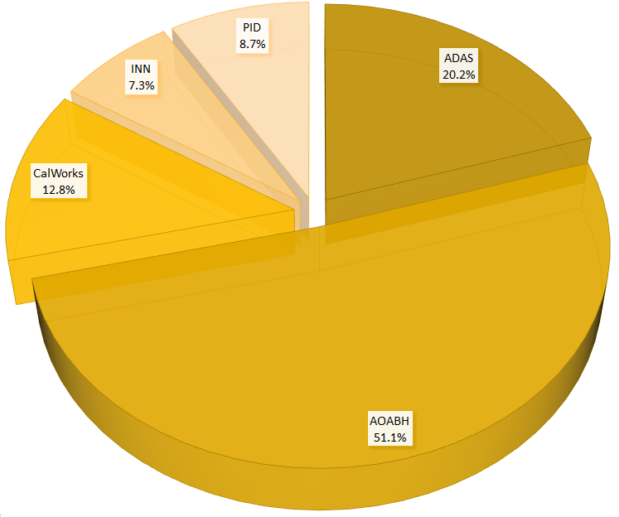

Figure 2. Race/Ethnicity (n = 762)
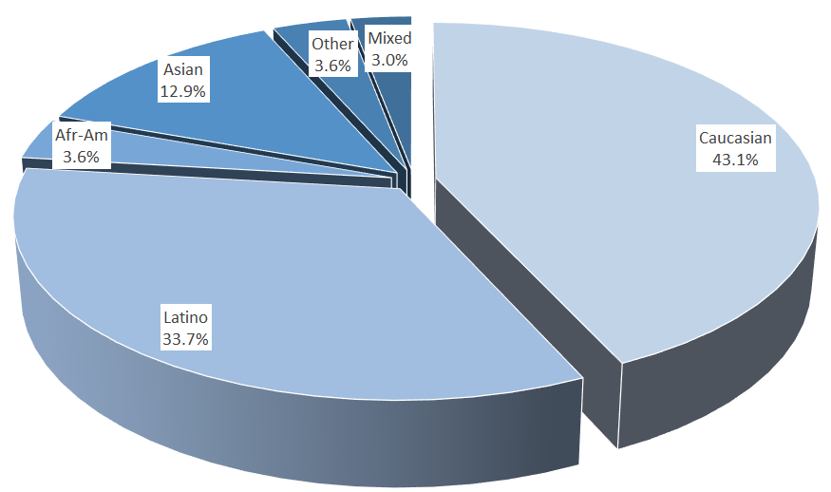

MHSIP Scale Scores:

Figure 3. Mean Scores: MHSIP Service Satisfaction
(Scale is 1-"strongly disagree" to 5-"strongly agree")

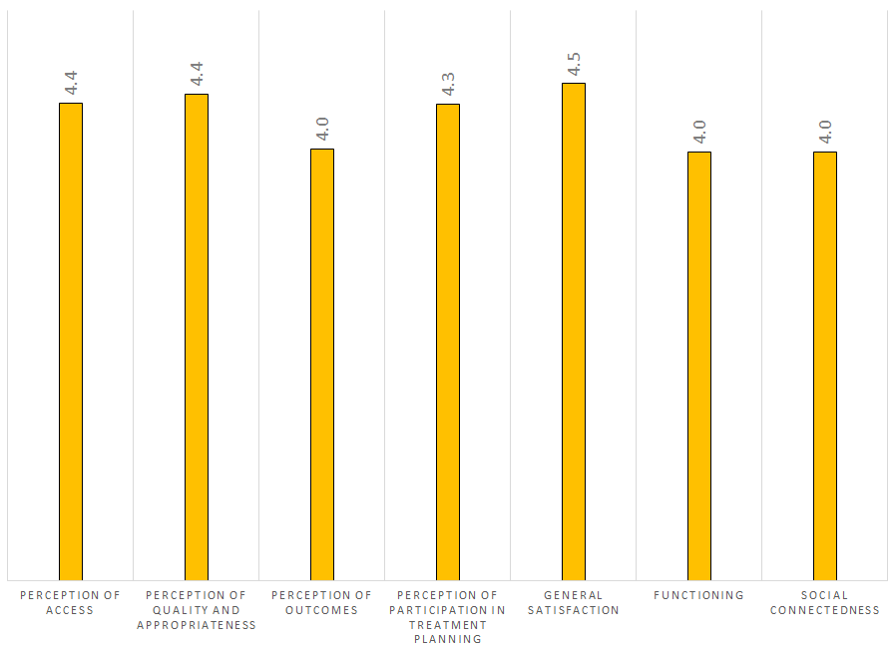

Figure 4. Percent with scores at or above 3.5, "Agree" and "Strongly Agree"
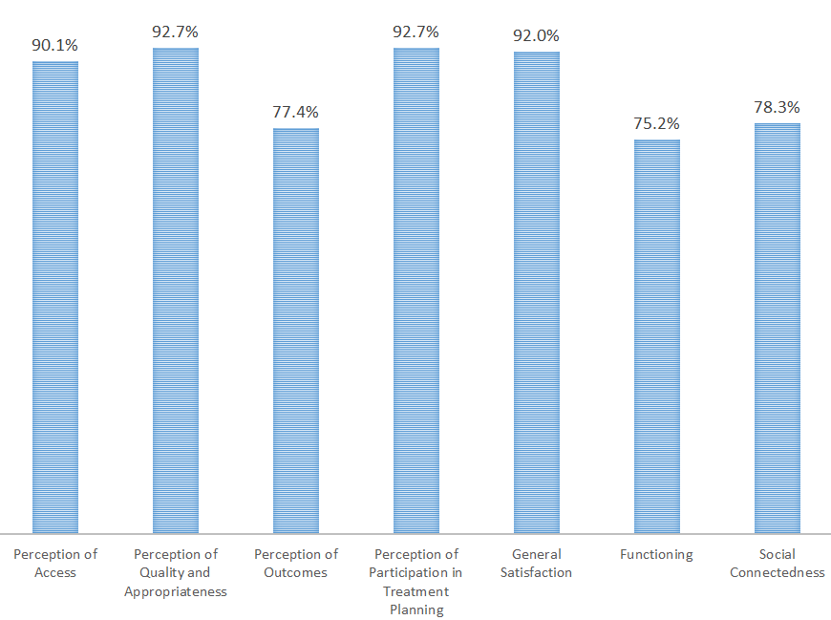

Factors affecting scores:

Factors affecting MHSIP scores are examined below. Because multiple comparisons are being made, a conservative alpha level of .01 is used.

Gender: General Satisfaction, Perception of Participation in Treatment Planning, and Perception of Quality and Appropriateness was slightly but significantly higher for women than for men.

Figure 5. MHSIP scale means by gender
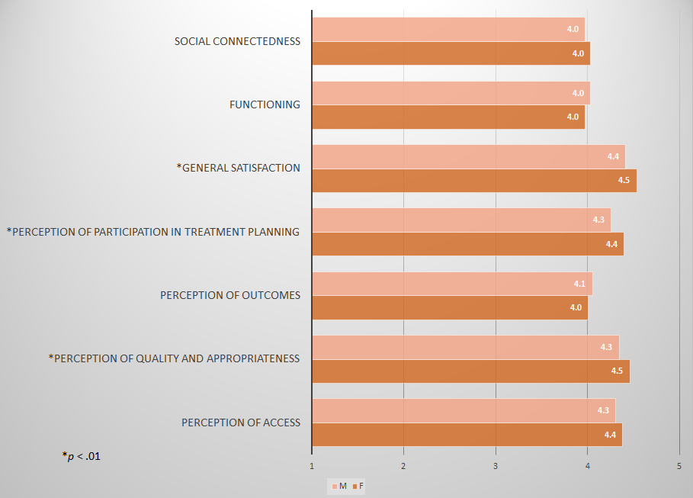

Form Language: Participants who complete forms in languages other than English gave mean ratings which were higher on all MHSIP scales.

Figure 6. MHSIP means by form language
(difference significant at p < .01 for all scales)
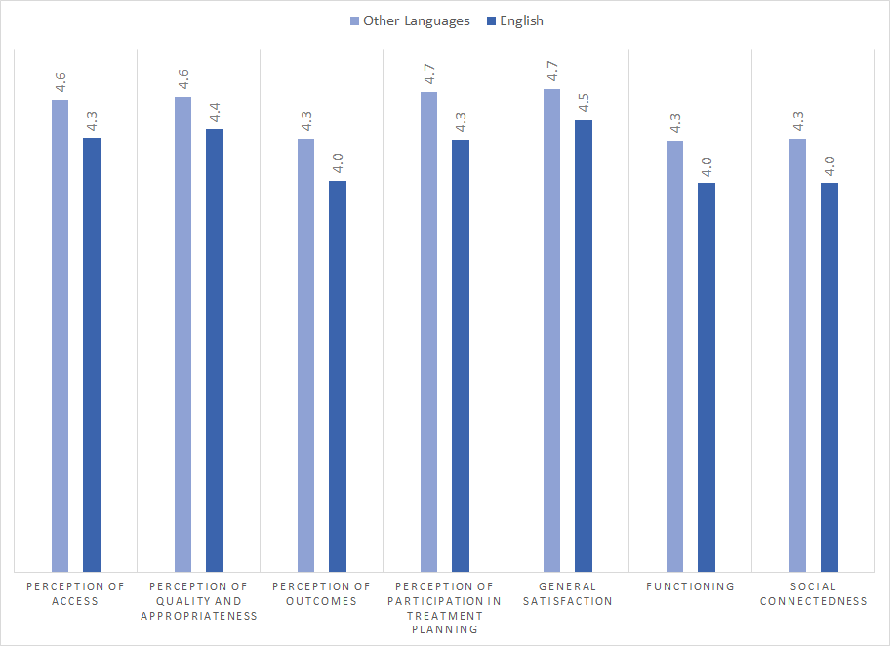

Age: Perception of Outcomes, Social Connectedness and Functioning varied significantly by age, with ratings dipping for the 46-65 year old group.

Figure 7. MHSIP Outcomes and Functioning means by age group
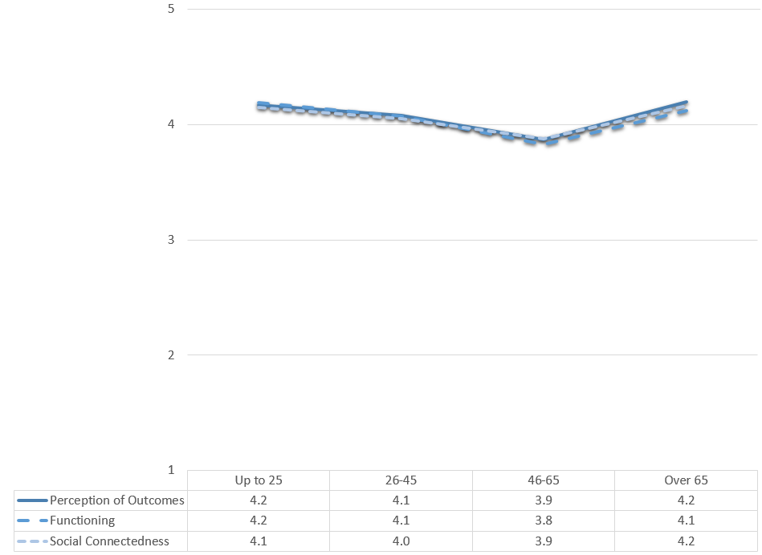

County vs. Contract Clinics: Clients at County clinics scored higher than contract clinic clients on their perception of outcomes of services and functioning.

Figure 8. MHSIP means, County vs. Contract Clinics
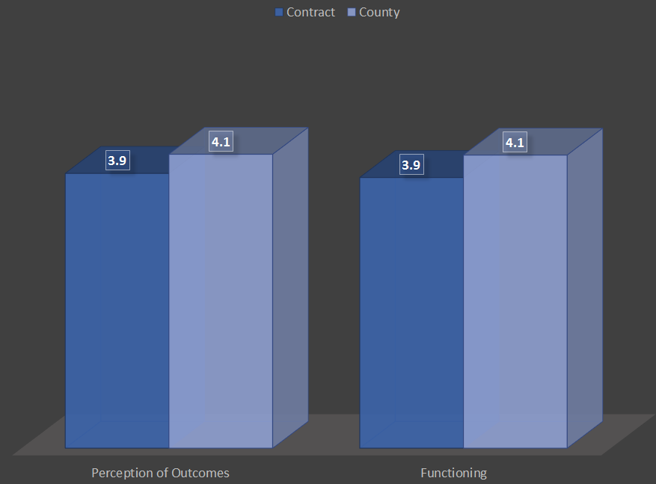

Division: There were significant differences across divisions on all MHSIP scales. In general, CalWorks and P&I clients gave the highest ratings of service satisfaction; ADAS and P&I clients gave the highest ratings of personal functioning.

Figure 9. MHSIP service satisfaction scores by division
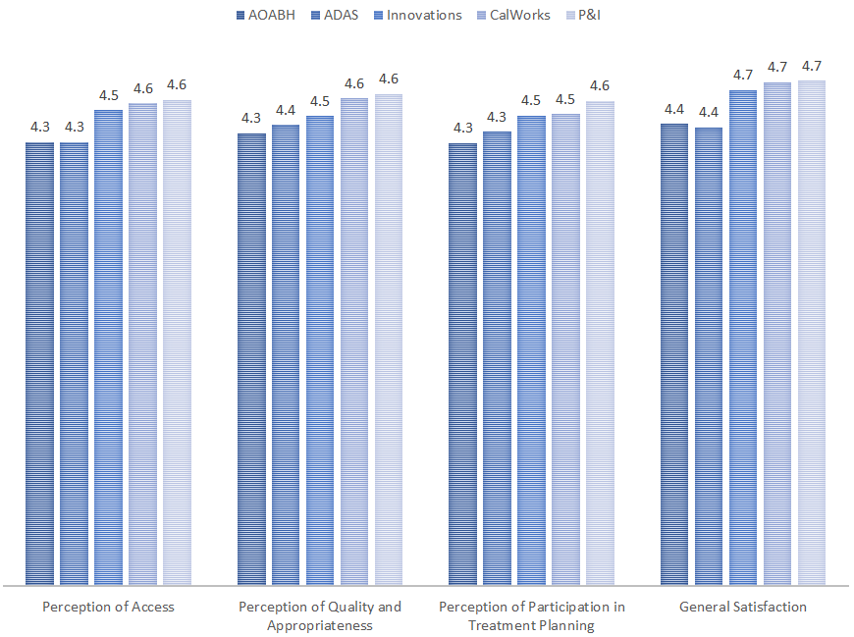

Figure 10. MHSIP, mean ratings of personal functioning, by division
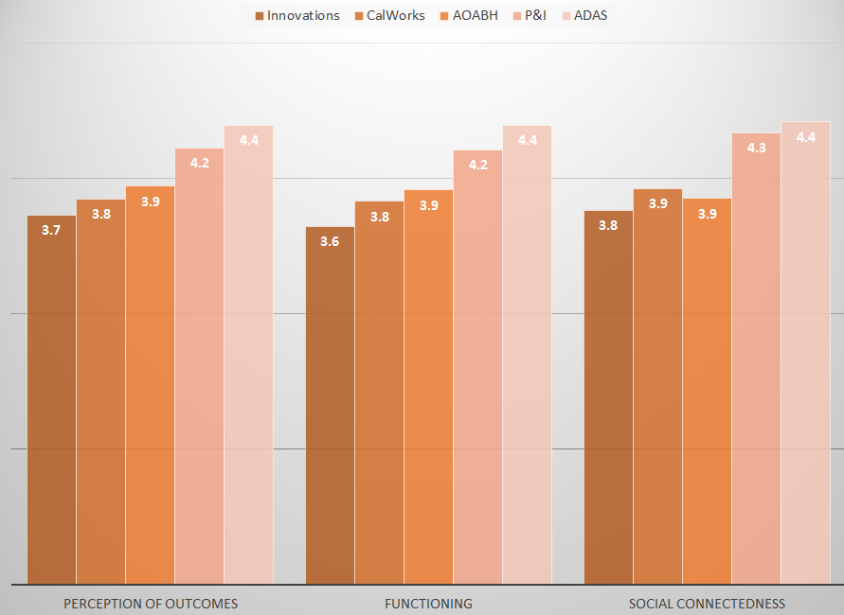

Race/Ethnicity: Five of the MHSIP scales varied significantly by race/ethnicity, as shown in Figure 11. Latino and Asian consumers generally expressed the highest levels of satisfaction.

Figure 11. MHSIP means by Ethnicity
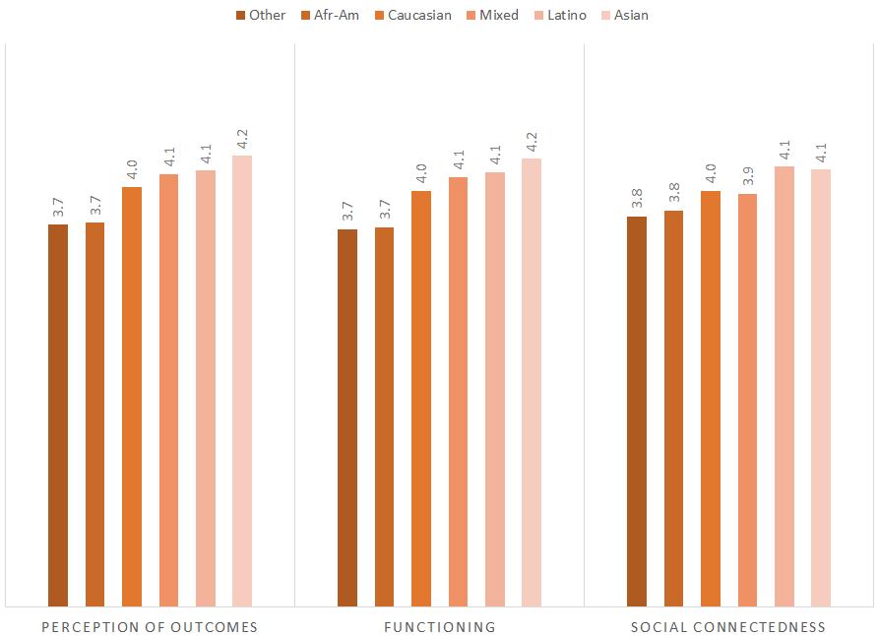

Time in Service

There were no significant relationships between the amount of time in service and mean MHSIP scores.

Program Means

The table below shows the mean MHSIP scores and the number of surveys returned, by program.

Table 1. Mean MHSIP scores and number of surveys returned, by program
 | MHSIP Scale Means
Program | ACC | QUAL | OUTC | PART | SATIS | FUNC | SOCIAL | N
ADAS Aliso Viejo Drug Court | 4.1 | 4.3 | 4.5 | 4.3 | 4.4 | 4.5 | 4.5 | 12
ADAS AOD Aliso Viejo | 4.5 | 4.6 | 4.5 | 4.4 | 4.6 | 4.5 | 4.6 | 20
ADAS AOD Anaheim Clinic | 4.2 | 4.5 | 4.3 | 4.3 | 4.4 | 4.3 | 4.3 | 19
ADAS AOD Westminster | 4.7 | 4.8 | 4.6 | 4.8 | 4.8 | 4.8 | 4.7 | 6
ADAS Perinatal, Aliso Viejo | 4.5 | 4.3 | 4.7 | 4.5 | 4.2 | 5.0 | 4.3 | 2
ADAS Perinatal, Anaheim | 4.1 | 4.3 | 4.3 | 4.1 | 4.2 | 4.2 | 4.3 | 23
ADAS Perinatal, Westminster | 4.5 | 4.7 | 4.4 | 4.5 | 4.7 | 4.4 | 4.4 | 23
Aliso Viejo PACT Services | 4.0 | 3.9 | 3.3 | 3.8 | 4.2 | 2.5 | 2.9 | 2
Anaheim N. DUI Cout | 4.2 | 4.3 | 4.5 | 4.3 | 4.1 | 4.5 | 4.4 | 26
AOABH Costa Mesa PACT | 4.1 | 4.2 | 4.1 | 4.1 | 4.1 | 4.2 | 3.9 | 17
AOABH Fullerton PACT - I | 4.5 | 4.6 | 3.8 | 4.5 | 4.6 | 3.6 | 3.6 | 14
AOABH Mission Viejo Clinic | 4.1 | 4.2 | 3.9 | 4.0 | 4.2 | 4.0 | 3.8 | 32
AOABH PACT TSR | 4.5 | 4.7 | 4.5 | 4.8 | 4.7 | 4.6 | 4.5 | 3
AOABH Santa Ana | 4.1 | 4.2 | 3.8 | 4.0 | 4.1 | 3.7 | 3.6 | 28
AOABH Santa Ana Pac Asian | 4.1 | 4.1 | 4.2 | 3.8 | 4.0 | 4.0 | 4.0 | 3
AOABH SHOPP | 5.0 | 4.9 | 4.9 |  | 5.0 | 5.0 | 5.0 | 1
AOABH Westminster Clinic | 4.1 | 4.3 | 3.7 | 3.9 | 4.3 | 3.6 | 3.6 | 14
AOABH Westminster PACT | 4.4 | 4.5 | 4.3 | 4.1 | 4.4 | 4.4 | 4.1 | 8
AOABH- Mental Health Assoc.- CM | 4.4 | 4.6 | 4.0 | 4.7 | 4.7 | 4.3 | 4.3 | 3
AOABH- Mental Health Assoc.- GG | 4.2 | 4.2 | 3.9 | 4.4 | 4.3 | 4.0 | 3.8 | 31
AOABH-Anaheim I | 4.0 | 4.3 | 3.7 | 4.1 | 4.4 | 3.8 | 4.1 | 18
AOABH-Anaheim II | 4.2 | 4.1 | 3.4 | 3.9 | 4.4 | 3.5 | 3.5 | 9
AOABH-Anaheim PACT | 4.4 | 4.3 | 3.7 | 3.9 | 4.3 | 3.6 | 3.6 | 8
Brighter Futures | 5.0 |  |  |  | 5.0 |  | 4.7 | 1
CalWORKS Mariposa Women & Family Center | 4.8 | 4.8 | 4.2 | 4.7 | 4.9 | 4.2 | 4.3 | 23
CCS CalWORKS Anaheim | 4.4 | 4.6 | 3.8 | 4.5 | 4.7 | 3.8 | 3.8 | 22
CCS CalWORKs Santa Ana | 4.7 | 4.8 | 4.0 | 4.7 | 4.9 | 4.0 | 4.2 | 22
CCS CalWORKs Westminster | 4.3 | 4.4 | 3.3 | 4.1 | 4.6 | 3.3 | 3.5 | 26
Collective Solutions | 4.2 | 4.7 | 3.9 | 4.8 | 4.6 | 3.9 | 3.9 | 9
College Community Services, Opportunity Knocks | 4.4 | 4.4 | 4.2 | 4.2 | 4.7 | 4.2 | 4.3 | 25
Drug/DUI/DV Court | 4.0 | 4.2 | 4.3 | 4.2 | 4.2 | 4.3 | 4.5 | 27
Early Intervention Service for Older Adults - MECCA | 4.3 | 4.6 | 4.3 | 4.5 | 4.6 | 4.2 | 4.5 | 26
ICS- Central City Community Health Center | 4.7 | 4.4 | 3.2 | 4.4 | 4.8 | 3.0 | 2.9 | 6
ICS- Korean Community Services Health Center | 4.6 | 4.7 | 3.8 | 4.6 | 4.6 | 3.8 | 4.0 | 7
ICS-Southland Health Center | 4.5 | 4.3 | 3.6 | 4.3 | 4.6 | 3.6 | 3.9 | 16
ICS: County Home | 4.5 | 4.3 | 3.6 | 4.4 | 4.6 | 3.5 | 3.6 | 18
Mariposa CalWORKs San Juan Capistrano | 4.5 | 4.5 | 3.9 | 4.5 | 4.6 | 3.9 | 3.9 | 27
Mental Health Assoc.  Lake Forest | 4.4 | 4.3 | 4.3 | 4.7 | 4.3 | 4.1 | 4.5 | 3
North Drug Court | 4.3 | 4.4 | 4.2 | 4.5 | 4.3 | 4.2 | 4.3 | 25
North Recovery Center | 4.4 | 4.4 | 3.8 | 4.3 | 4.5 | 3.9 | 3.8 | 42
OA Mental Health Recovery Program | 4.9 | 4.8 | 4.4 | 4.8 | 4.9 | 4.3 | 4.2 | 31
OC ACCEPT | 4.5 | 4.9 | 4.2 | 5.0 | 4.8 | 4.2 | 4.2 | 5
OASIS | 4.3 | 4.3 | 3.9 | 4.1 | 4.5 | 4.0 | 3.8 | 19
OC CREW | 4.8 | 4.9 | 3.3 | 5.0 | 5.0 | 4.0 | 3.0 | 1
Orange County Postpartum Wellness | 4.7 | 4.6 | 4.2 | 4.6 | 4.8 | 4.2 | 4.2 | 55
Project Life Coach | 4.5 | 4.5 | 4.2 | 4.4 | 5.0 | 4.0 | 4.1 | 7
South Recovery Center | 4.8 | 4.7 | 4.0 | 4.8 | 4.9 | 3.9 | 3.3 | 10
Telecare and Orange (TAO-South) | 4.2 | 4.4 | 4.0 | 4.4 | 4.5 | 3.9 | 3.9 | 43
Telecare and Orange (TAO) Anaheim | 4.2 | 4.3 | 3.9 | 4.3 | 4.4 | 3.8 | 3.8 | 94
Telecare WIT | 4.1 | 4.2 | 4.0 | 4.2 | 4.1 | 3.8 | 4.0 | 23
West Drug Court | 4.5 | 4.6 | 4.7 | 4.7 | 4.6 | 4.5 | 4.6 | 8
Total | 4.4 | 4.4 | 4.0 | 4.3 | 4.5 | 4.0 | 4.0 | 943

