Consumer Perception Survey
November 2017 YSS Administration
Children and Youth
Jonathan Rich, Ph.D.
June 30, 2018

The Youth Satisfaction Survey (YSS) was offered to all teen and transitional age youth clients attending mental health services at a County or contract CYBH clinic from November 13-17, 2017. The intended age range for the YSS is 13 and older. The initial file contained 760 client records. YSS records with birthdates corresponding to an age of 13 – 25 and with a CYBH or Prevention & Intervention program indicated were retained for this analysis. Records with no birthdate, a birthdate outside of the age range, or a program code that was missing, was not a recognized code, or that was associated with an AOABH program were eliminated from this analysis. This left 589 records.

YSS Results

Sample description:

N: 589
Gender (n = 572): F-350 (59.4%), M-209 (35.5%), O-13 (2.3%)
Age (n = 589): Mean = 16.1, s = 2.6, range = 13-25.
Form Language (n = 589): English-576 (97.8%), Spanish-8 (1.4%), Vietnamese -2 (0.3%)
Race/Ethnicity (n = 536):
Figure 1. Client race/ethnicity (569)
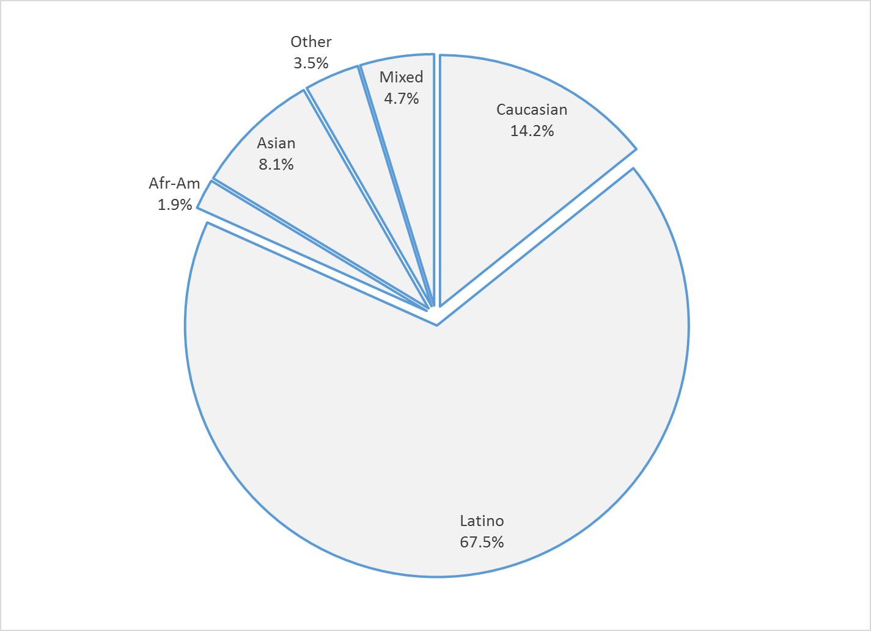

County vs. Contract (n = 589): County 17.5% vs. Contract 82.5%
Division (n = 589): CYBH 98.5%, P&I 1.2% Innovations 0.3%

Mean YSS scale scores:

Figure 2. Mean Scores: YSS
(Scale is 1-"strongly disagree" to 5-"strongly agree")
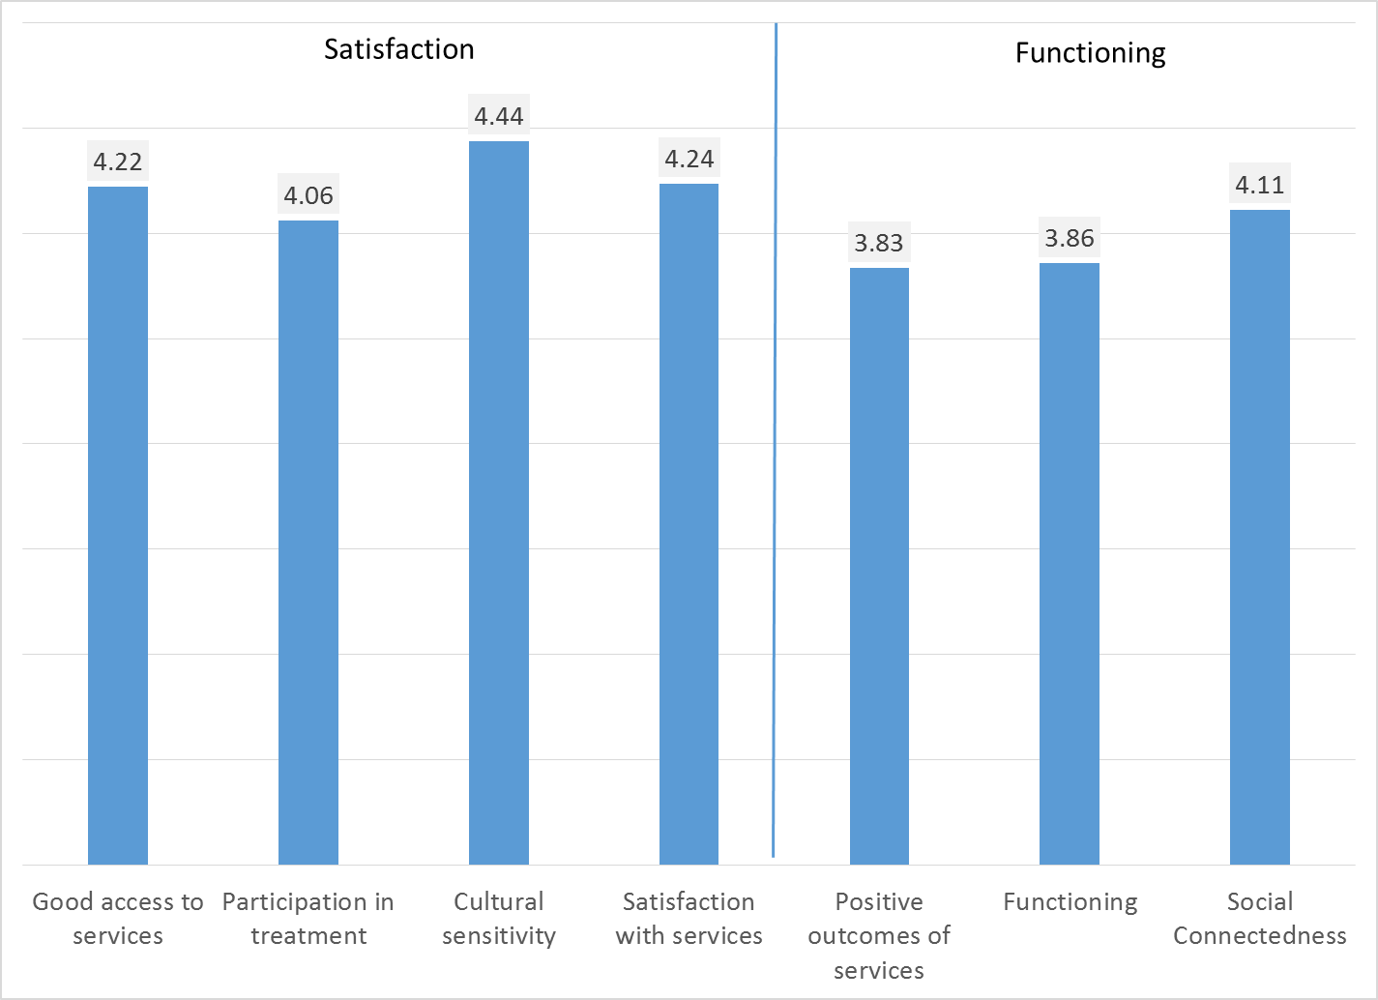

Factors affecting YSS scores:

Race/ethnicity was associated with only one YSS scale, Social Connectedness, p < .01. On this scale, Caucasians scored higher than Asians and Latinos. This scale measures the degree to which clients feel more socially connected as a result of services received.

Figure 3. YSS scores by race/ethnicity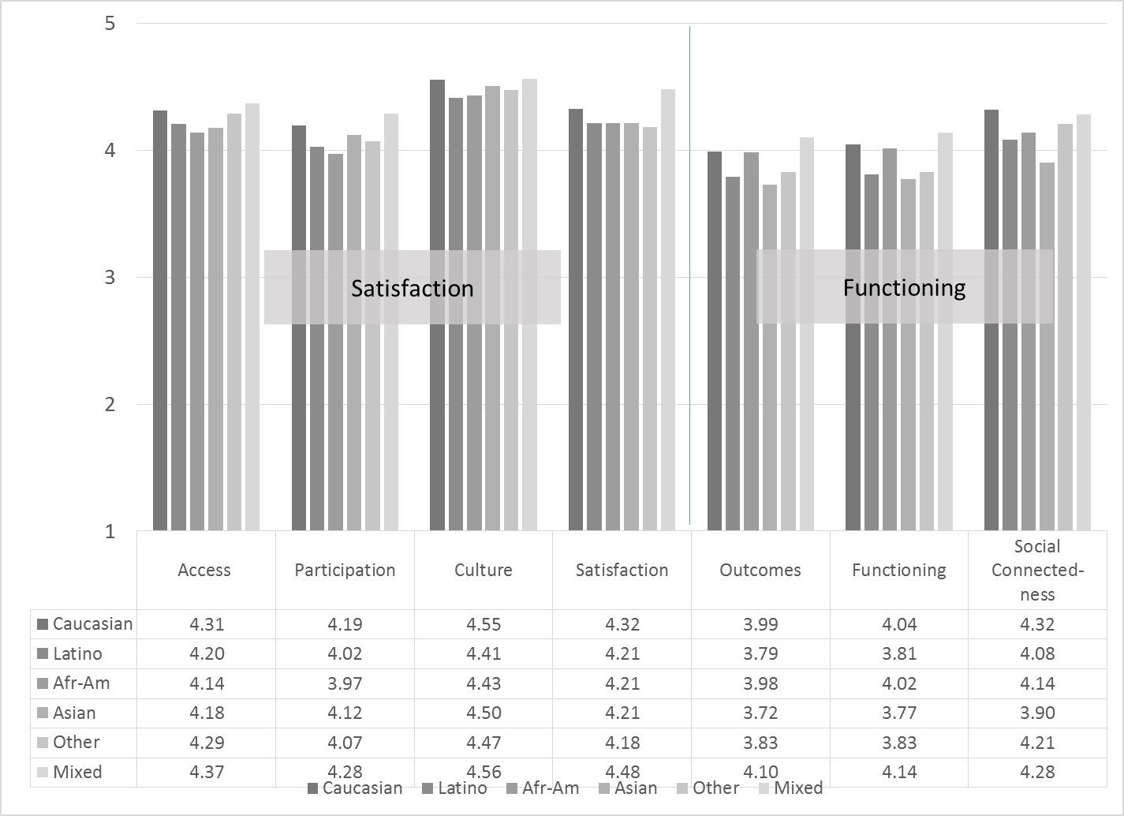

There were significant gender differences across the YSS Outcomes and Functioning scores. On both of these scales, males scored higher than females.

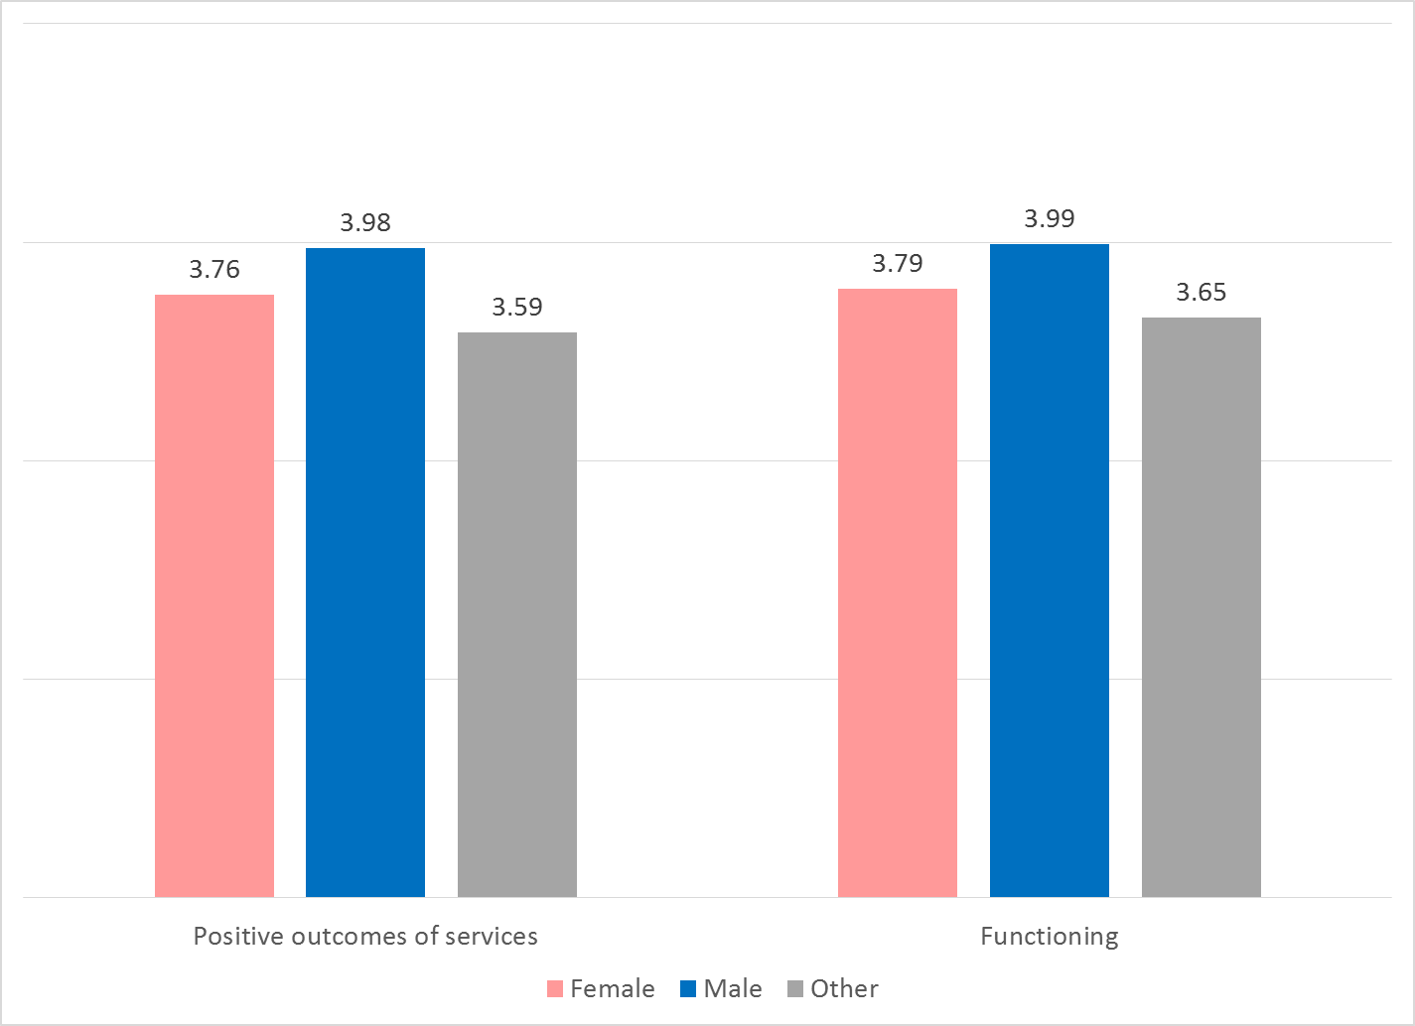

Clients who had been enrolled longer in services tended to score higher on YSS scales. These relationships are depicted in Figure 4. All are significant at p < .01.

Figure 4. YSS Scores by time in service
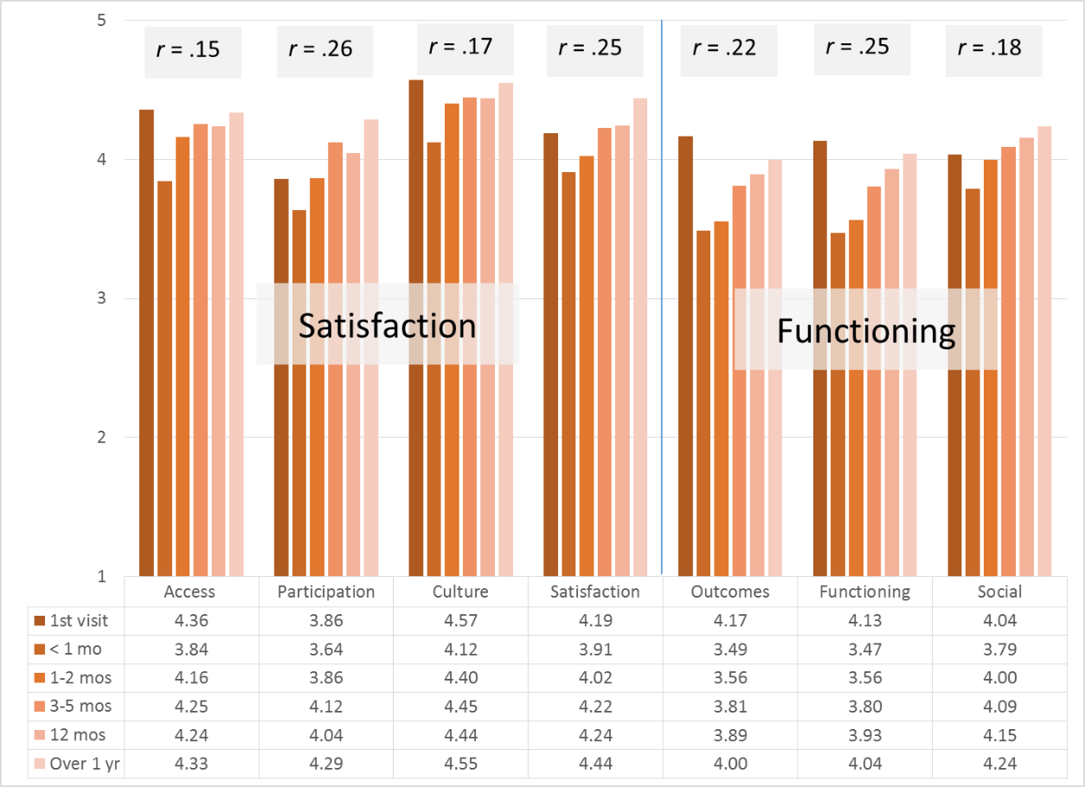

Older participants obtained higher YSS scores on all but the Social Connectedness scale. The Pearson correlation coefficients are shown in Table 1 and the trends are shown in Figures 5 and 6.

Table 1. Pearson correlation between YSS scales and age
 | Good access to services | Partici-pation in treatment | Cultural sensitivity | Satisfaction with services | Positive outcomes of services | Functioning | Social Connect-edness
Correlation with age | 0.146 | 0.272 | 0.136 | 0.208 | 0.129 | 0.152 | 0.074
Sig. (2-tailed) | <.001 | <.001 | 0.001 | <.001 | 0.002 | <.001 | 0.075

Figure 5. Satisfaction (YSS) by age group
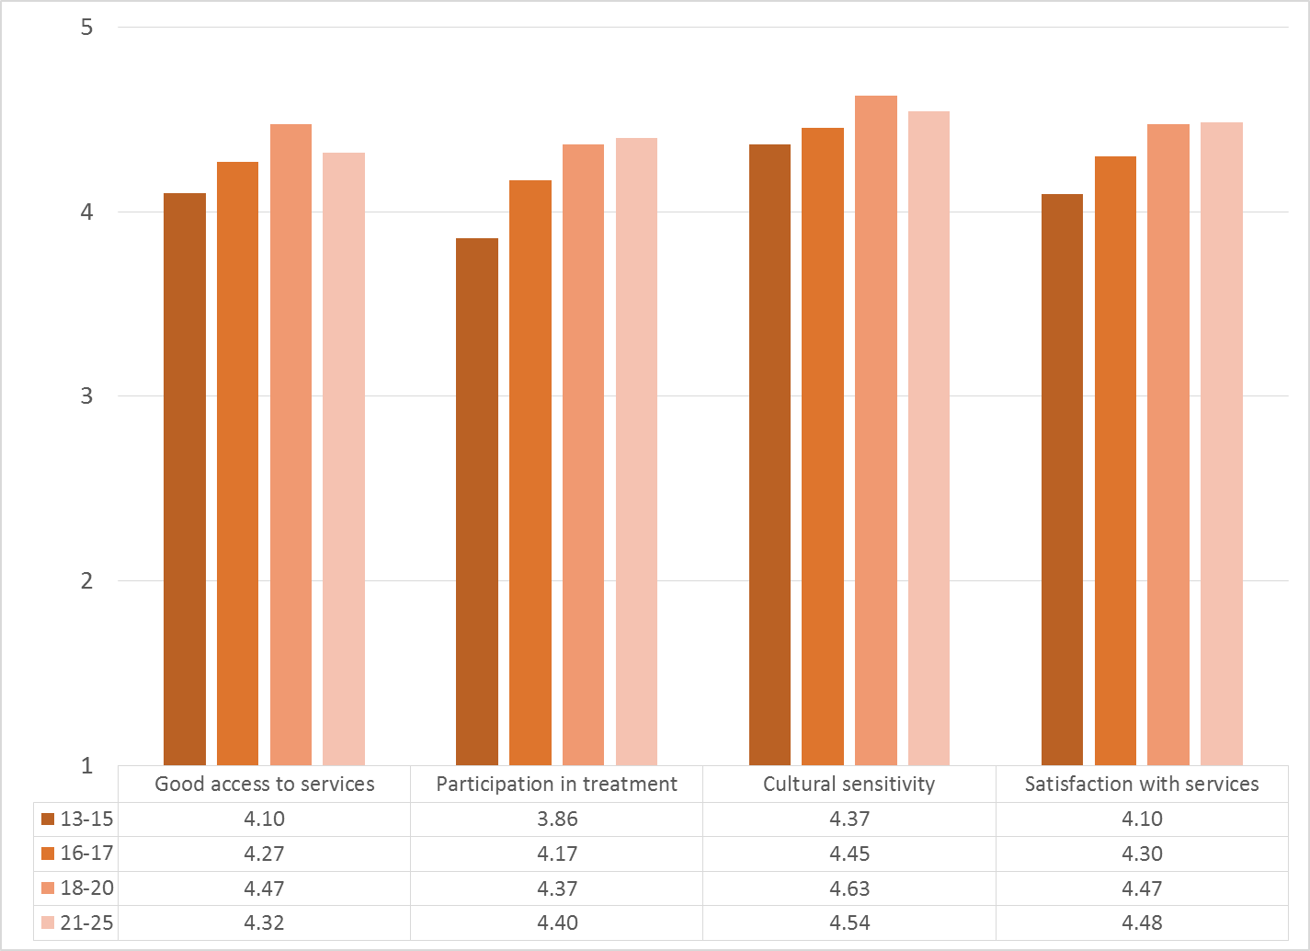

Figure 6. Functioning (YSS) by age group
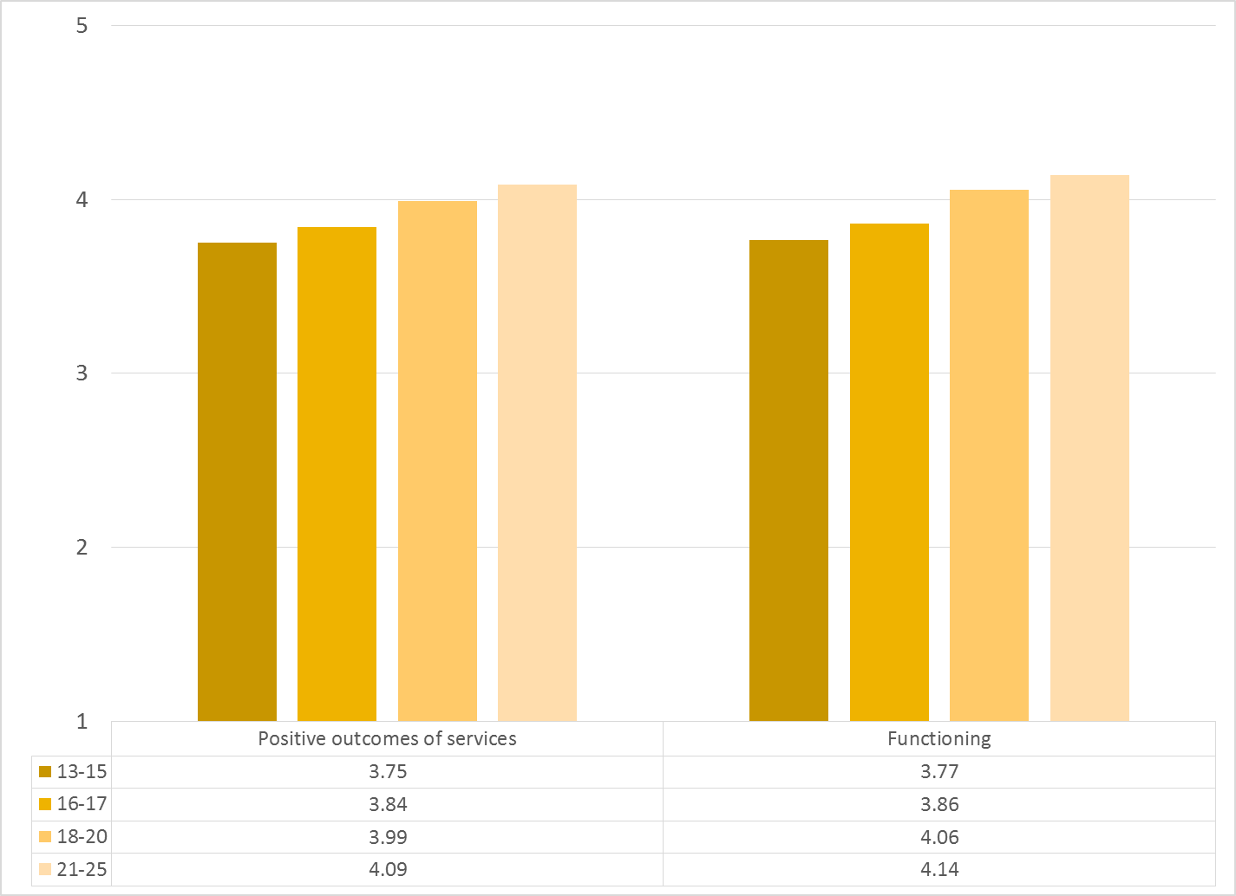
Figure 4

Living Situation

Clients were asked, “Have you lived in any of the following places in the last 6 months? (Mark all that apply.)” The responses to this question are seen in Figure 6. Three out of four youths resided with one or both parents during the prior six months. Three percent of youth reported homelessness during this same period and 3.9% had either been homeless or lived in a homeless shelter. Homelessness increased markedly at age 21 and above, affecting one out of six clients (Figure 7).

Figure 6. Percentage in living situation over past 6 months
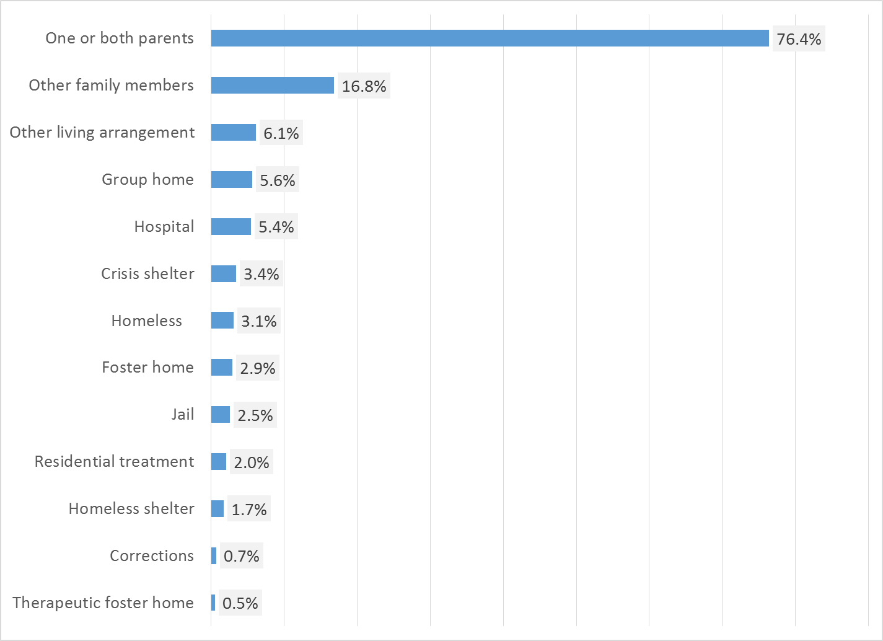

Figure 7. Homeless or in homeless shelter in last 6 months, by age
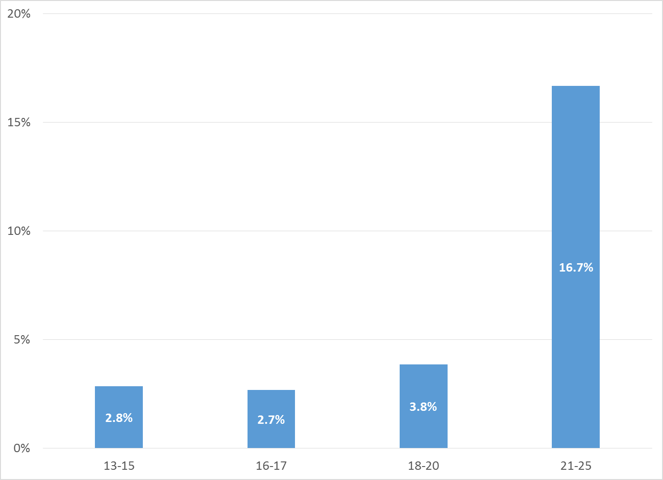

Doctor visits and medication

As reflected by Figure 8, 66.0% of clients reporting (316/479) were seen for a medical clinic or office visit in the prior year. This rate did not differ significantly by age, ethnicity, and county vs. contract clinic, gender, or living situation.

Figure 8. "In the last year, did you see a medical doctor (or nurse)
for a health check-up or because you were sick?" (n = 479)
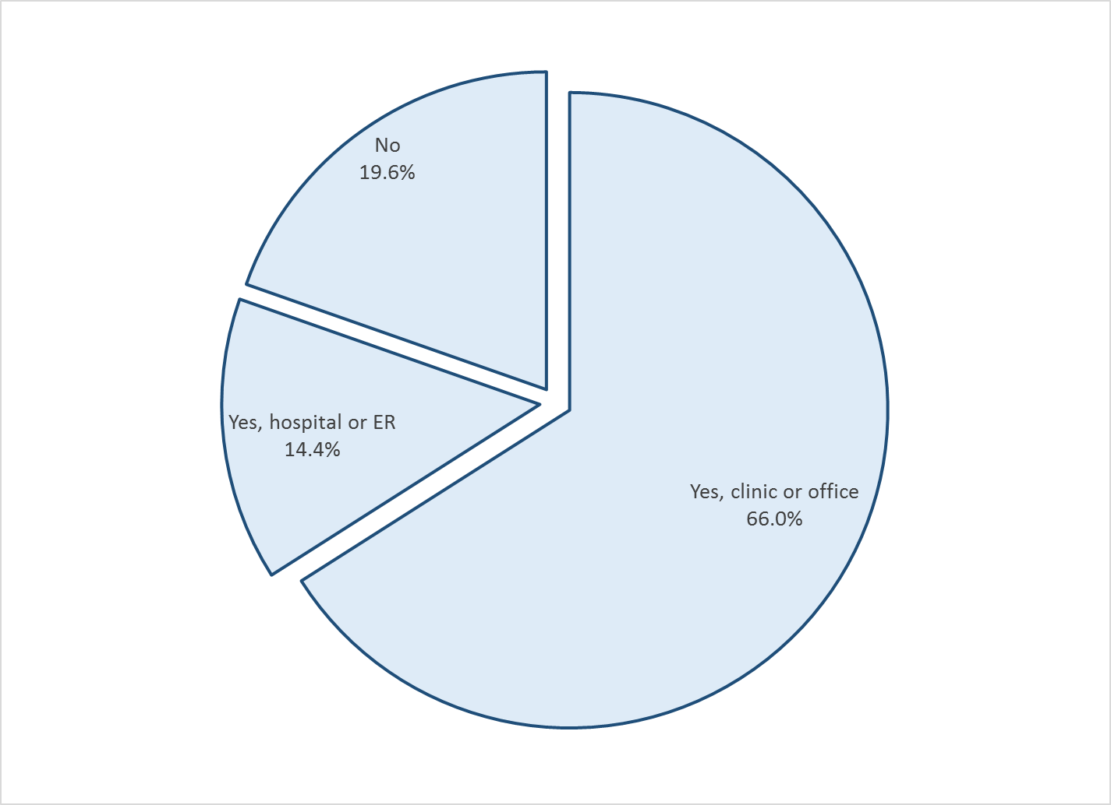

Psychotropic medication is taken by 38.2% of clients reporting this information (213/587). Of those receiving medication, 85.1% (166/195) indicated that the doctor or nurse told them what side effects to watch for.

Table 1. YSS mean scores by program
Program | Access | Partici- pation | Culture | Satis- faction | Out-comes | Function- ing | Social | N
Behavioral Health Services for Military Families Child Guidance Center | 4.5 | 4.7 | 4.6 | 4.8 | 4.0 | 3.9 | 4.5 | 2
Child Guidance Center | 4.3 | 3.9 | 4.4 | 4.2 | 3.6 | 3.6 | 3.8 | 15
Child Guidance Center, BP | 4.3 | 4.1 | 4.3 | 4.3 | 3.5 | 3.6 | 3.9 | 4
Children?s Hospital of Orange County Co Occurring Clinic | 4.1 | 3.9 | 4.5 | 4.3 | 4.0 | 4.0 | 4.3 | 22
Collaborative Courts FSP | 4.6 | 4.4 | 4.6 | 4.6 | 4.1 | 4.1 | 4.3 | 49
Community Counseling and Supportive Services | 5.0 | 4.7 | 5.0 | 5.0 | 4.0 | 3.8 | 4.0 | 1
CYBH CCPU | 4.9 | 4.6 | 4.8 | 4.8 | 4.7 | 4.8 | 4.8 | 5
CYBH CM | 3.7 | 3.6 | 5.0 | 4.3 | 4.2 | 4.1 | 4.1 | 3
CYBH East | 4.2 | 3.9 | 4.3 | 4.2 | 3.7 | 3.7 | 4.0 | 54
CYBH PACT | 4.5 | 4.0 | 4.5 | 4.3 | 3.6 | 3.7 | 4.3 | 4
CYBH West Region | 4.3 | 4.3 | 4.6 | 4.3 | 3.8 | 3.8 | 4.3 | 17
CYBH, North | 4.5 | 4.6 | 4.6 | 4.5 | 4.0 | 4.0 | 4.3 | 13
Family Preservation Community Services WRAP | 4.0 | 4.0 | 4.6 | 4.2 | 4.3 | 4.3 | 4.5 | 9
KCS (Korean Community Services) [Distribute through OCAPICA, 22120] | 4.2 | 4.1 | 4.3 | 4.2 | 3.7 | 3.8 | 3.9 | 3
New Alternatives WRAP | 4.6 | 4.4 | 4.6 | 4.7 | 4.5 | 4.4 | 4.5 | 6
OC Accept | 4.5 | 4.7 | 4.9 | 4.4 | 3.7 | 3.6 | 4.3 | 2
OCAPICA FSP | 4.3 | 4.3 | 4.5 | 4.3 | 3.9 | 4.0 | 4.1 | 33
Orange County Center for Resiliency, Education & Wellness(OC CREW) | 4.4 | 4.1 | 4.1 | 4.1 | 4.0 | 4.0 | 4.2 | 4
Pathways CS STAY | 4.2 | 4.3 | 4.5 | 4.4 | 4.1 | 4.1 | 4.3 | 39
Pathways RENEW | 4.5 | 4.2 | 4.6 | 4.3 | 4.0 | 4.0 | 4.2 | 36
Phoenix House Wraparound | 4.5 | 4.1 | 4.3 | 4.4 | 3.7 | 3.8 | 4.5 | 3
SCCS-Outpatient | 3.5 | 3.4 | 3.7 | 3.7 | 3.7 | 3.8 | 3.8 | 9
Seneca OC Outpatient | 4.0 | 4.1 | 4.5 | 4.2 | 4.1 | 4.1 | 4.5 | 15
Seneca OC Wraparound | 4.0 | 3.8 | 4.0 | 4.1 | 3.8 | 3.8 | 4.0 | 2
Wayfinders-Families First | 4.2 | 3.9 | 4.5 | 4.3 | 3.9 | 3.9 | 4.2 | 20
Western Youth Services West: Fountain Valley | 4.2 | 4.1 | 4.5 | 4.2 | 4.0 | 4.0 | 4.1 | 43
WYS East (Santa Ana) | 4.2 | 3.9 | 4.3 | 4.0 | 3.4 | 3.4 | 3.6 | 40
WYS North (Anaheim) | 4.1 | 4.0 | 4.4 | 4.2 | 3.8 | 3.8 | 4.1 | 81
WYS, Mission Viejo | 3.9 | 3.8 | 4.3 | 3.8 | 3.5 | 3.5 | 3.9 | 52
Total | 4.2 | 4.1 | 4.4 | 4.2 | 3.8 | 3.9 | 4.1
Significantly Higher
Significantly Lower
(+/- 2 std.errors)

