Consumer Perception Survey
November 2016 YSS Administration
Children and Youth
Jonathan Rich, Ph.D.
September 26, 2017

The Youth Satisfaction Survey (YSS) was offered to all teen and transitional age youth clients attending mental health services at a County or contract CYBH clinic from November 2016. The initial data file contained 816 records. The intended age range for the YSS is 13 and older. YSS records with birthdates corresponding to an age of 13 – 25 and with a CYBH, ADAS or Prevention & Intervention program indicated were retained for this analysis. Records with no birthdate, a birthdate outside of the age range, or a program code that was missing, was not a recognized code, or that was associated with an AOABH program were eliminated from this analysis. This left 626 records.

YSS Results

Sample description:

N: 626
Gender (n = 606): F-349 (57.6%), M-249 (41.1%), O-8 (1.3%)
Age (n = 626): Mean = 16.0, s = 2.6, range = 13-25.
Form Language (n = 626): English-619 (98.9%), Spanish-5 (0.8%), Vietnamese-2 (0.3%)
Race/Ethnicity (n = 604):
Figure 1. Client race/ethnicity
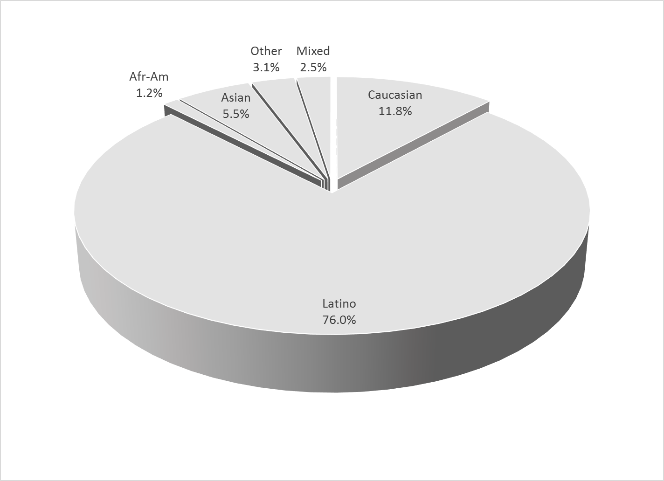

County vs. Contract (n = 626): County 24.8% vs. Contract 75.2%
Division (n = 626): CYBH 82.4%, P&I 15.5%, ADAS 2.1%

Mean YSS scale scores:

Figure 2. Mean Scores: YSS
(Scale is 1-"strongly disagree" to 5-"strongly agree")
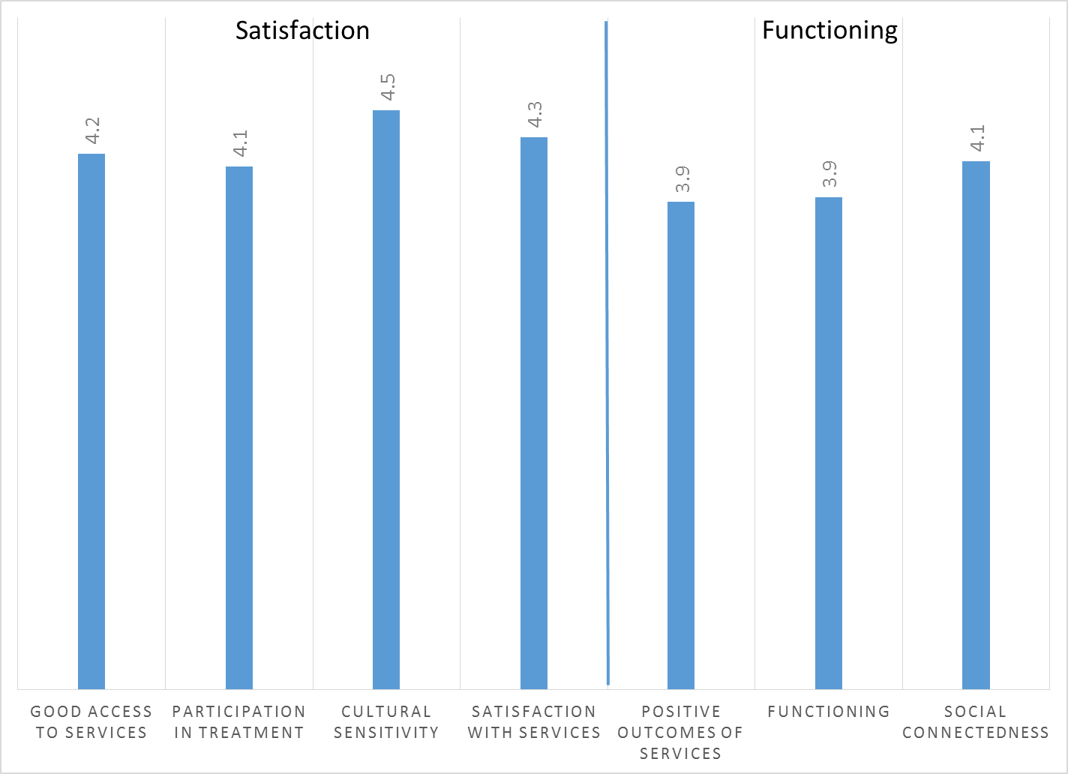

Factors affecting YSS scores:

There were no significant ethnic differences on any of the YSS scores (Figure 3).

Figure 3. YSS scores by race/ethnicity (no statistically significant differences)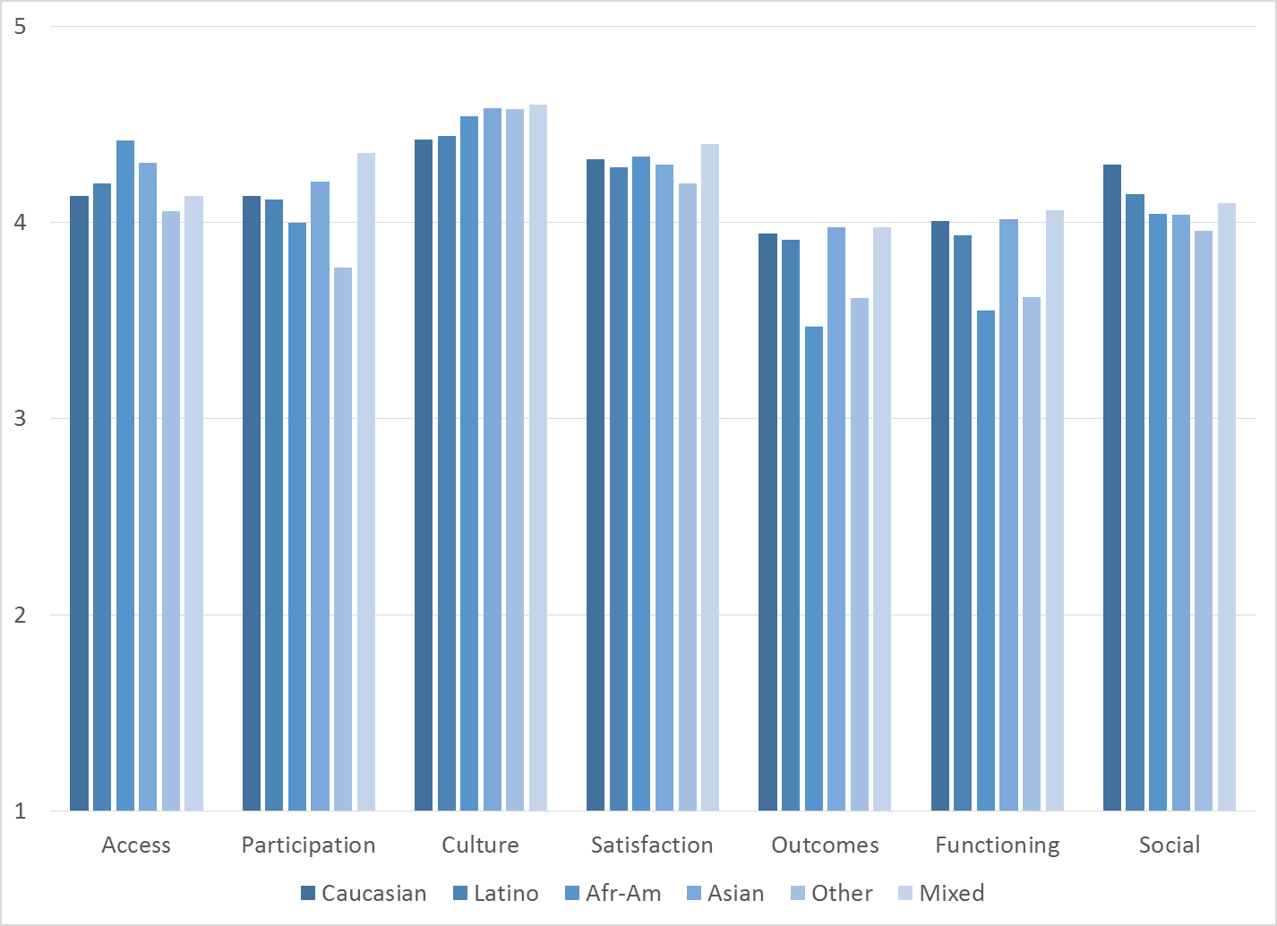

There was a small but statistically significant gender difference on the Cultural Sensitivity scale, with females giving a higher rating, 4.5 vs. 4.4.

Clients who had been enrolled longer in services tended to score higher on YSS scales. These relationships are depicted in Figure 4. All except Access and Social Connectedness are significant at p < .01.

Figure 4. YSS Scores by time in service
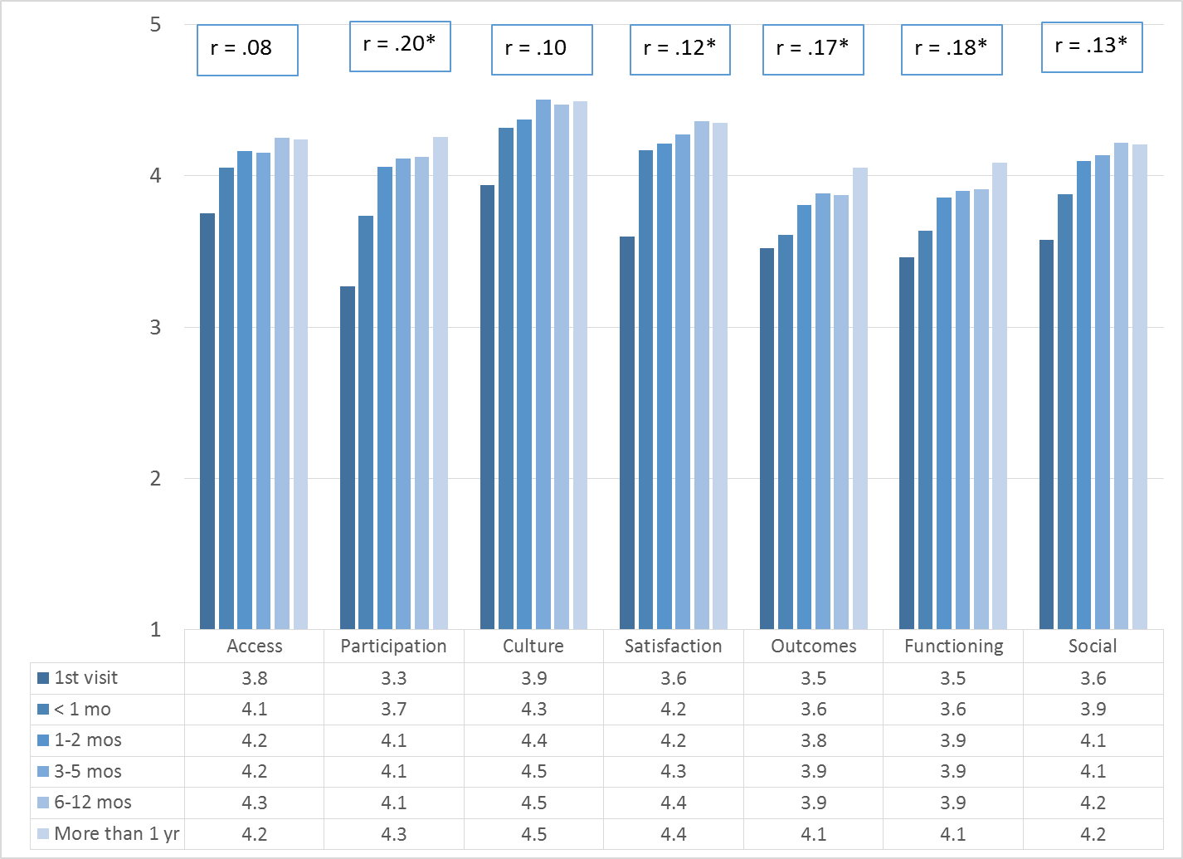
*p < .01.

Older participants reported greater participation in treatment, better outcomes, and better functioning, r = .15, .14, .15 respectively, p < .01. These trends are shown in Figure 5.

Figure 5. YSS Participation, Outcomes and Functioning, by age
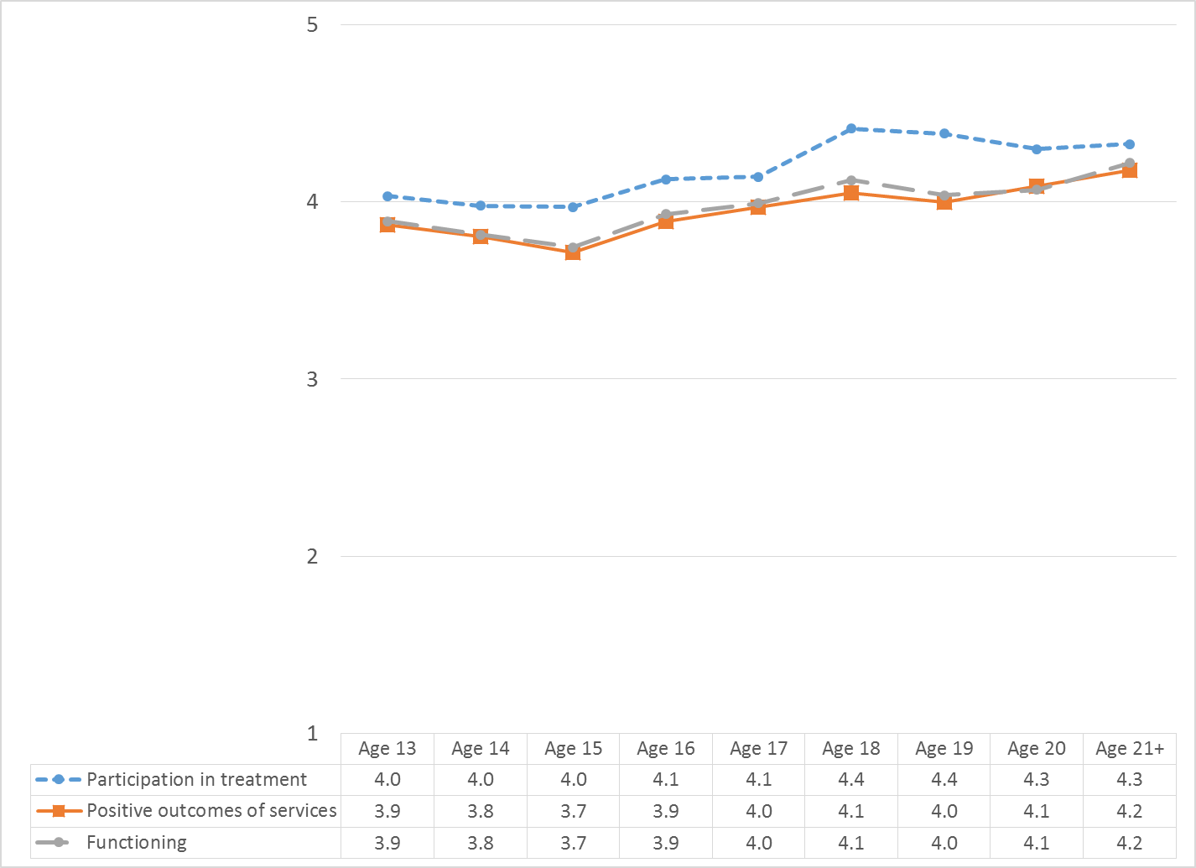

Living Situation

Clients were asked, “Have you lived in any of the following places in the last 6 months? (Mark all that apply.)” The responses to this question are seen in Figure 6. Four out of five youths resided with one or both parents during the prior six months. Two percent of youth reported homelessness during this same period and 2.7% had either been homeless or lived in a homeless shelter. Homelessness differed by age, peaking at age 19 (Figure 7).

Figure 6. Percentage in living situation over past 6 months
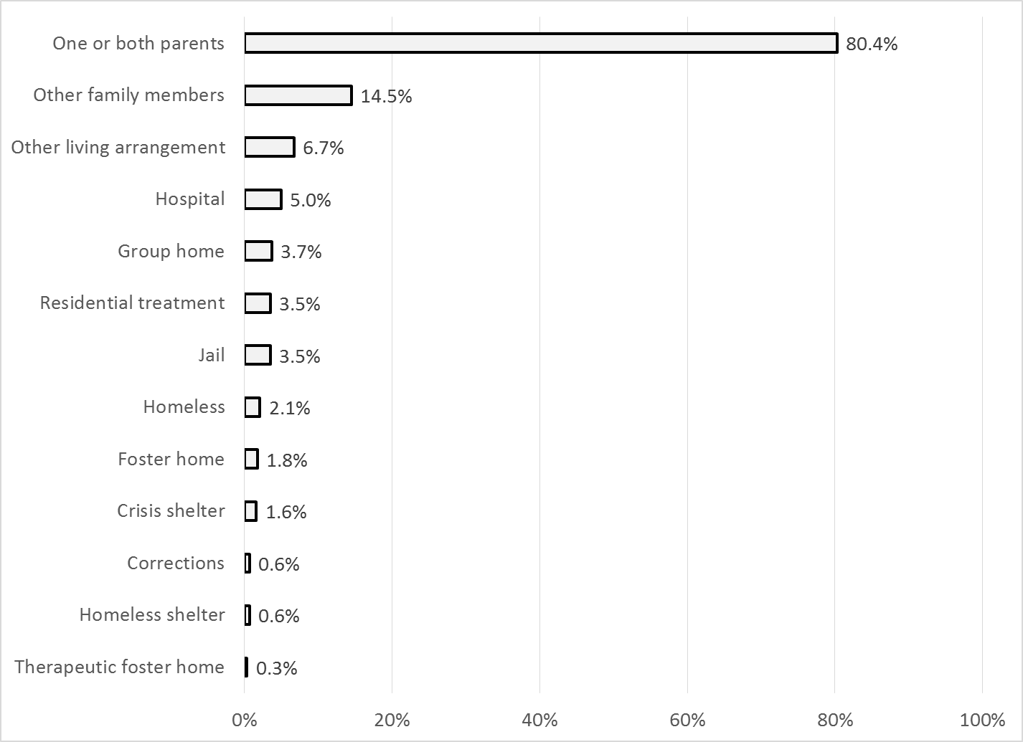

Figure 7. Homeless or in homeless shelter in last 6 months, by age
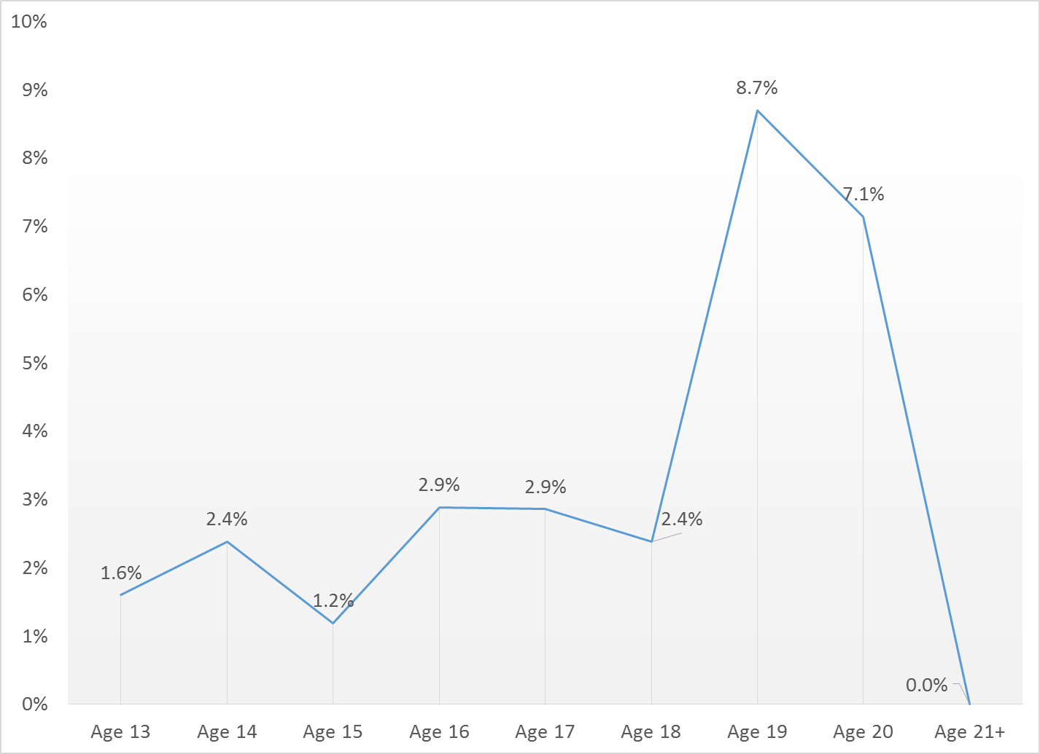

Doctor visits and medication

As reflected by Figure 8, 68.5% of clients reporting (341/498) were seen for a medical clinic or office visit in the prior year. This rate did not differ significantly by age, ethnicity, county vs. contract clinic, or gender.

Figure 8. "In the last year, did you see a medical doctor (or nurse)
for a health check-up or because you were sick?"
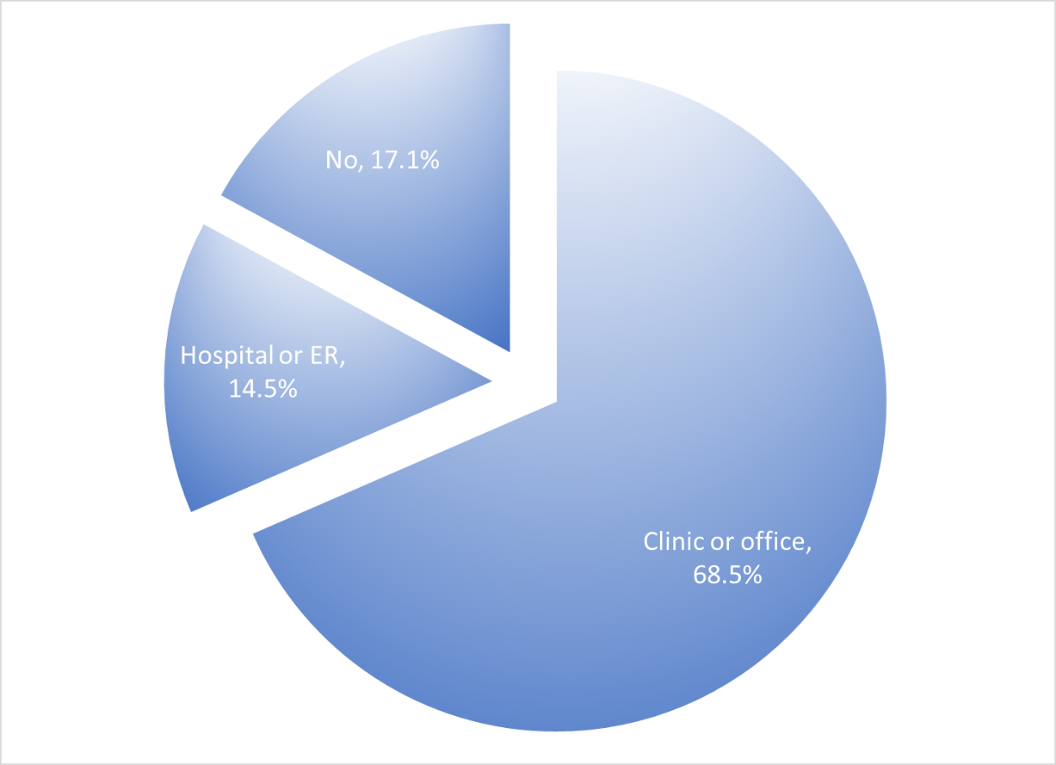

Psychotropic medication is taken by 65.8% of clients reporting this information (392/596). Of those receiving medication, 84.7% (161/190) indicated that the doctor or nurse told them what side effects to watch for.

Table 1. YSS mean scores by program
Program | Access | Partici- pation | Culture | Satis- faction | Out-comes | Func- tioning | Social | N
Child Guidance Center, Ful | 4.1 | 4 | 4.3 | 4.2 | 3.9 | 3.9 | 4.1 | 36
Child Guidance Center, BP | 3.5 | 3.1 | 5 | 3.3 | 4 | 4.1 | 4.8 | 3
Children’s Hospital of Orange County Co Occurring Clinic | 3.8 | 3.7 | 4.1 | 4 | 3.8 | 3.8 | 4.1 | 25
Collaborative Courts FSP | 4.5 | 4.5 | 4.7 | 4.7 | 4.2 | 4.2 | 4.4 | 34
Community Counseling and Supportive Services | 4 | 2.7 | 3.8 | 3.8 | 3 | 3 | 3 | 1
CYBH CCPU | 4.3 | 4.1 | 4.3 | 4 | 3.9 | 3.9 | 4 | 4
CYBH CM | 4.4 | 4.3 | 4.7 | 4.5 | 4 | 4 | 4.4 | 10
CYBH East | 4.3 | 4.3 | 4.6 | 4.5 | 3.7 | 3.7 | 4.1 | 25
CYBH South RH Dana: Dana Point | 4.1 | 3.7 | 4.3 | 4.2 | 4.2 | 4.3 | 4.2 | 4
CYBH South, LB Wesley | 4.1 | 4.4 | 4.8 | 4.6 | 4.1 | 4.1 | 4.2 | 14
Families First | 4.1 | 4.1 | 4.3 | 4.1 | 3.6 | 3.7 | 4.1 | 8
Juvenile Recovery Court | 4 | 4.7 | 5 | 4.8 | 5 | 5 | 5 | 1
KCS (Korean Community Services) [Distribute through OCAPICA, 22120] | 4.5 | 3.8 | 4.3 | 4.5 | 4.6 | 4.7 | 4.3 | 2
Kinship Seneca | 2.8 | 3.7 | 4.5 | 4.1 | 4 | 4.1 | 4.1 | 3
OC Accept | 5 | 4.8 | 5 | 5 | 4.2 | 4.2 | 4.5 | 2
OCAPICA FSP | 3.5 | 4.3 | 4.3 | 4.3 | 4.3 | 4.3 | 4.3 | 1
Orange County Center for Resiliency, Education & Wellness(OC CREW) | 4.4 | 3.5 | 4.1 | 3.9 | 3.9 | 3.9 | 3.6 | 5
Pathways CS STAY | 4.2 | 4.3 | 4.6 | 4.3 | 3.9 | 4 | 4.1 | 30
Pathways Garden Grove | 3.9 | 3.7 | 4.7 | 4.2 | 3.9 | 3.9 | 4.2 | 8
Pathways RENEW | 4.2 | 4.1 | 4.6 | 4.3 | 3.9 | 4 | 4.3 | 32
Pathways, Anaheim | 4.4 | 4.1 | 4.5 | 4.4 | 4 | 4 | 4.2 | 7
Pathways, Costa Mesa | 4.1 | 3.9 | 4.2 | 4.2 | 3.4 | 3.5 | 3.6 | 6
Pathways, Santa Ana | 4.4 | 4.4 | 4.3 | 4.5 | 4.1 | 4.2 | 4.3 | 9
School Based Mental Health Services | 4.2 | 4.1 | 4.5 | 4.3 | 3.9 | 4 | 4.2 | 79
South Coast Children's Society | 4.3 | 4.1 | 4.4 | 4.5 | 3.6 | 3.6 | 4.1 | 11
Touchstones (Adolescent) | 4.1 | 4.3 | 4.1 | 4.1 | 3.9 | 3.9 | 4.2 | 13
VNCOC (Vietnamese Community of OC) OCAPICA FSP | 4.8 | 4.7 | 4.6 | 4.6 | 4.4 | 4.4 | 4.5 | 8
Western Youth Services West: Fountain Valley | 4.1 | 4.1 | 4.4 | 4.2 | 3.7 | 3.8 | 4 | 35
WYS East (Anaheim) | 4.1 | 4 | 4.4 | 4.1 | 3.7 | 3.7 | 4 | 56
WYS North (Anaheim) | 4.2 | 3.9 | 4.4 | 4.2 | 3.8 | 3.8 | 4 | 65
WYS, Mission Viejo | 4.1 | 4 | 4.4 | 4.2 | 3.8 | 3.8 | 4.1 | 35
Youth as Parents | 4.8 | 4.7 | 4.8 | 4.7 | 4.1 | 4.2 | 4.4 | 10
Youthful Offender Wraparound | 4.3 | 4.4 | 4.4 | 4.4 | 4.3 | 4.3 | 4.4 | 40
Total | 4.2 | 4.1 | 4.5 | 4.3 | 3.9 | 3.9 | 4.1

Note: Yellow highlight is significantly higher than the total (2.5 standard errors). Grey highlight is significantly lower than total (-2.5 standard errors).

