Consumer Perception Survey
May 2016 YSS Administration
Children and Youth
Jonathan Rich, Ph.D.
January 3, 2017

The Youth Satisfaction Survey (YSS) was offered to all teen and transitional age youth clients attending mental health services at a County or contract CYBH clinic from May16-20, 2016. The intended age range for the YSS is 13 and older. YSS records with birthdates corresponding to an age of 13 – 25 and with a CYBH or Prevention & Intervention program indicated were retained for this analysis. Records with no birthdate, a birthdate outside of the age range, or a program code that was missing, was not a recognized code, or that was associated with an AOABH program were eliminated from this analysis. This left 463 records.

YSS Results

Sample description:

N: 463
Gender (n = 455): F-246 (54.1%), M-203 (44.6%), O-6 (1.3%)
Age (n = 463): Mean = 17.0, s = 2.9, range = 13-25.
Form Language (n = 455): English-457 (98.7%), Spanish-6 (1.3%)
Race/Ethnicity (n = 436):
Figure 1. Client race/ethnicity
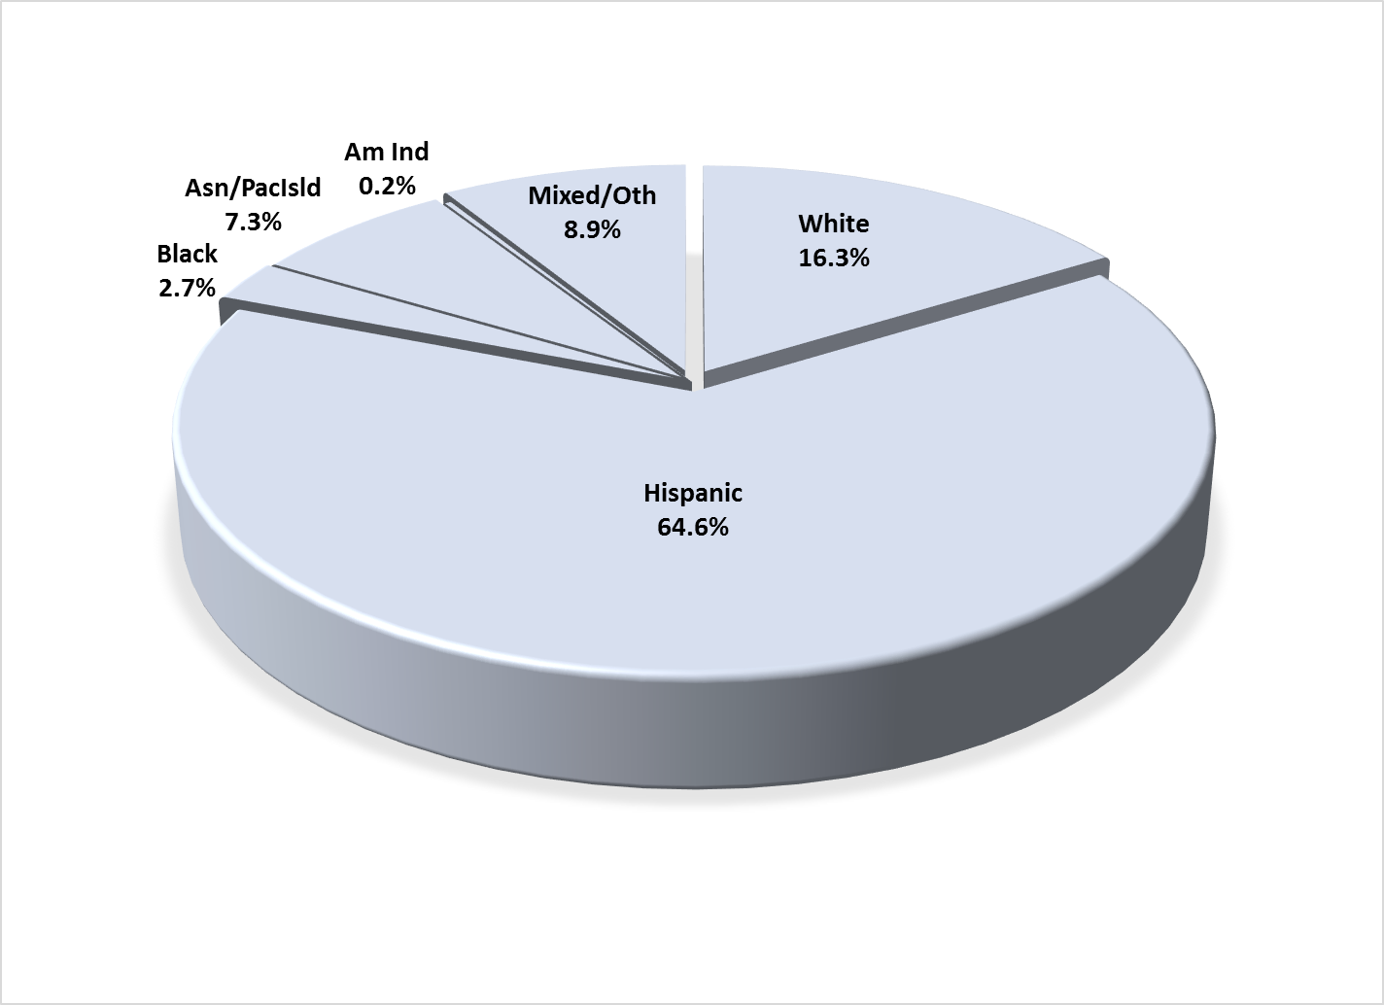

County vs. Contract (n = 463): County 18.8% vs. Contract 81.2%
Division (n = 463): CYBH 96.5%, P&I 3.5%

Mean YSS scale scores:

Figure 2. Mean Scores: YSS
(Scale is 1-"strongly disagree" to 5-"strongly agree")
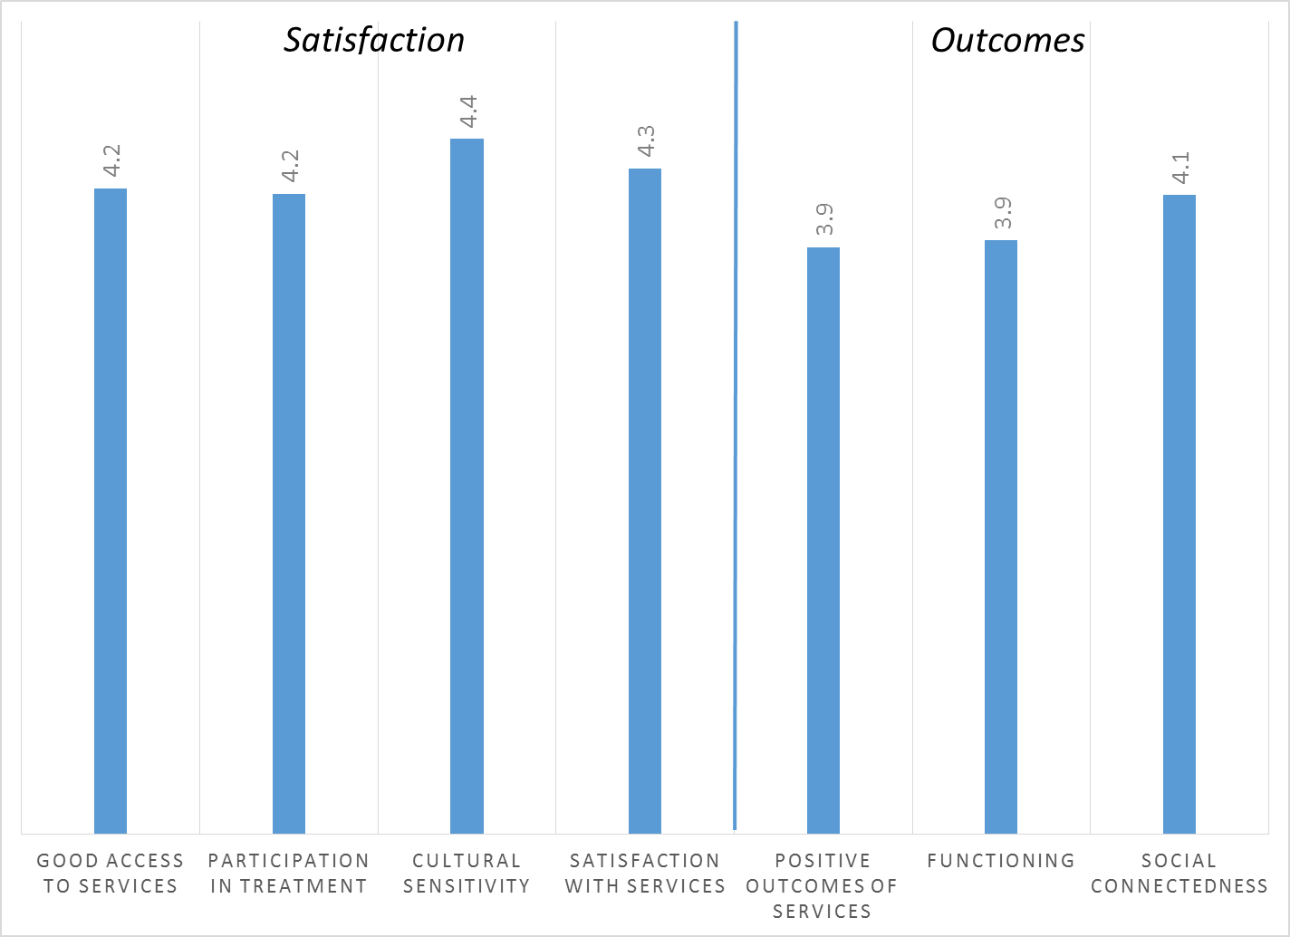

Factors affecting YSS scores:

There were no significant ethnic differences on any of the YSS scores (Figure 3).

Figure 3. YSS scores by race/ethnicity (no statistically significant differences)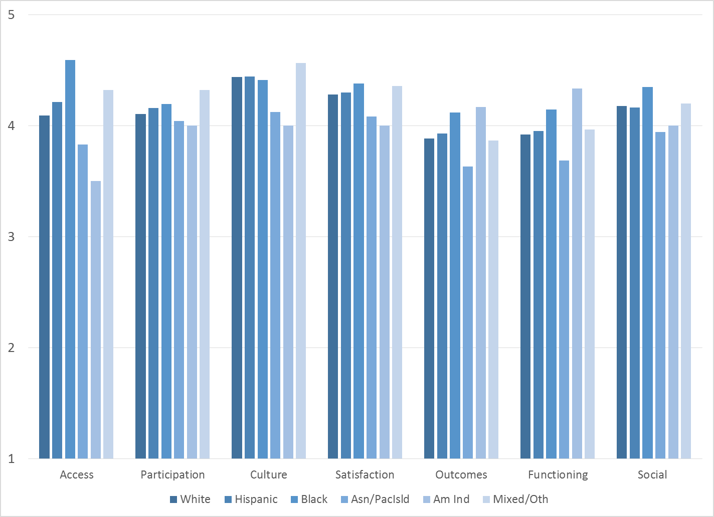

There were also no significant gender differences across the YSS scores. Clients who had been enrolled longer in services tended to score higher on YSS scales. These relationships are depicted in Figure 4. All except Access and Social Connectedness are significant at p < .01.

Figure 4. YSS Scores by time in service
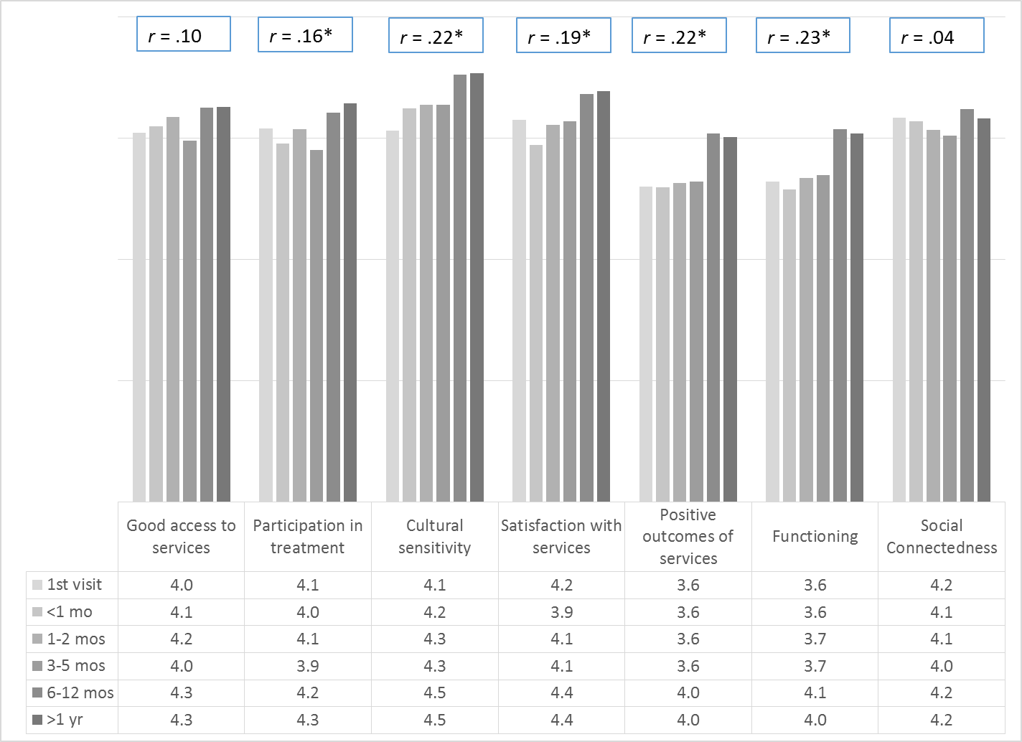
*p < .01.

Older participants reported greater participation in treatment, better outcomes, and better function, r = .13, .16, .18 respectively. These trends are shown in Figure 5.

Figure 5. YSS Participation, Outcomes and Functioning, by age
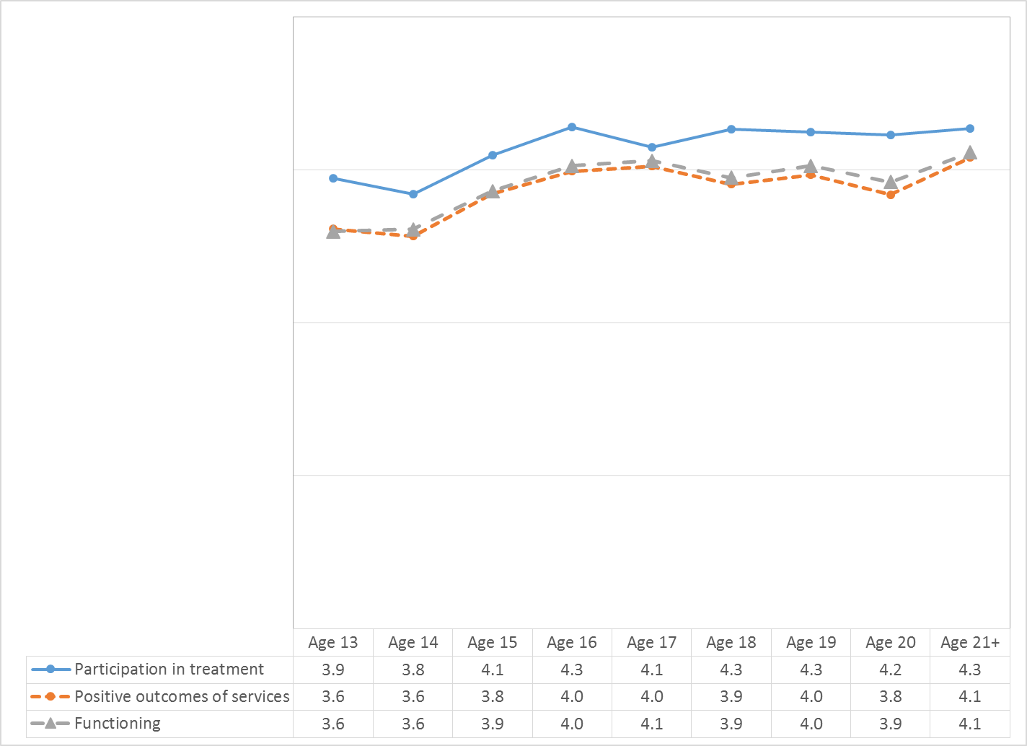

Living Situation

Clients were asked, “Have you lived in any of the following places in the last 6 months? (Mark all that apply.)” The responses to this question are seen in Figure 6. Three out of four youths resided with one or both parents during the prior six months. Four percent of youth reported homelessness during this same period and 5.8% had either been homeless or lived in a homeless shelter. Homelessness differed by age, with the percent of youths reporting increased homelessness at age 20 and older (Figure 7).

Figure 6. Percentage in living situation over past 6 months
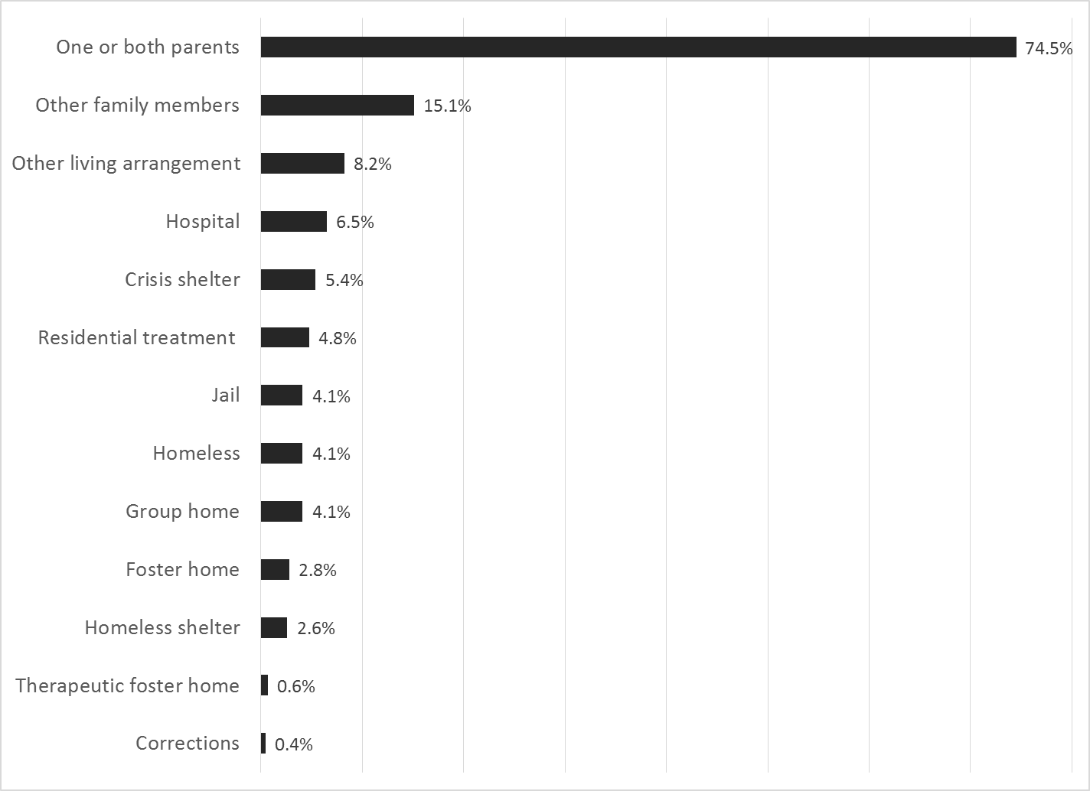

Figure 7. Homeless or in homeless shelter in last 6 months, by age
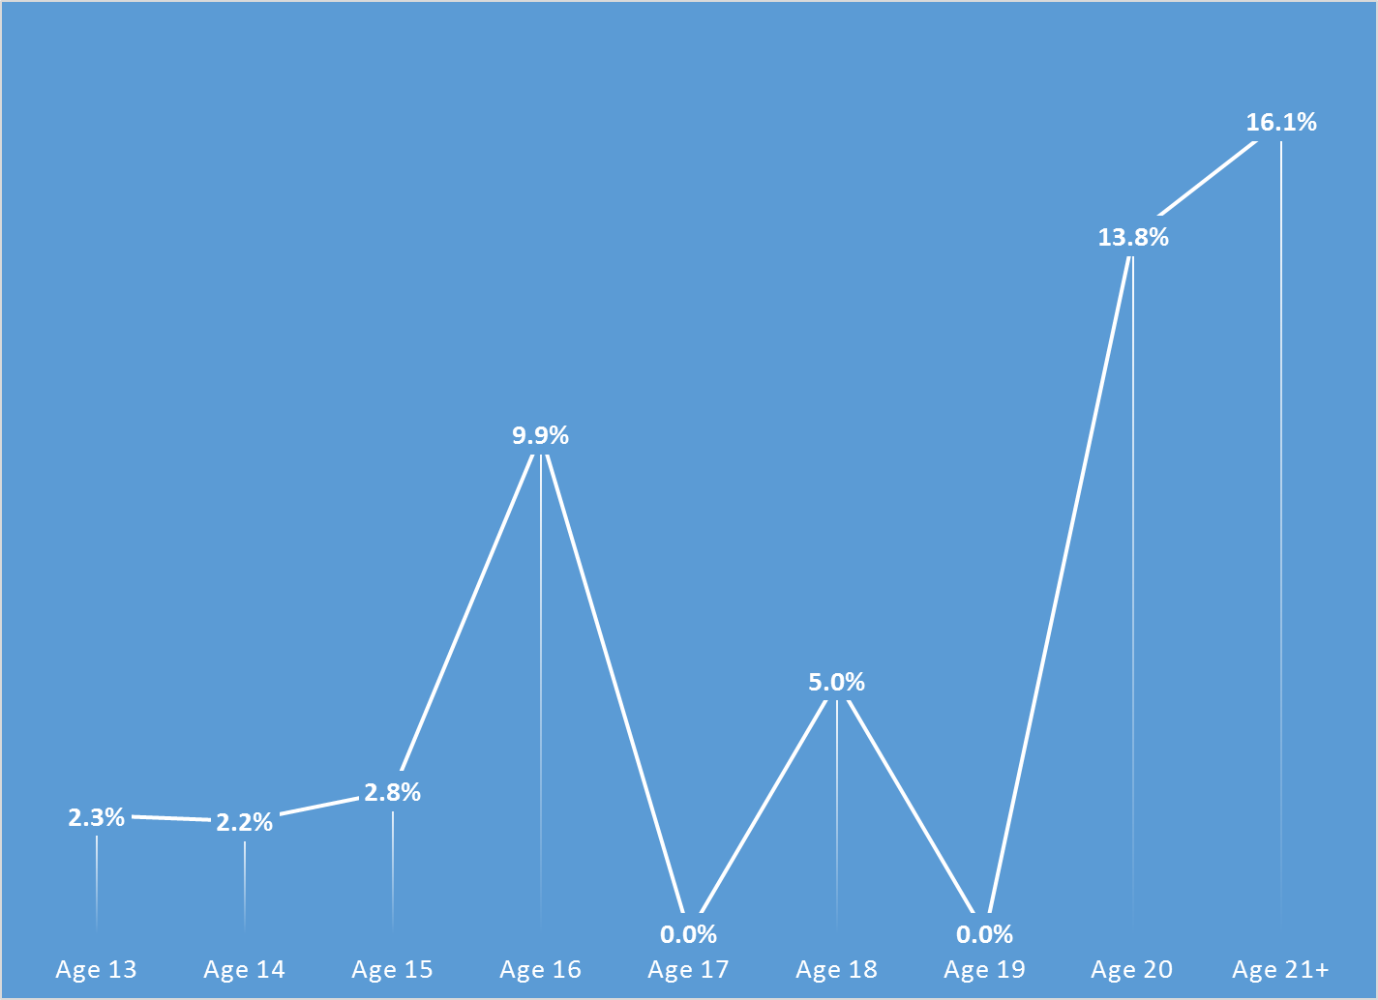

Doctor visits and medication

As reflected by Figure 8, 66.4% of clients reporting (259/390) were seen for a medical clinic or office visit in the prior year. This rate did not differ significantly by age, ethnicity, county vs. contract clinic, or gender. However, for those who had lived with one or both parents over the past year, the likelihood of being seen by a doctor on an outpatient basis rose to 70.4%.

Figure 8. "In the last year, did you see a medical doctor (or nurse)
for a health check-up or because you were sick?"
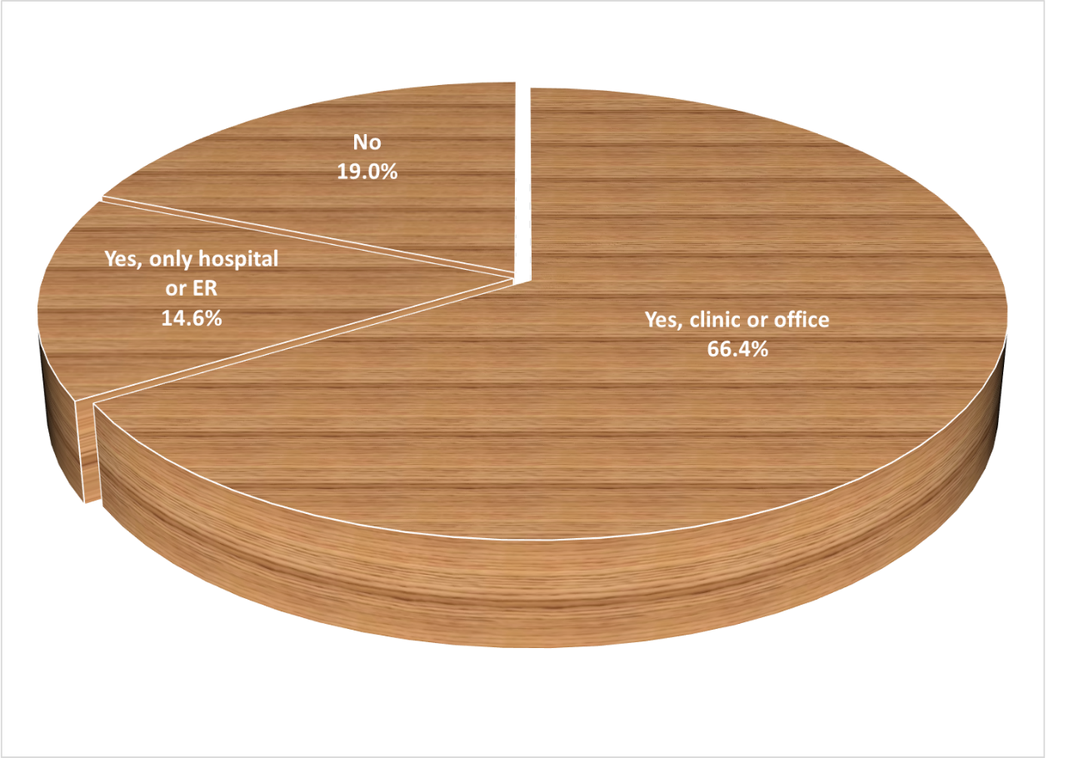

Psychotropic medication is taken by 68.2% of clients reporting this information (78/245). Of those receiving medication, 86.6% (162/187) indicated that the doctor or nurse told them what side effects to watch for.

Table 1. YSS mean scores by program
Program | Access | Partic | Culture | Satis | Outcomes | Func | Social | N
Canyon Acres Seneca, Anaheim | 4.8 | 4.2 | 4.4 | 4.8 | 4.5 | 4.6 | 4.9 | 2
Child Guidance Center, BP | 4.5 | 4.2 | 4.6 | 4.4 | 3.9 | 3.9 | 4.1 | 11
Child Guidance Center, Fullerton | 4.4 | 4.1 | 4.7 | 4.4 | 3.9 | 3.9 | 4.2 | 4
Child Guidance Center, Santa Ana | 4.1 | 3.9 | 4.4 | 4.1 | 3.9 | 3.9 | 4.1 | 20
Children’s Hospital of OC CoOccurring | 3.9 | 3.6 | 4.2 | 3.7 | 3.8 | 3.8 | 4.1 | 7
Collaborative Courts FSP | 4.5 | 4.5 | 4.6 | 4.6 | 4.1 | 4.1 | 4.4 | 49
Community Counseling and Supportive Services | 4.1 | 4.2 | 4.3 | 4.2 | 3.7 | 3.8 | 4.1 | 4
CYBH CM | 4.5 | 4.5 | 4.5 | 4.5 | 4.0 | 4.0 | 4.3 | 8
CYBH East | 4.4 | 4.4 | 4.5 | 4.6 | 4.2 | 4.2 | 4.3 | 17
CYBH South RH Dana: Dana Point | 4.3 | 4.3 | 4.5 | 4.4 | 4.1 | 4.0 | 4.4 | 4
CYBH South, LB Wesley | 3.7 | 3.6 | 4.2 | 3.8 | 3.7 | 3.7 | 3.9 | 13
CYBH West Region | 4.0 | 4.1 | 4.6 | 4.4 | 3.9 | 3.9 | 4.3 | 18
CYBH, North | 4.3 | 4.0 | 4.3 | 4.2 | 3.8 | 3.8 | 4.1 | 9
Juvenile Recovery Court | 3.3 | 4.5 | 4.8 | 4.5 | 4.3 | 4.3 | 4.6 | 2
KCS (Korean Community Services) [Distribute through OCAPICA, 22120] | 4.5 | 4.0 | 3.8 | 4.0 | 4.0 | 4.0 | 4.0 | 2
Kinship Seneca Tustin | 3.4 | 4.0 | 4.7 | 4.2 | 3.9 | 4.0 | 4.1 | 5
OCAPICA FSP | 3.9 | 4.1 | 4.2 | 3.8 | 3.4 | 3.6 | 3.5 | 7
Orange County Center for Resiliency, Education & Wellness(OC CREW) | 4.1 | 4.1 | 4.3 | 4.0 | 4.0 | 4.0 | 4.1 | 11
Orange County Postpartum Wellness (OCPPW) |  | 3.7 | 3.0 | 3.7 | 2.5 | 2.5 | 4.0 | 1
Pathways CS STAY | 4.0 | 4.0 | 4.2 | 4.2 | 3.8 | 3.8 | 4.1 | 51
Pathways RENEW | 4.4 | 4.4 | 4.7 | 4.5 | 4.0 | 4.0 | 4.3 | 46
Pathways, Anaheim | 4.1 | 4.0 | 4.3 | 4.3 | 4.1 | 4.2 | 3.9 | 9
Pathways, Santa Ana | 4.1 | 4.3 | 4.6 | 4.6 | 3.9 | 3.9 | 4.4 | 4
Seneca OC Wraparound | 4.3 | 4.0 | 4.3 | 4.2 | 3.9 | 4.1 | 3.6 | 3
South Coast Children's Society | 3.9 | 3.7 | 4.1 | 3.8 | 3.3 | 3.3 | 3.7 | 9
VNCOC (Vietnamese Community of OC) OCAPICA FSP | 4.8 | 4.7 | 4.7 | 4.8 | 4.3 | 4.3 | 4.5 | 8
WYS West: Fountain Valley | 4.0 | 4.0 | 4.3 | 4.2 | 3.7 | 3.8 | 4.0 | 33
WYS East (Anaheim) | 4.2 | 4.1 | 4.2 | 4.1 | 3.6 | 3.7 | 4.0 | 38
WYS North (Anaheim) | 4.1 | 3.8 | 4.4 | 4.1 | 3.8 | 3.8 | 4.0 | 26
WYS, Mission Viejo | 4.3 | 4.1 | 5.0 | 4.4 | 4.1 | 4.1 | 4.5 | 6
Youthful Offender Wraparound | 4.3 | 4.4 | 4.4 | 4.4 | 4.0 | 4.1 | 4.1 | 35
Total | 4.2 | 4.2 | 4.4 | 4.3 | 3.9 | 3.9 | 4.1
 | Significantly higher
 | Significantly lower

