Consumer Perception Survey
November 2015 YSS-F Administration
Children and Youth
Jonathan Rich, Ph.D.
May 31, 2016

The Youth Satisfaction Survey for Families (YSS-F) was offered to all parents and guardians of children and youths attending mental health services at a County or contract CYBH clinic from November 16-20, 2015. YSS-F records with birthdates corresponding to an age of 0 – 21 and with a CYBH, ADAS, Innovations or Prevention & Intervention program indicated were retained for this analysis.

YSS-F Results

Sample description:

N: 780
Gender (n = 755): F-320 (42.4%), M-432 (57.2%), O-2 (0.4%)
Age (n = 780): Mean = 10.5, s = 4.3, range = 0-20.
Form Language (n = 780): English-419 (53.7%), Spanish-329 (42.2%), Vietnamese-31 (4.0%), Chinese-1 (0.1).
Race/Ethnicity (n = 750):

Survey respondents describe their race and ethnicity by selecting as many of the following categories as applicable: Hispanic, American Indian, Asian, Black, Pacific Islander, White, Other Race, and Unknown Race. These selections were reduced to six categories as follows. If either Asian, Pacific Island, or both are selected, that is considered a single category, “Asian/Pacific Islander.” If only one category is selected, then the participant is assigned to that category. If more than one category is selected, or if “Other Race” or “Unknown Race” is selected, the participant is classified as “Mixed/Other.” If “Hispanic” is selected, the client is classified as “Latino,” regardless of the other selections.

Figure 1. Client race/ethnicity
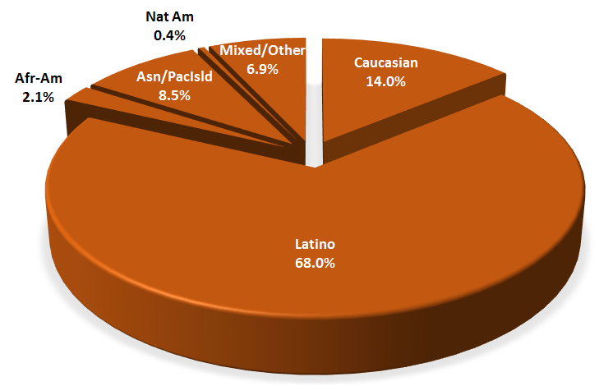

County vs. Contract (n = 780): County 19.2% vs. Contract 80.8%
Division (n = 780): CYBH 90.8%, P&I 9.0%, Innovations 0.3%

Mean YSS-F scale scores:

Figure 2. Mean Scores: YSS-F
(Scale is 1-"strongly disagree" to 5-"strongly agree")
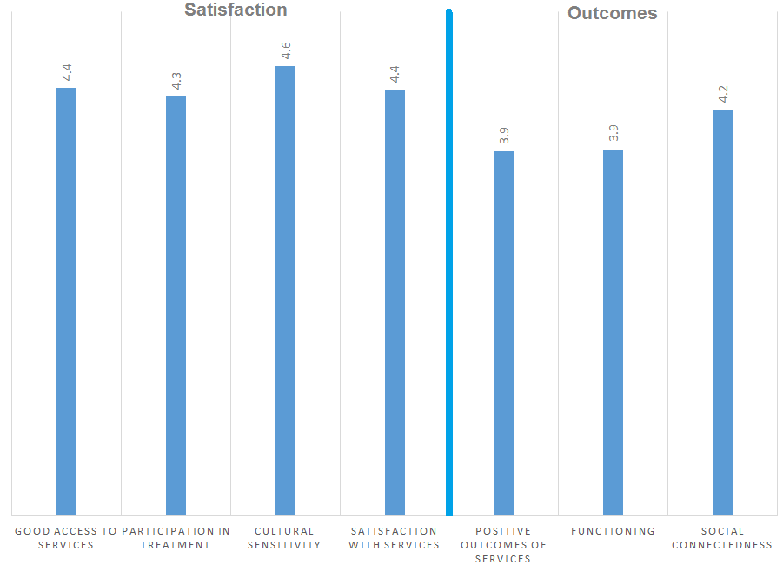

Factors affecting YSS-F scores:

“Positive Outcomes of Services” and “Functioning” varied significantly by ethnic group, with African-Americans (n = 13) tending to report worse outcomes and functioning and Asian/Pacific Islanders (n = 56) reporting better outcomes and functioning (Figure 3).

Figure 3. YSS-F scores by race/ethnicity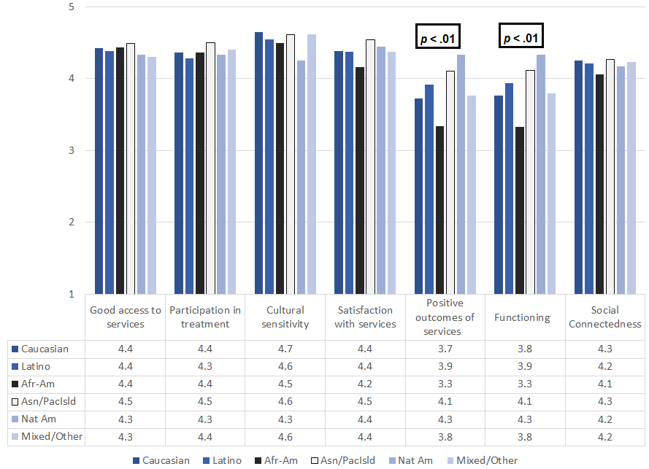

Participants completing the form in English were compared to those completing the form in Spanish. As seen in Figure 4, those responding to the Spanish forms gave significantly more favorable ratings on the Outcomes and Functioning scales.

Figure 4. YSS-F mean ratings, English vs. Spanish forms
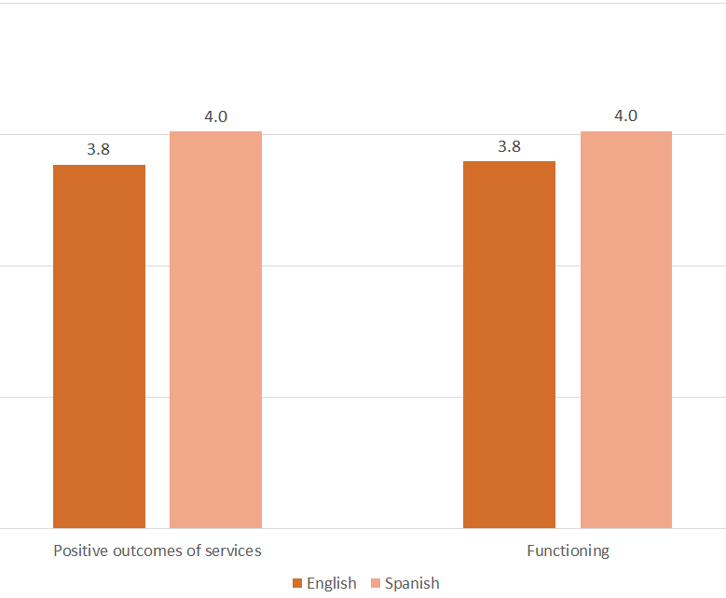

There were no significant gender differences.

Clients who had been enrolled longer in services tended to score higher on the Outcomes and Functioning scales. These relationships are depicted in Figure 5.
Figure 4. YSS-F Scores by time in service (*p < .01)
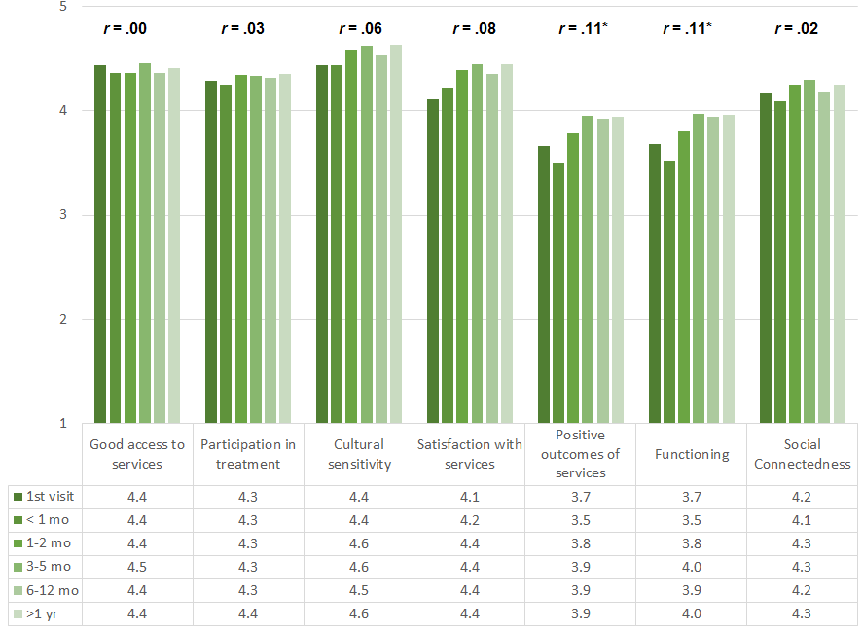

Living Situation

Clients were asked, “Have you lived in any of the following places in the last 6 months? (Mark all that apply.)”

Figure 5. Percentage in living situation over past 6 months
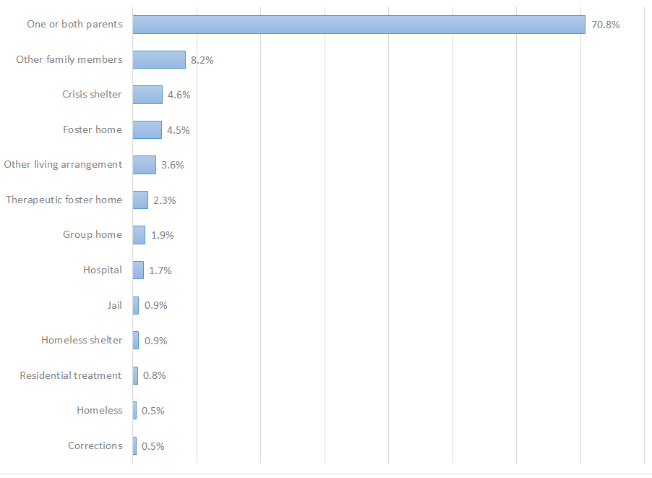

Doctor visits and medication

Figure 6. "In the last year, did you see a medical doctor (or nurse)
for a health check-up or because you were sick?"
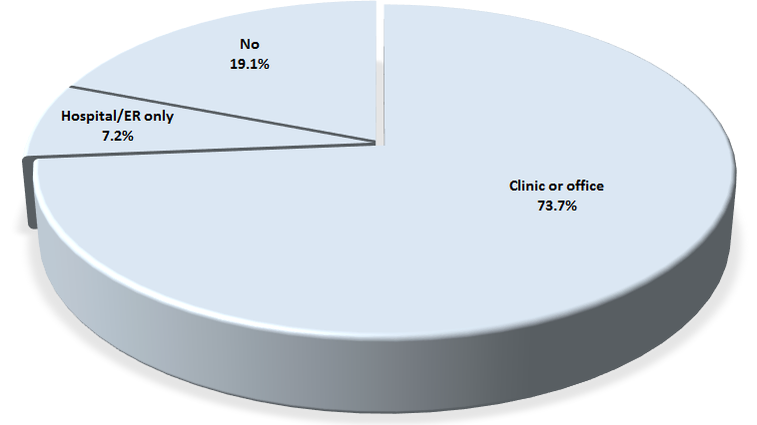
Seventy-four percent of clients reporting (532/722) were seen for a medical clinic or office visit in the prior year. Those seen in a clinic or office were, on average, younger, 10.2 vs 11.2 years. The rate did not differ by county vs. contract clinic or gender. The rate differed by form language: 76.8% (312/406) of those completing an English-language form vs. 68.5% (198/289) of those completing a Spanish-language form were seen in a medical clinical or office.

Three out of four clients (73.5%, 208/283) are taking psychotropic medication. Of the clients taking medication, 90.4% (188/208) reported that their medical provider had discussed side-effects with them.

Table 2. YSS-F mean scores by program
Program | Access | Partic. | Culture | Satis. | Outcomes | Func. | Social | N
Behavioral Health Services for Military Families Child Guidance Center | 3.8 | 4.3 | 4.5 | 4.5 | 2.4 | 2.5 | 4.4 | 2
Canyon Acres Seneca, Anaheim | 4.4 | 4.6 | 4.7 | 4.6 | 4.0 | 4.1 | 4.3 | 25
Child Guidance Center | 4.3 | 4.3 | 4.4 | 4.3 | 3.8 | 3.8 | 4.1 | 84
Child Guidance Center, BP | 4.2 | 3.9 | 4.4 | 4.0 | 3.6 | 3.7 | 3.9 | 42
Collaborative Courts FSP | 4.5 | 4.5 | 4.6 | 4.5 | 4.0 | 4.0 | 4.3 | 14
Connect the Tots | 4.7 | 4.5 | 4.7 | 4.6 | 4.5 | 4.4 | 4.4 | 62
CYBH CCPU | 4.9 | 4.8 | 4.9 | 4.8 | 4.2 | 4.1 | 4.9 | 9
CYBH CM | 4.3 | 4.4 | 4.6 | 4.4 | 4.1 | 4.1 | 4.4 | 24
CYBH East | 4.2 | 4.2 | 4.6 | 4.4 | 4.1 | 4.1 | 4.3 | 26
CYBH West Region | 4.4 | 4.2 | 4.5 | 4.3 | 3.9 | 4.0 | 4.2 | 21
KCS (Korean Community Services) [Distribute through OCAPICA, 22120] | 4.3 | 4.2 | 4.5 | 4.4 | 3.8 | 3.9 | 4.1 | 10
Kinship Seneca Tustin | 4.3 | 4.6 | 4.7 | 4.4 | 3.8 | 3.9 | 4.3 | 13
OCAPICA FSP | 4.4 | 4.2 | 4.7 | 4.4 | 4.1 | 4.1 | 4.2 | 5
Orange County Center for Resiliency, Education & Wellness(OC CREW) | 4.5 | 4.2 | 4.8 | 4.9 | 4.3 | 4.3 | 4.6 | 6
Providence Garden Grove | 4.2 | 4.2 | 4.3 | 4.2 | 3.7 | 3.7 | 3.9 | 19
Providence RENEW | 4.6 | 4.4 | 4.7 | 4.6 | 3.7 | 3.7 | 4.2 | 52
Providence, Anaheim | 4.2 | 4.2 | 4.5 | 4.3 | 3.7 | 3.8 | 4.0 | 36
Providence, Santa Ana | 4.6 | 4.4 | 4.7 | 4.5 | 4.0 | 4.0 | 4.4 | 32
South Coast Children's Society | 4.5 | 4.3 | 4.7 | 4.3 | 3.2 | 3.3 | 4.4 | 16
VNCOC (Vietnamese Community of OC) OCAPICA FSP | 4.7 | 4.7 | 4.7 | 4.6 | 4.1 | 4.1 | 4.1 | 3
Western Youth Services West: Fountain Valley | 4.4 | 4.4 | 4.6 | 4.3 | 3.9 | 4.0 | 4.4 | 84
WYS East (Anaheim) | 4.3 | 4.2 | 4.5 | 4.3 | 3.8 | 3.9 | 4.2 | 100
WYS North (Anaheim) | 4.4 | 4.3 | 4.5 | 4.3 | 3.9 | 3.9 | 4.0 | 39
WYS, Mission Viejo | 4.5 | 4.3 | 4.7 | 4.5 | 3.9 | 4.0 | 4.3 | 48
Total | 4.4 | 4.3 | 4.6 | 4.4 | 3.9 | 3.9 | 4.2 | 763

