OC Health Care Agency
Behavioral Health Services
Continuing Education
Training Coordinator
(CETC)
Handbook
2024

Table of Contents
I. Purpose of the CETC Handbook 4
II. CME Program: Mission Statement and Purpose 5
III. CE Program: Mission Statement for CE Credits 7
IV. APA Committee 7
V. Other CE Approval Agencies 7
VI. Administrative Support 7
VII. Needs Assessment 8
VIII. Selection of Trainer(s) 8
IX. Development of Objectives 9
X. Development of Curriculum for an Activity 9
XI. References Used as Basis of Training 10
XII. Selection of Training Methods 10
XIII. Selection of Setting 11
XIV. Selection of Target Audience 11
XV. Responsibilities of CETC After Approval of CME or CE Credits 11
XVI. Responsibility of CETC After Activity 11
XVII. References 12
XVIII. Attachments 13
1. Continuing education Course Approval for HCA Programs P&P’s 13
2. Joint Providership Agreement Ineligible Companies Form 22
3. CME Letter of Agreement w Ineligible Company Provider and Collaborative Partner 25
4. Training Request and CE Application_approved 06.06.23 29
5. Sponsor_Approval_Form–APA_Checklist 33
6. CME_Activity_Review_&_Planning_Checklist 34
7. OCHCA CME Disclosure Form 35

Purpose of the CETC Handbook

The purpose of this Continuing Education Training Coordinator (CETC) Handbook is to provide guidance to Orange County Health Care Agency, Behavioral Health Training Services (HCA BHTS) training coordinators as they begin the process of developing a training. A training coordinator is the individual applying for Continuing Education (CE) or (CME) credits and is usually the individual overseeing the training event. The following, as outlined in the CME/CE Application, describes the procedure to be followed for planning, coordinating, implementing, and evaluating learning activities for CE or CME credits. Not all trainings will qualify for CME or CE credits. The requirements outlined in the application are imposed by each of the governing agencies for which HCA is approved as a CME or CE provider.
As noted on the first page of the “BHTS Training Request and CE Application” the procedure for applying for CME/CE credits included the following steps:
- Complete the BHTS – Training Request and CE Application
- Submit the completed application form to the Behavioral Health Training Services (BHTS) “BH Training Request” email inbox as stated below. The application must be submitted at least 60 days prior to the training.
- Submit curriculum vita/resume of the presenter(s).
- Submit a brief bio for each presenter.
- Submit timed agenda for presentation.
- Submit the presentation (e.g., PowerPoint).
- Submit draft promotional material for learning activity (such as a flyer, email, brochure, etc.)
- Submit the Financial Interest Disclosure Forms if applying for CME credit(s).

After these steps are met submit the completed application and all required supporting documentation to the assigned Training Coordinator with the subject line:
Subject: BHTS – Training Request and CE Application Completed
This CETC Handbook is designed to provide more specific directions on the reasons this information is required to properly evaluate training activities for CME/CE credits.
The purpose of the HCA BHS Continuing Education Program is to provide licensed professionals with continuing education to meet requirements of their licensing boards for license renewal to ensure they are up to date with current best practices, including culturally competent care, and legal and ethical considerations . All training activities must be created to meet an identified training need or practice gap in order to qualify for Continuing Medical Education (CME) or Continuing Education (CE) credits. Specific learning objectives of each training must be identified related to observable changes expected in clinicians which would be expected to result in improvements in competence or performance and ultimately lead to improvements in outcomes for the people served. Trainings must be unbiased, balanced, and based on current research in evidence-based practices, community-based practices, laws and regulations, or updated practice guidelines. CME and CE trainings need to advance the education of these licensed professionals beyond what they received in their graduate school training.
The Orange County Health Care Agency (OCHCA), Behavioral Health Services (BHS) is approved by several organizations for continuing education credits.
- The California Medical Association (CMA) – to provide CME credits to physicians.
- The American Psychological Association (APA) -- to provide CE credits for psychologists.
- The California Association of Marriage and Family Therapists (CAMFT) -- to provide CE credits for Licensed Marriage and Family Therapists, Licensed Clinical Social Workers, Licensed Educational Psychologists, and Licensed Professional Clinical Counselors
- The California Board of Registered Nursing (CBRN) - to offer CE credits for Registered Nurses.
- All Alcohol and Other Drug (AOD) Counselor Certification organizations are required to accept County Behavioral Health training program certificates as continuing education hours.

CME Program: Mission Statement and Purpose

The HCA BHS CME Program’s mission is to provide high quality CME educational activities to physicians offering evidence-based and innovative approaches in the prevention, diagnosis, and treatment of physical and behavioral health disorders, which leads to increased competence or performance which can be applied in clinical practice and improve the quality of care. All training activities will be provided with due sensitivity and understanding of the cultural and linguistic needs of clients and practitioners.

The HCA BHS CME committee has had consecutive accreditation cycles since restarting in 1998. When a department within HCA wishes to develop a CME activity, they must identify a Continuing Education Training Coordinator (CETC), who has familiarity with the requirements of CME accreditation, and submits applications for each presentation to the CME committee.

The CME committee consists of members from various divisions within HCA BHS and diverse cultural backgrounds. The chair convenes meetings of the CME committee and prepares reports, such as the annual report to the agency Director. The committee is responsive to the educational needs of the agency and accepts applications for CME programs from all programs within the agency. The committee will review and aid with the application process for each presentation.

Learning activities must be reviewed and approved by either CME Committee members or by Content Area Experts to qualify for CME credits. The Content Area Experts are physicians identified as experts in their specific program or division.

CME Committee members, including the Chair, CME Coordinator, CME Committee Members, and/or staff may attend trainings about CME training activities or conferences provided by California Medical Association (CMA) or the Accreditation Council for Continuing Medical Education (ACCME). Attending these events keeps the HCA BHS’s CME program up to date on the evolving world of CME Accreditation.

All CME activities must address Cultural and Linguistic Competency. The CETC needs to consider such questions as: Are cultural/ethnic or linguistic information or data used to establish therapeutic relationships, diagnosis/treatment, enhance process of clinical care? Is there evidence that no cultural or linguistic concerns affect treatment or outcomes?

Cultural competency is defined as a set of integrated attitudes, knowledge, and skills that enables health care professionals or organizations to care effectively for patients from diverse cultures, groups, and communities. Linguistic competency is defined as the ability of a physician or surgeon to provide patients who do not speak English or who have limited ability to speak English, direct communication in the patient’s primary language.

AB 1195 - Cultural and Linguistic Competency (uci.edu)

California Assembly Bill 241
This bill requires all CME courses to contain curriculum that includes specified instruction in the understanding of implicit bias in medical treatment. Implicit bias is defined as, “the attitudes or internalized stereotypes that affect our perceptions, actions, and decisions in an unconscious manner, exists, and often contributes to unequal treatment of people based on race, ethnicity, gender identity, sexual orientation, age, disability, and other characteristics.”

The HCA BHS CME Program has 3 measurable goals:
- Create and provide educational activities in a variety of formats to accommodate different learning styles which address the identified needs or practice gaps of the physicians.
- Provide learners with up-to-date, evidence-based, peer-reviewed scientific information about the prevention, treatment, and management of physical health and behavioral health issues. Innovative approaches will also be examined to increase the body of knowledge in these areas.
- Measure the learning that results from the CME activities in either competence or performance of the physicians we serve.

Expected Results of the Program
The expected direct result of our CME program is to expand the competence or performance of practicing physicians regarding current clinical practices and new research in prevention, intervention, and management of physical and behavioral health issues. The expected indirect result of meeting clinicians’ educational needs is improved patient outcomes. Our level of achievement of the expected direct result is assessed by survey evaluation forms that are an integral part of every CME activity. The evaluation questionnaire is used to assess the quality of the activity and its relevance to the physician’s interactions with patients and others in the prevention, treatment, and management of mental and physical health issues. Commitment-to-change assessments are used to provide data on whether our participants are translating the information provided into their practices, and if not, to identify the barriers to change. Annual program evaluation reports examine data from individual activities and the program. The results assist us in continually improving our program to meet identified needs or practice gaps. We are developing new procedures to quantify the changes/improvements brought about by our learning activities.

CE Program: Mission Statement for CE Credits
The CE Program is managed by the CE Coordinator. The CE Coordinator is responsible for overseeing the CME and CE programs and ensuring compliance with criteria/rules/standards of each of the accrediting agencies. The CE Coordinator will attend trainings and conferences as needed to stay current with those standards of the accrediting agencies.

The mission of the HCA BHS Behavioral Health Training Services (BHTS) Program is to provide the highest level of excellence in clinical training to Psychologists, Licensed Marriage and Family Therapists (LMFTs), Licensed Clinical Social Workers (LCSWs), Licensed Professional Clinical Counselors (LPCCs), and other mental health professionals of HCA and collaborating agencies in order to create and support a service system which promotes the achievement of optimal mental health for the citizens of Orange County.

APA Committee

The APA Committee provides oversight of the APA program to ensure compliance with the APA Standards for Continuing Education programs. Members of the APA Committee review each training which is designed to meet the needs of psychologists for CE credits.

Other CE Approval Agencies

HCA BHS is also an approved provider of continuing education through the California Association of Marriage and Family Therapists (CAMFT) and the California Board of Registered Nursing (BRN). The CE Coordinator is responsible for ensuring all continuing education activities uphold the requirements of all relevant approval agencies.

Administrative Support

HCA BHS’s administrative support is reflected in the Continuing Education Accreditation for HCA Programs. This is P&P (03.01.01) in the Behavioral Health Services (BHS) Policy & Procedure Manual. Additionally, HCA’s umbrella Policies & Procedures have an entire section related to personnel and financial issues. Our CME/CE program was designed to support the mission of our agency; the mission statement of the Orange County Health Care Agency is as follows:

In partnership with the community, deliver sustainable and responsive services that promote population health and equity.

Needs Assessment

To be considered for CME or CE credits the need for training must be clearly identified. This identified need would be a professional practice gap, which is the difference between present knowledge, skills, competence, practice, performance, or patient outcomes and an ideal or optimal level of service. This is the primary consideration upon which any training is developed.it is the very first consideration. The need for the training must be based on at least one of the following:
a) Demonstrated Needs – From QI data, committee studies of care, county data, national trends from national data, professional literature review, US health data
b) Expressed Needs – From requests submitted on participants’ activity evaluation forms, surveys of potential participants, informal verbal comments, patient problems, consensus of licensed professionals
c) Presumed Needs Assessment – New methods of diagnosis, treatment, or technology, input from experts regarding advances in medical knowledge, regulatory changes affecting patient care
After the need has been identified, a training is designed to fill that need. This includes the selection of trainer, teaching methods, and content of the training. Trainings must be developed with the goal of improving participants’ competence or performance with the expectation of improving outcomes for the people they serve.

Selection of Trainer(s)

The selection of the trainer is very important. It is essential for the trainer to have expertise in the field related to the contents of the training—over and above the specific content of the training so they have a thorough understanding of the subject matter. This expertise can be acquired through education, training, and experience. The CV (or resume’) for each presenter is required to be submitted with the application so the qualifications of each trainer can be established prior to the training. The CV (or resume) must clearly provide evidence of expertise related to the content of the specific learning activity. People receiving services can provide training especially related to meeting the needs of communicating with them, with addressing CLC and IB concerns, and providing patient centered care.

Development of Objectives

The content of a training is developed to meet the identified needs/practice gap. It is organized around learning goals covering the content of the training. This information regarding the content of the training and what participants are expected to learn is provided to potential learners prior to registering for the training. People can make informed decisions regarding participating in the training. These learning goals are provided as a brief description of the training.
The learning objectives are the expected outcomes of the training. How will participants be able to demonstrate the learning they have achieved as a result of the training? Learning objectives describe behaviors so they are action oriented. Learning information is not enough to meet an identified need. Understanding how the information learned can be used results in change in the competence of the learner. Changing behavior and implementing what was learned is a change in performance. Such changes in performance would be expected to improve outcomes. While the intention for every training is to meet identified needs to improve outcomes the minimal level of change expected is related to competence. Learning objective must be clearly written to describe actions learners will be able to take as a result of the learning activity.

Development of Curriculum for an Activity

The curriculum for any learning activity must be designed to fill a need or practice gap of professionals. The CETC is required to ensure that instructors, during each CE presentation, include statements that describe the accuracy and utility of the materials presented, the empirical basis of such statements, the limitations of the content being taught, and the severe and the most common risks.
To qualify for continuing medical education (CME) credits material must be designed to produce changes in learner abilities as related to desirable physician attributes (formerly Criterion 6 in ACCME Accreditation requirements). The following are lists of topic areas which would be related to these Competencies or Core Competencies:
ACGME/ABMS Competencies
Patient Care
Medical Knowledge
Practice-based Learning and Improvement
Interpersonal and Communication Skills
Professionalism
System-based Practice
Institute of Medicine (IOM) Core Competencies
Provide patient-centered care
Work in Interdisciplinary teams
Employ evidence-based practice
Apply quality improvement
Utilize informatics

Curriculum related to other licensed professionals must be designed to increase their competence by adding to their education which prepared them for licensure, be relevant to improving their practice and providing care, and be evidence-based (based on current research or studies including accepted community practices.) Trainings may also meet these criteria by focusing on ethical, legal, statutory, or regulatory policies, guidelines, and standards that impact psychological practice, education, or research or focusing on topics related to psychological practice, education, or research other than application of psychological assessment and/or intervention methods that are supported by contemporary scholarship grounded in established research procedures.

References Used as Basis of Training

References are required to demonstrate the support for the information/curriculum provided in the learning activity. All the approving agencies require the collection of information on the evidence used as the basis of each training. The preference is for journal-based articles on research conducted on the effectiveness of any therapy, intervention, or assessment used to help people attain optimal mental or physical health functioning. For community based and evidence based practices which are being taught, a minimum of 3 references need to be provided from journal-based research articles published within the past 5 - 10 years which are relevant to the learning objectives and content. All references need to be complete and provided in APA format. More references are needed if more techniques are presented. Internet sites frequently have references for the information they provide in their articles. It is important to use the source information rather than what is written in an article or book. There is a strong preference for journal based, peer reviewed articles on current research. Training may be designed to address changes in legal and ethical standards under which licensed professionals are required to operate and receive training or information to maintain their licenses. References related to these changes need to be provided.

Selection of Training Methods

The selection of training methods requires careful consideration. The training coordinator should consider what method will produce the outcomes expected in terms of maximizing learning and producing changes in learner competence or performance which should lead to improved outcomes for the people served by the licensed clinicians. While lecture-based training methods are acceptable, other methods are encouraged to facilitate success in meeting the learning objectives. Active participation in training leads to more robust learning in participants and is encouraged for all training modalities. Training modalities include lecture (with or without power-point slides), interactive discussion, skills trainings, audio-visual segments, roll play, or blended approaches.

Selection of Setting

The selection of the setting or format for a training is an important consideration. The setting of the training must be conducive to ensuring the success of the training in meeting the learning objectives. Trainings which include opportunities for, and promote, active participation are preferred over static trainings.

Selection of Target Audience

Each of the accrediting agencies require identification of the target audience. To be approved for CME or CE credits, training must be created with the needs of the licensed professionals in mind. Training can include other people as part of the target audience if the primary focus is on meeting the identified needs of those receiving CME or CE credits. Each of the approving bodies requires the identification of the target audience to ensure the training is relevant and will meet the CME or CE requirements of the state for maintaining licensure.

Responsibilities of CETC After Approval of CME or CE Credits

After receiving confirmation of the approval of CME or CE credits, the CETC is responsible for updating and submitting the “BHTS Training Request and CE Application” to the BHTS program manager. This becomes a prompt for the creation of CME or CE certificates and the construction of the evaluation form and links.

Responsibility of CETC After Activity

After a learning activity occurs the training coordinator is responsible for collecting and returning the following information to BHTS for our records:
- Completed Sign-in sheets or other verification of participation (e.g., Zoom user report)
- Evaluation forms (either paper evaluations or other versions, such as electronic submissions).
- Disclosure of relevant financial relationships for every person having control over the content of a learning activity (the training coordinator is responsible for ensuring disclosure of relevant financial interests prior to the start of an activity and documenting this disclosure.) The disclosure must also be made even if there are no relevant financial interests to disclose. The documentation of disclosure can be any of the following:
  - Attestation of disclosure—a form stating the disclosure was made
  - A copy of the full disclosure as made to participants prior to the activity
    - Full disclosure statement as written and provided to participants
    - Copy of PowerPoint presentation including full disclosure at start of activity prior to content.

References

  - California Medical Association (CMA) Accreditation website -- https://www.cmadocs.org/cme/accreditation

  - Accreditation Council for Continuing Medical Education (ACCME) Accreditation website
https://www.accme.org/publications/accme-accreditation-requirements

  - Continuing Education Accreditation for HCA Programs P&P’s (Section 03.01.01)
https://www.ochealthinfo.com/bhs/pnp

  - Desirable Physician Attributes – including Institute of Medicine (IOM) Core Competencies, ACGME/ABMS Competencies, and ABMS Maintenance of Certification (the following links provide examples of competencies
https://www.massmed.org/Continuing-Education-and-Events/CME-Accreditation-for-Institutions/Desirable-Physician-Attributes-(pdf)/

https://pedialink.aap.org/File%20Library/About%20AAP%20CME/Desirable-Physician-Attributes.pdf#:~:text=Definitions%20of%20Desirable%20Physician%20Attributes%20%20%20%28ACGME%2C,%20problems%20and%20the%20promotion%20of%20health%29%20

Attachments

Continuing education Course Approval for HCA Programs P&P’s
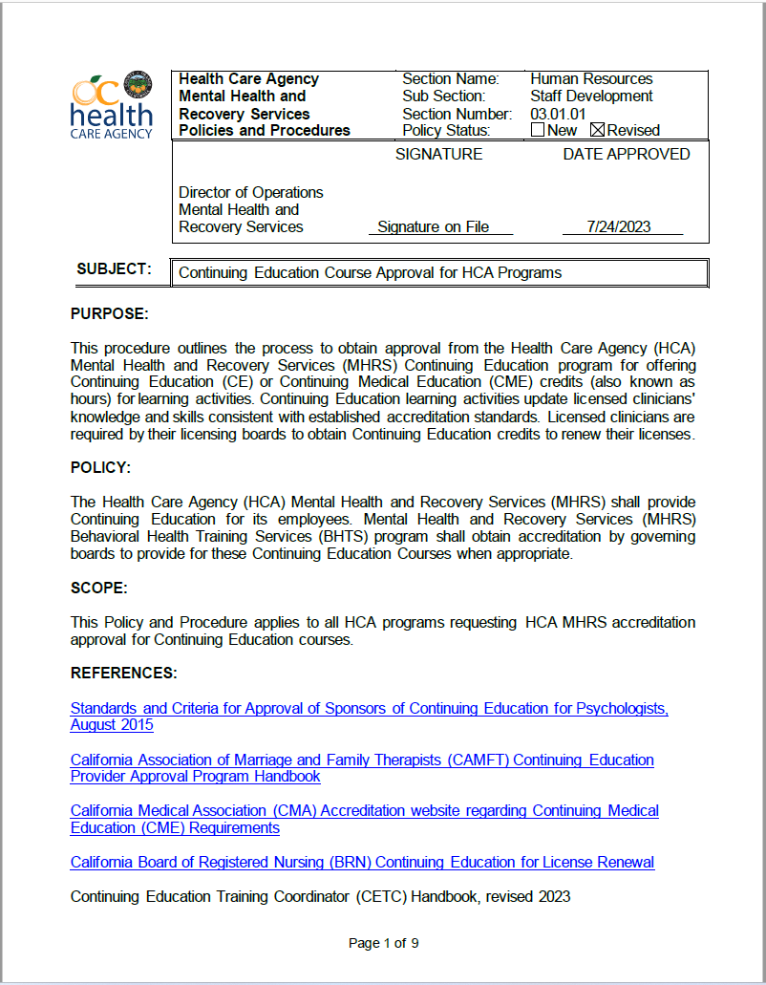
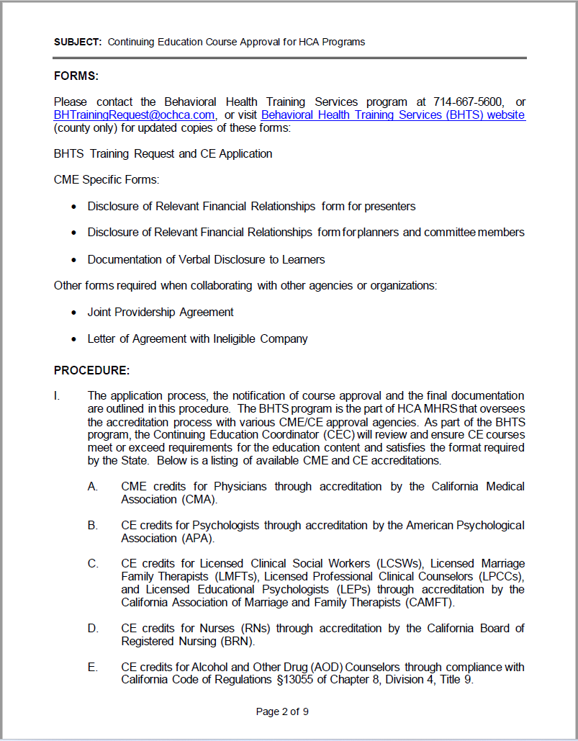
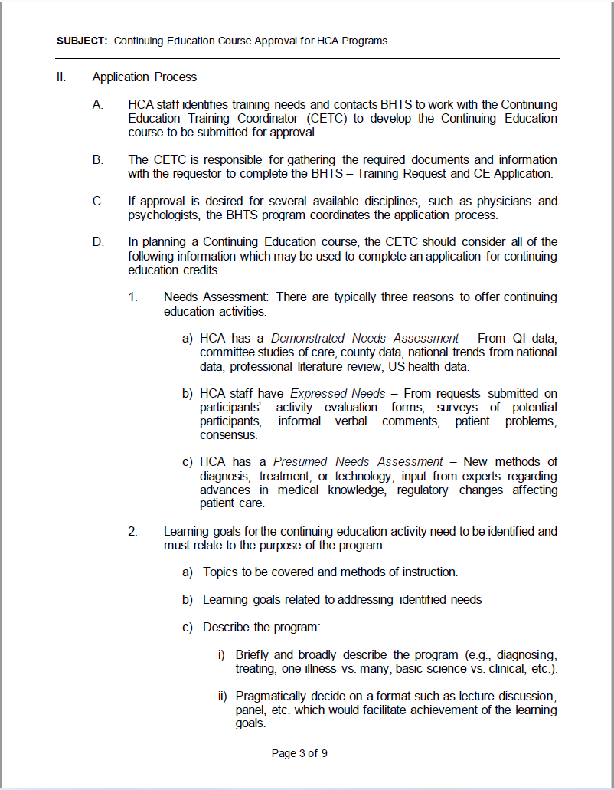
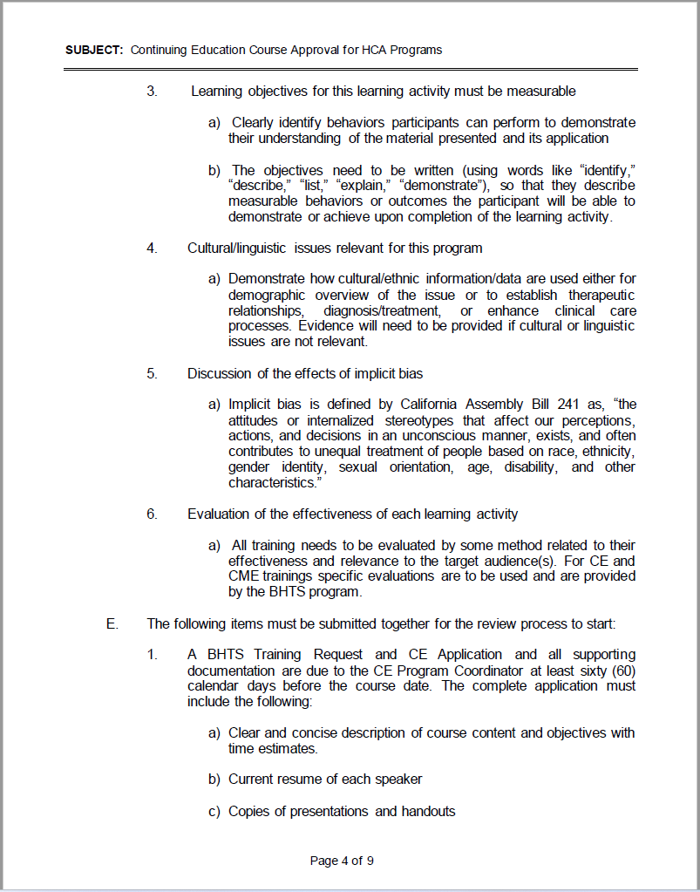
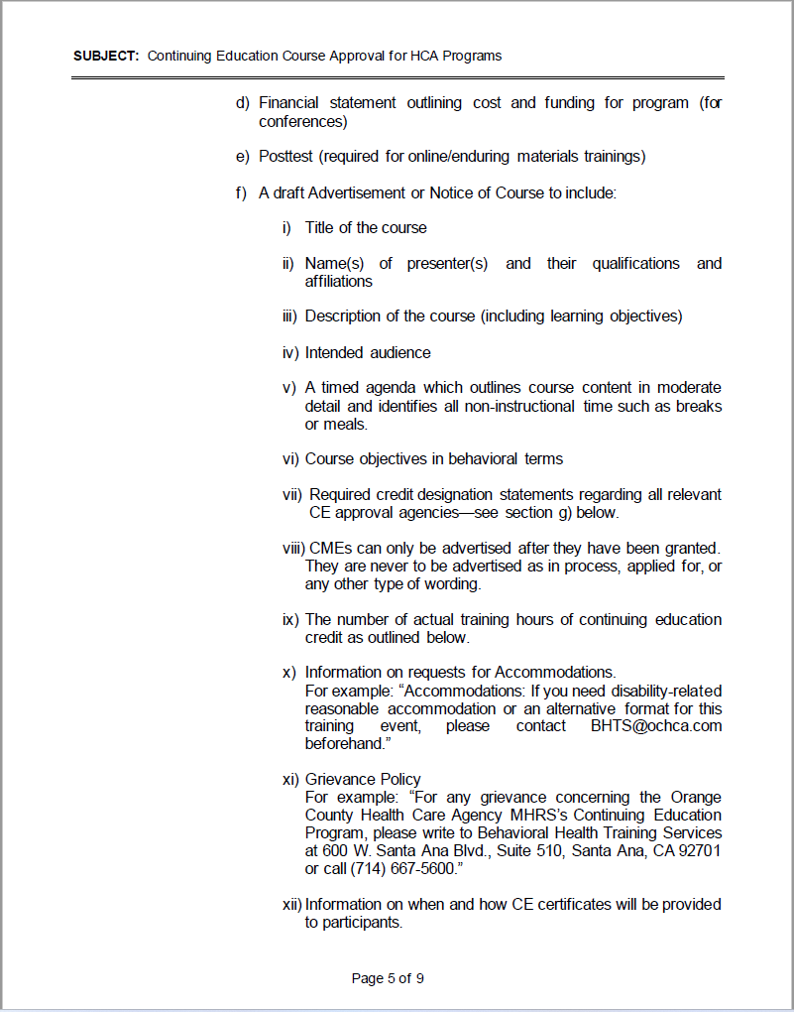
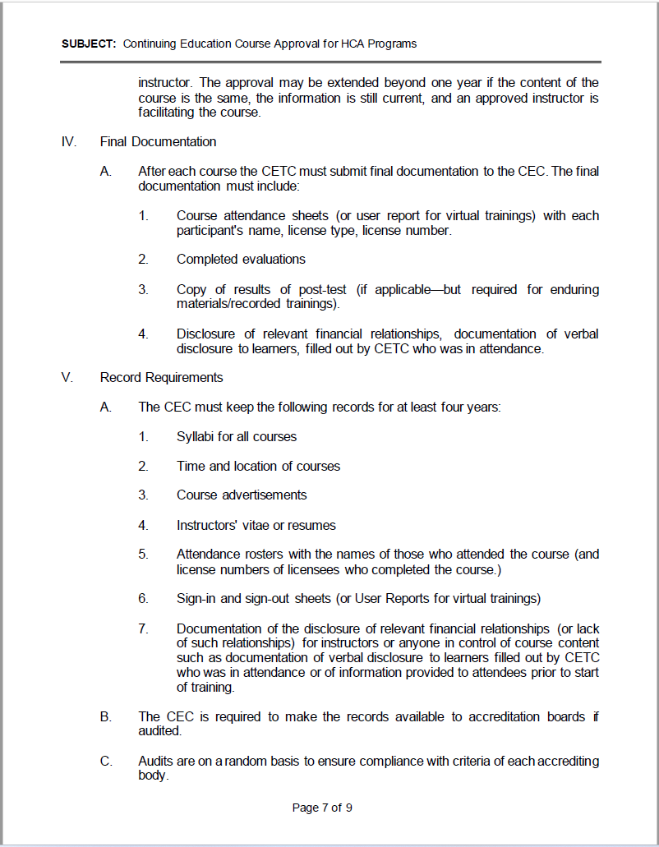
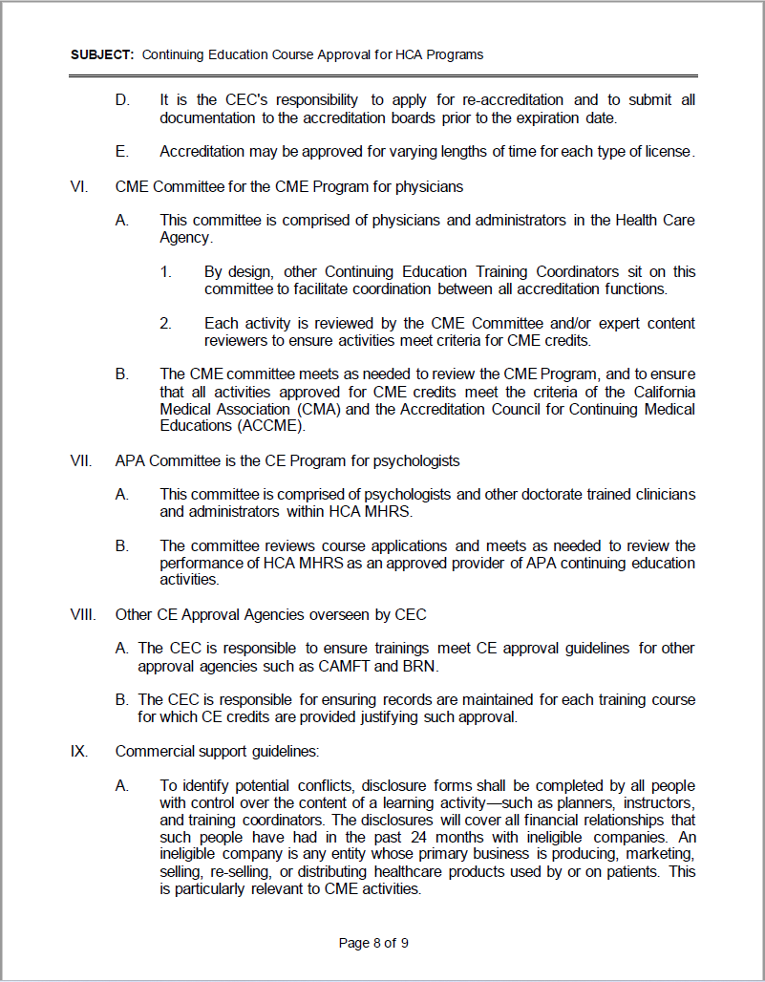
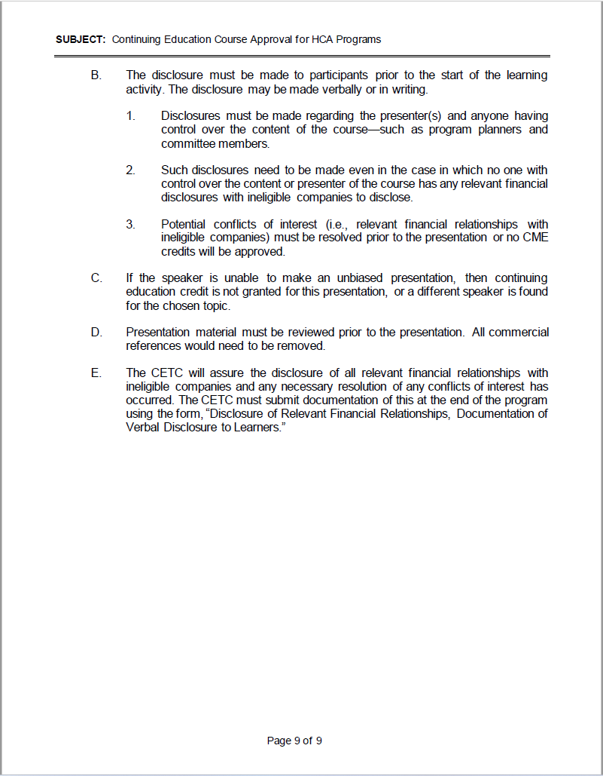

Joint Providership Agreement Ineligible Companies Form
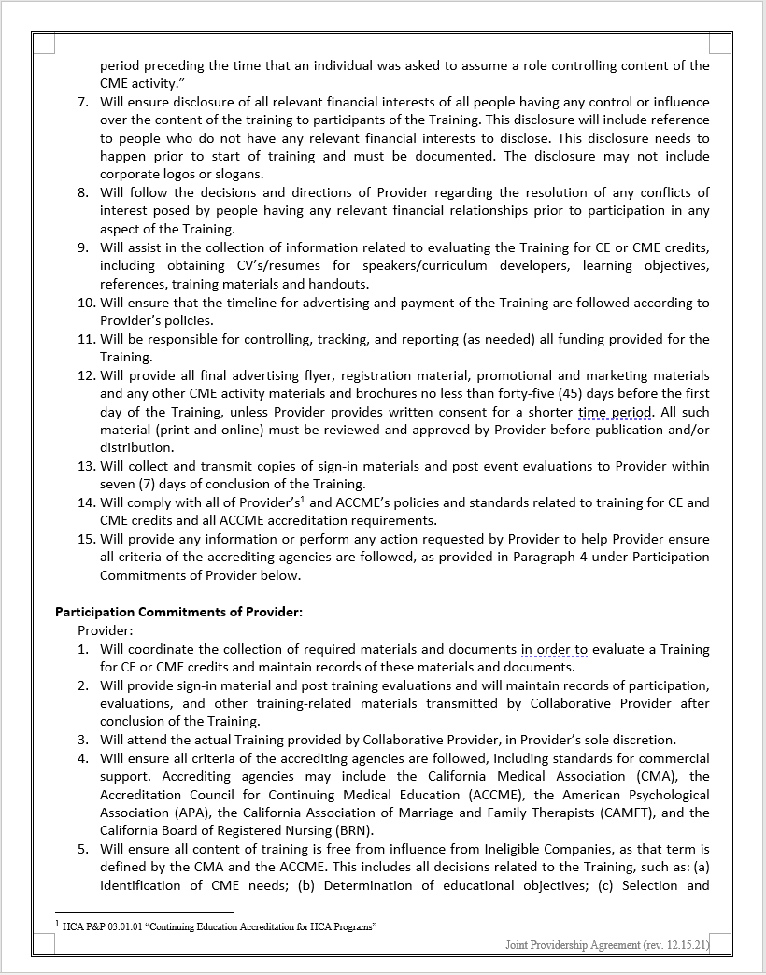
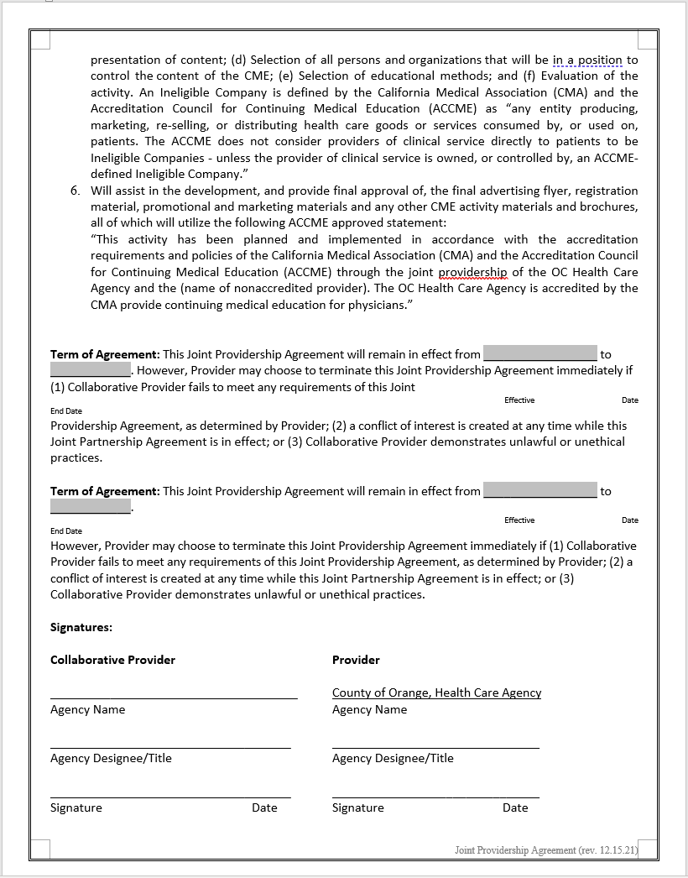

CME Letter of Agreement w Ineligible Company Provider and Collaborative Partner
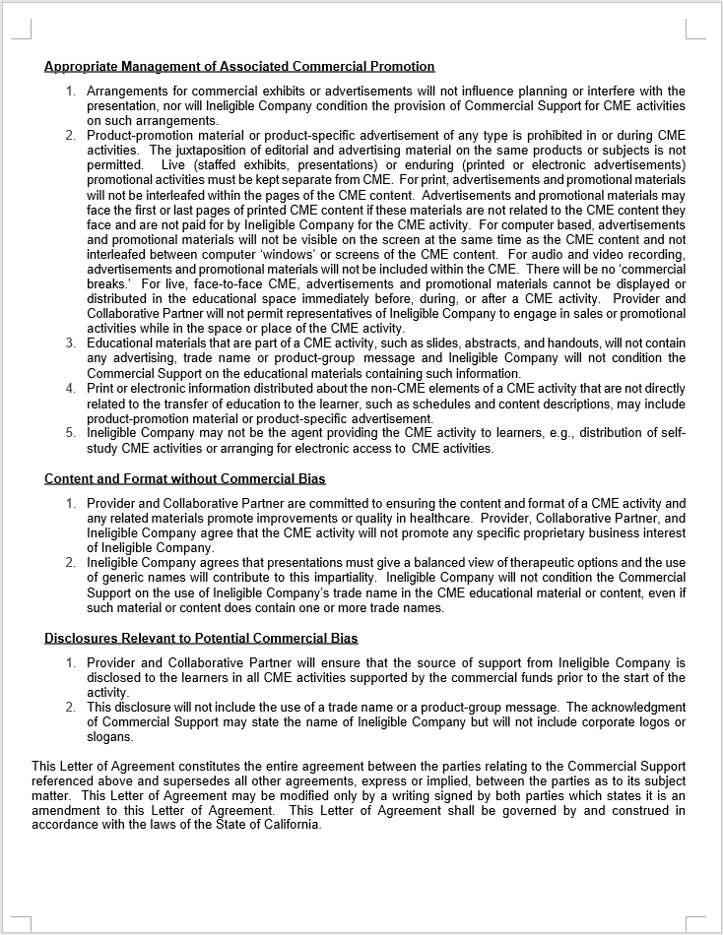

Training Request and CE Application_approved 06.06.23
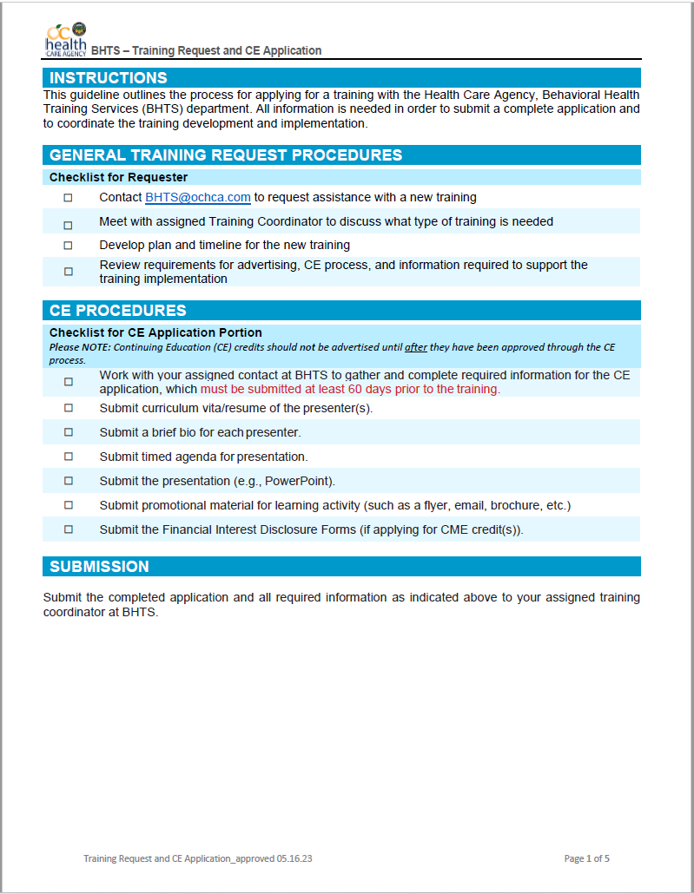
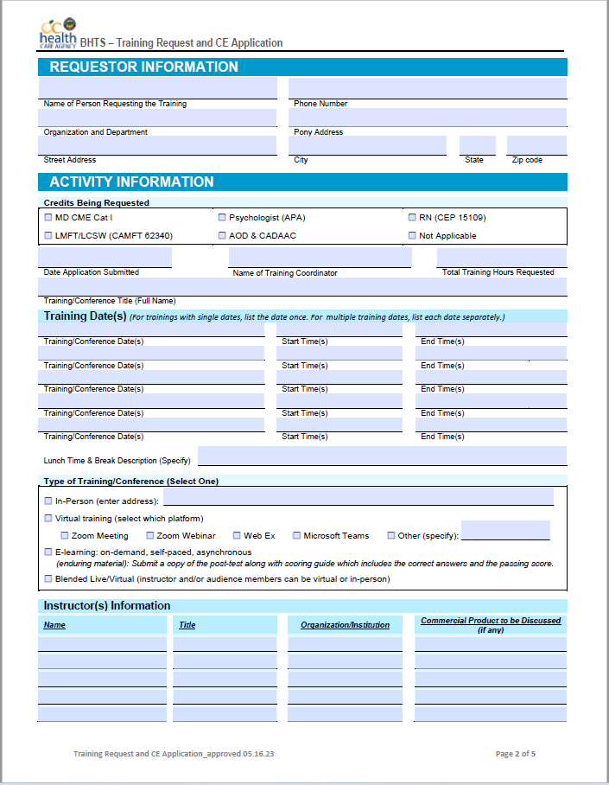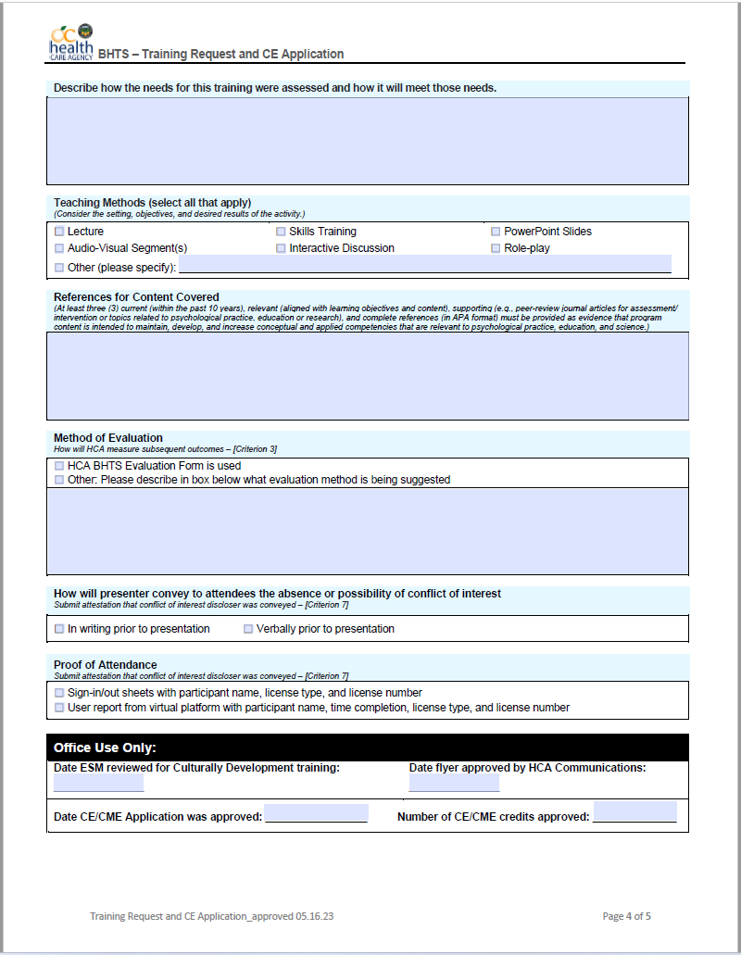
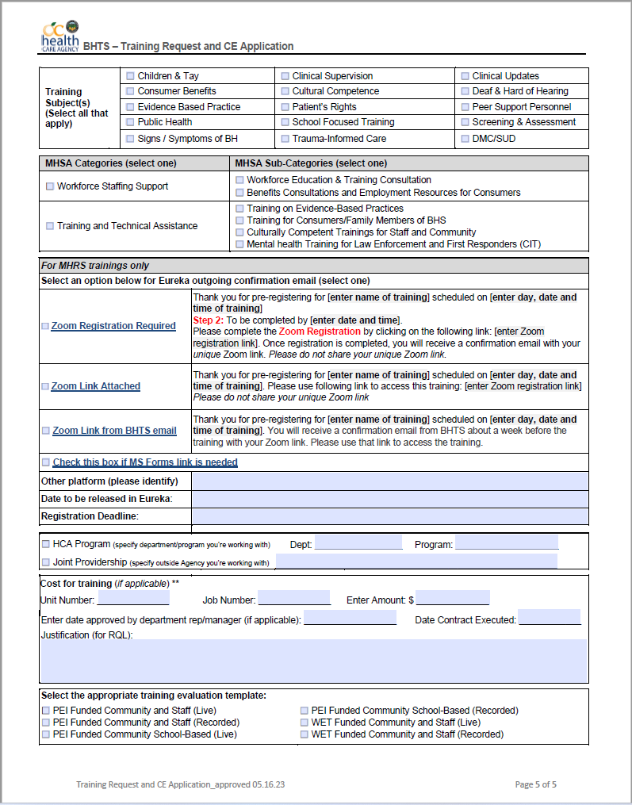

Sponsor_Approval_Form–APA_Checklist

CME_Activity_Review_&_Planning_Checklist
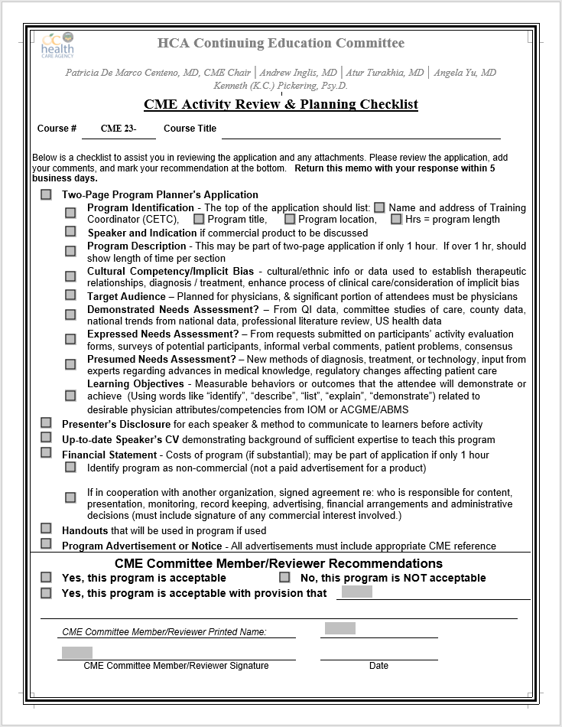

OCHCA CME Disclosure Form
